7.10.24

Dear Felicia, Drs. Johnson and Li.

Thank you for submitting to Level 5 for an optional third review. This review is my final review. Please see the comments I embedded in your document and my summary of Must Address items listed below.

You should work with your committee to address these changes before the defense. You may schedule the dissertation defense once your committee feels confident of your revisions. Incomplete or incorrect revisions will cause delays in progressing promptly after the defense.

The defense must be scheduled with at least 10 days advanced notice; and within regularly scheduled business hours (Arizona time). At least five days before the scheduled defense, you will need to send out the revised dissertation to all committee members. The revised dissertation and the PowerPoint presentation should also be sent to me. I’ll attend the defense (I’ll have a vote along with the rest of your committee) and later, I will conduct the preliminary Dean’s Read (to either recommend or not recommend the dissertation for the Dean’s signature).

You will need to add a slide to the PowerPoint explaining either how you addressed the recommendations from your first Level 5 review and the optional second and third reviews or, if you decided not to follow them, explaining why.

**MUST ADDRESS**

Here are the major issues I identified that must be addressed before the defense.

* See the adjustment to make in the Abstract.
* You are still missing a table in the Appendix visualizing the alignment of the seven categories to the five themes.
* Place the coding tables in the Appendix in the correct order and ensure the Appendix lettering matches the lettering in the body of Chapter 4 and the Table of Content.  
    
  .Codebook  
  .Codes to Categories.  
  .Categories to Themes (Missing)  
  .Themes to Research Questions
* In Chapter 5 from p. 150 through 152, you updated the literature, but have not connected the dots as to how each of the findings you present from recent studies confirm or rival your findings. Revise.
* Writing mechanics continue to be a challenge. I will not be able to recommend to the Dean to sign your dissertation unless scholarly writing is present throughout the dissertation. See the three examples I highlighted on p. 151. The entire document must be copy edited.

Contributions of African American Faculty on Alumni Goals, Motivation, and Persistence at Predominantly White Institutions

Submitted by

Felicia Sims Williams

A Dissertation Presented in Partial Fulfillment

of the Requirements for the Degree

Doctor of Education

Grand Canyon University

Phoenix, Arizona

April 12, 2024

© by Felicia Sims Williams 2024

All rights reserved.

Contributions of African American Faculty on Alumni Goals, Motivation, and Persistence at Predominantly White Institutions

By

Felicia Sims Williams

Successfully Defended and Approved by All Dissertation Committee Members

[Insert Date]

DISSERTATION COMMITTEE APPROVAL:

The following committee members certify they have read and approve this dissertation and deem it fully adequate in scope and quality as a dissertation for the degree of Doctor of Education.

Jill Johnson, PhD, Dissertation Chair

Manyu Li, PhD, Methodologist

Stephen Lee, PhD, Committee Member

ACCEPTED AND SIGNED:

________________________________________ ____________________

Michael R. Berger, EdD Date

Dean, College of Doctoral Studies

GRAND CANYON UNIVERSITY

Contributions of African American Faculty on Alumni Goals, Motivation, and Persistence at Predominantly White Institutions

I verify that my dissertation represents original research, is not falsified or plagiarized, and that I accurately reported, cited, and referenced all sources within this manuscript in strict compliance with APA and Grand Canyon University (GCU) guidelines. I also verify my dissertation complies with the approval(s) granted for this research investigation by GCU Institutional Review Board (IRB).

[Wet Signature Required]

_____________________________________________ ______________________

Felicia Sims Williams Date

Abstract

The purpose of this qualitative descriptive study is to explore how African American alumni describe the contributions of African American faculty and peers on goal setting, self-motivation, and ongoing persistence at PWIs. Using a qualitative descriptive design, data was gathered through interviews and questionnaires from 26 alumni in the South Atlantic Region. Three research questions guided the study: RQ1: How African American college alumni from PWIs describe the contributions of their African American faculty and peers on goal setting? RQ2: How African American college alumni from PWIs describe the contributions of their African American faculty and peers on self-motivation? RQ3: How African American college alumni from PWIs describe the contributions of their African American faculty and peers on ongoing persistence? The study revealed five themes, with a strong emphasis on the sense of belonging. Participants highlighted the importance of African American faculty as role models, contributing to their persistence. The findings, grounded in Tinto’s Retention Model of Motivation, suggest the need for retention plans and increased hiring of African American faculty to promote diversity within PWIs. . The study's findings reinforced the theory and demonstrated potential for developing retention plans for African American students at PWIs. Additionally, the results advocate for college administrators to enhance cultural diversity by increasing the hiring of African American faculty.

*Keywords*: African American, Tinto Retention Model of Motivation, PWI

|  |  |  |  |  |
| --- | --- | --- | --- | --- |
| **Criterion**  **\*(Score = 0, 1, 2, or 3)** | **Learner Score** | **Chair Score** | **Methodologist Score** | **Content Expert Score** |
| **ABSTRACT**  **(Dissertation Only—Not Required for the Proposal)**  (one page) | | | | |
| The abstract provides a succinct summary of the study and MUST include: the purpose of the study, theoretical foundation, research questions stated in narrative format, sample, location, methodology, design, data sources, data analysis, results, and a valid conclusion of the research. **Note: *The most important finding(s) should be stated with actual codes and resulting themes data/numbers (qualitative).*** | 2 | 2 | 2 | 2 |
| The abstract is written in APA format, one paragraph fully justified with no indentations, double-spaced with no citations, one page, and includes key search words. Keywords are on a new line and indented. | 2 | 2 | 2 | 2 |
| The abstract is written in a way that is well structured, has a logical flow, uses correct paragraph structure, uses correct sentence structure, punctuation, and APA format. | 2 | 2 | 2 | 2 |
| **\*Score each requirement listed in the criteria table using the following scale:**  0 = Item Not Present or Unacceptable. Substantial Revisions are Required.  1 = Item is Present. Does Not Meet Expectations. Revisions are Required.  2 = Item is Acceptable. Meets Expectations. Some Revisions May be Suggested or Required.  3 = Item Exceeds Expectations. No Revisions are Required. | | | | |
| **Reviewer Comments:** | | | | |

Dedication

I believed, so I achieved. Becoming Dr. Felicia Williams marks a significant academic milestone in my life—one filled with challenges and immense rewards. First and foremost, I dedicate this dissertation to God. God has shown me that all things are possible. I am excited about my future, and I will honor God through my works.

To my husband, Jeffrey, your sacrifices, laughter, and unwavering belief in me have been my pillars of strength. Thank you for believing in me, making me laugh, for cheering me on during tough times, and celebrating with me during moments of triumph. I love you more than words can express.

To my mom, Jacqueline, your love, strength, and sacrifices have guided me every step of the way. I am forever grateful for your wisdom and belief in me. Thank you for your sacrifices. Thank you for everything. Mom. I love you endlessly.

To my beautiful daughters, Kanisha and Danyelle, you are my inspiration and the greatest blessings in my life. Your love and encouragement have been my driving force. Dreams can be reached! No obstacle is too great! Believe in yourself and you can achieve anything! I love you both!

To my son, Braxton, and grandson, Ky’Rei, your love and enthusiasm kept me going. Your pride fills my heart with joy. Ky’Rei, your laughter was my fuel on this journey. I love you both!

To my dear sister, Demetrian, bonus dad, Windell, and father-in-law, Curtis, thank you for your unwavering support. Demetrian, your motivation and encouragement mean the world to me. Thank you for being my confidant and closet friend. I love y’all!

Acknowledgments

I would like to express my heartfelt gratitude all my family for their unwavering love, support, and understanding throughout the challenging process of my dissertation journey. Your encouragement kept me going, even during the most difficult times.

I am indebted to my dissertation committee, Dr. Jill Johnson, Dr. Stephen Lee, Dr. Manyu Li, and Dr. Kenneth Sherman, for their invaluable guidance, expertise, and insightful feedback. Your dedication to excellence and commitment to my success have been instrumental in my completion of my dissertation.

A special thanks to my friends and colleagues for their encouragement, understanding, and occasional distractions that brought much-needed moments of respite. Your friendship has made this journey more enjoyable.

I also want to acknowledge my BFF, Regina Breed for your words of wisdom, Frederick Sr and Destiny Poole for being an important part of my family village by supporting and helping me with my grandson, my sorority sisters of Kappa Eta Omega Chapter of Alpha Kappa Alpha Sorority, Incorporated, My OES Sisters of Halel 008 Chapter, and my Sister Circle. Your support has been immensely valuable.

Lastly, I extend my deepest appreciation to all those who have supported me in ways both seen and unseen. Your belief in me has been a source of strength and motivation. Thank you all for being a part of this incredible journey.

Table of Contents

List of Tables xiv

List of Figures xv

Chapter 1: Introduction to the Study 1

Introduction 1

Background of the Study 3

Definition of Terms 5

Anticipated Limitations 6

Summary and Organization of the Remainder of the Study 7

Chapter 2: Literature Review 9

Introduction to the Chapter and Background to the Problem 9

Background to the Problem 11

Identification of the Problem Space 13

Theoretical Foundations 15

Review of the Literature 17

History of African American Experience in Education 18

Goals 20

Motivation 21

Persistence 22

Self-efficacy 24

Sense of Belonging 25

Perception of Curriculum 31

Mentoring and Retention 32

Campus Climate at PWI 37

History of Microaggressions 37

Interpersonal Challenges of African American Students 39

African American Faculty Representation 40

Diversity 43

Problem Statement 46

Summary 48

Chapter 3: Methodology 51

Introduction 51

Purpose of the Study 52

Research Questions and Phenomenon 55

Nature and Sources of Data to Answer Research Questions 56

Data Collection Methods 56

Rationale for a Qualitative Methodology 57

Rationale for Research Design 59

Population and Sample Selection 62

Qualitative Sample Size 63

Recruiting and Sampling Strategy 64

Demographics 65

Inclusion Criteria 66

Site Authorizations 66

Sources of Data 67

Research Data 68

Trustworthiness 72

Credibility 73

Dependability 74

Transferability 75

Confirmability 76

Data Collection and Management 77

Recruitment Procedures and Sampling 79

Data Analysis Procedures 81

Braun and Clarke’s (2022) Thematic Analysis Steps 83

Coding 87

Ethical Considerations 87

Delimitations and Assumptions 89

Delimitations 89

Summary 92

Chapter 4: Data Analysis and Results 94

Introduction 94

Important Changes and Updates to Information in Chapters 1-3 95

Preparation of Raw Data for Analysis and Descriptive Data 96

Descriptive Data 100

Data Analysis Procedures 103

Reflexivity Protocol 108

Braun and Clarke’s (2022) Thematic Analysis Steps 108

Data Analysis Steps 118

Results 122

Presenting the Results 122

Limitations 138

Summary 141

Chapter 5: Summary, Conclusions, and Recommendations 146

Introduction and Summary of Study 146

Summary of Findings and Conclusion 149

Overall Organization 149

Reflection on the Dissertation Process 162

Implications 166

Theoretical Implications 167

Practical Implications 167

Future Implications 168

Strengths and Weaknesses of the Study 169

Recommendations 174

Recommendations for Future Research 175

Recommendations for Future Practice 177

Holistic Reflection on the Problem Space 179

References 182

Appendix A. Ten Strategic Points 216

Appendix B. Site Authorizations 222

Appendix C. IRB Approval Letter 227

Appendix D. Informed Consent 229

Appendix E. Copy of Instruments 236

Appendix F Full Codebook 243

Appendix G. Transcripts 253

Appendix H. Feasibility and Benefits Checklist 260

Appendix I. Readability 264

Appendix J. Developing Qualitative Interview Questions Systematically 265

Appendix K. Recruitment Letter 267

Appendix L. Alignment of Questionnaire to Research Question 270

Appendix M. Copy of Invitation to Participant (Study Advertisement) 271

Appendix N. Full Codes, Categories , and Category Meaning 273

Appendix O Categories to Themes 277

Appendix P Final Themes to Research Questions 279

# List of Tables

**Table 1** *Alignment Table* 8

**Table 2** *Descriptive Information for Interviews* 99

**Table 3** *Data Collection Characteristics for Questionnaire* 100

**Table 4** *Participant Demographic Characteristics from Questionnaire* 102

**Table 5** *Example of Generating Initial Codes from the interviews* 110

**Table 6** *Example Codes to Categories* 113

**Table 7** *Example of Codes to Category to Themes* 115

**Table 8** *Analyzing Themes* 116

**Table 9** *Themes, Theme Meanings, and Aligned Categories* 117

*Questionnaire and RQ Alignment* 280

*Final Themes and Definitions* 288

# List of Figures

**Figure 1** *Retention Model of Motivation* 17

**Figure 2** *Example of Code Groupings* 107

**Figure 3** *Example of Codes to Category* 111

# Chapter 1: Introduction to the Study

## Introduction

Historically, research has shown that experiences that occur to African American students who attend Predominantly White Institutions (PWI) directly affect the student's ability to persist to graduation. Even though research has proven that the lack of diversity with faculty of color diminishes African American students 'sense of belonging at PWIs (Benitez et al., 2017), there is still much to understand in terms of how self-motivation, goal setting, and ongoing persistence from African American faculty and peers contributed to African American students and alumni success. Therefore, it is not known how African American faculty and peers contributed to goal setting, self-motivation, and ongoing persistence in the college experiences for African American alumni of Predominantly White Institutions. Further exploration of this topic could potentially lead to showing the impact of having diversity in faculty and peers at PWIs.

The purpose of this qualitative descriptive study was to explore how African American alumni describe the contributions of African American faculty and peers on goal setting, self-motivation, and ongoing persistence at PWIs in the South Atlantic Region of the United States of America. This study could potentially advance knowledge and practice by offering insight into the retention of African American students at PWIs. This study also shows that hiring African American faculty can help with diversity and the academic success of African American students (Foster, 2018).

The problem space in the research has been identified by various research. D’Amico and Fruiht (2020) conducted a quantitative study to determine how on-campus social support predicts students' perceived ability to persist and succeed in college. The purpose of this study explores how hope and social support predict overall satisfaction with academic progress with the ability to graduate and achieve educational goals in college students. This study shows that on-campus support from teachers, advisors, peers, and other staff members increases retention and success in college students (Tinto, 1993, 2006). Relationships with faculty members are vital in retention and academic success. Students who have regular contact with a faculty member have a greater connection and persistence to the campus (Fischer, 2007; Heisserer & Parette, 2002).

994 undergraduate students from a mid-sized public university participated in this study. Snyder's theory of hope was used as the theoretical foundation. Participants completed the Trait and Academic Hope Scale. Participants responded to questions related to social support, experiences on campus, and demographic information. The result of this study shows that on-campus support from teachers and professors predicted academic outcomes. This study supports the gap that underrepresented ethnic minorities report that they had no support from educators on campus. The findings from this study showed the need for more research on how social support helps with retention and hope in college. This study shows how relationships between students and faculty on campus predict the success of students.

This chapter includes the background of the study, information found in the literature on African American attending PWIs, and the problem statement for this study. The section includes the purpose of the research, research questions that direct this study, and gives reasons why this study advances knowledge through the Tinto Retention Model of Motivation. This chapter includes the definition of terms, assumptions, limitations, delimitations, and a summary to further understand this study.

## Background of the Study

Relationships with African American faculty have been shown to serve a compensatory role in the success of African American students. Many years ago, colleges and universities were racially integrated but there is still a difference in the graduation rates of African American students and White students (Griffith et al., 2017). The phenomenon of how African American college alumni from the South Atlantic Region describe the contribution of their African American faculty and peers on goal setting, self-motivation, and ongoing persistence at PWIs can be explored through research. Diversity is important in communities. To create diversity, colleges should hire more African American faculty at PWIs (Foster, 2018). It is important for African American students to have representation at PWIs. Benitez et al. (2017) investigated how the lack of diversity among African American faculty and peers decreases African American students' sense of belonging. This study found that African American students understand that the lack of faculty of color decreases their sense of belonging and resilience at PWIs. Academic motivation and persistence are lessened by feelings of self-doubt and the lack of a sense of belonging. The presence of African American faculty reduces these effects. As a result, African American students perform better on tests when African American faculty are present.

Multiple studies have shown that relationships with African American faculty and peers are important in the retention of African American students at PWIs. African American faculty relationships were an essential component in assisting in the success of African American students. Brooms (2019) conducted a qualitative study with 90 African American college students who participated in a Culture Attitude and Climate survey on the direct relationship between campus climate, racial stereotypes, faculty relationships, and student retention in African American students attending a PWI. This study concluded that African American women graduate students view mentors who shared their racial and cultural identities as vital for optimal success. Minnett et al. (2019) conducted a qualitative study on mentorship being a crucial component of the doctoral student experience. This study showed that African American graduate students view mentors who share their racial and cultural identities as being vital int the success of their program (Minnett et al. (2019). African American women doctoral students who attend PWIs look for mentors who share comparable identity experiences. African American students seek out African American women faculty mentors who attended PWIs (Adams et al., 2016). The researchers found that there was a significant relationship between self-efficacy, motivation, and persistence within these studies.

The research that needs to be better understood is how African American teachers benefit African American students’ success at PWIs. African American students who attend PWIs tend to have lower graduation rates than White students (National Center for Education Statistics, 2020). Adams (2014) research shows that African American students have common factors that make it difficult for students to persist and graduate such as not performing well academically, having no sense of belonging, financial issues, or racial microaggressions/discrimination. Academics and interpersonal relationships impact persistence and retention among African American students but there is little research that addresses the problem (White & Ali-Khan, 2013). Holland (2016), research shows that colleges and universities are increasing their efforts in diversity in enrollment, however, there are no efforts made in retention and effective teaching and classroom intervention strategies. The research that needs to be better understood is how motivation, goal setting, and persistence from African American faculty and peers contributed to African American students and alumni success. To address this problem, PWIs should understand the diversity, motivational factors, and framework that supports their African American students.

## Definition of Terms

Some terms require further explanation in a study. The phenomenon of this study is how African American college alumni from the South Atlantic Region describes the contributions of their African American faculty and peers on goal setting, self-motivation, and ongoing persistence at PWIs. The following terms was used in this study:

Discrimination.Discrimination is when a person is treated negatively based on race, religious preferences, or gender (Clair & Denis, 2015).

Ethnicity. Ethnicity is the cultural trait shared by a social group (Clair & Denis, 2015).

Goal Setting. The process by which goals are achieved by identifying what you want to accomplish through measurable objectives and time limits (Latham, 2004).

Historically Black Colleges and Universities (HBCU).Historically Black Colleges and Universities established for African Americans to serve their educational needs (Taylor, 2018).

Mentor.A mentor is an advisor, coach, counselor, or role model who contributes to the personal or professional development of the mentee (Edwards & Ross, 2018).

Microaggression. Microaggression is unintentionally discriminatory against members of a marginalized group (Bourke, 2016).

**National Pan-Hellenic Council**. Composed of the nine historically Black Fraternities and Sororities to promote community awareness and action through cultural activities (Taylor, 2018).

Ongoing Persistence. Continuing to do something that you’re determined to do even when facing difficulties or oppositions. (Gloria, A. M. et al., 1999).

Predominantly White Institution (PWI). Colleges and universities in which at least half of the student population are White (Brown & Dancy, 2010).

Self-efficacy. The belief in someone successfully executing a required behavior or a person confidence to solve a problem (Davis et al., 2018).

## Anticipated Limitations

This study could have limitations that this researcher cannot control. Limitations are weaknesses within a research study. Limitation could potentially affect the outcomes of the research (Ross & Bibler Zaidi, 2019). Methodology and research design could affect the limitations in this study. The following is an example of potential limitations that could affect this study:

* Sampling strategy-This researcher will employ convenience sampling, Convenience sampling is used for a group that is easily accessible, non-random, and at times members of a similar group or geographic location (Etikan, 2016). For this study, convenience sampling was used to recruit African American participants that can contribute data to the study. Participants must be able to contribute to the phenomenon being studied.
* Limitations of data sources- The data from the study was gathered from participants through self-reported data through questionnaires and interview questions which could be difficult to verify. Self-reported data can lead to potential biases (Hopwood et al., 2018).
* Semi-structured interview questions- Questions could limit the narrative and narrow the focus. Semi structured questions could cause the loss of valuable information (Cronin, 2014)
* Transferability of information-Participants must share or not share their experience at PWI which could lead to issues with the transferability of the data (McQuestion & Cashell, 2020)
* Transcription of data-Third-party sources may be used to transcribe and code the data. Third party sources could potentially introduce biases into the study.

## Summary and Organization of the Remainder of the Study

A review of the literature was fully done in this study. The literature review shows that there is still much to be known about the contributions of African American faculty and peers on African American alumni goal setting, self-motivation, and ongoing persistence at PWIs. This study explored the problem space/gap that are present within the existing research.

Feasibility was addressed through the planning of the study. Informed consent and site authorizations were implemented. A recruitment plan for the participants was implemented to address the expectations, requirements, and the benefits of the research. Feasibility was increased by the participants having a limited amount of time for the study. Participants were allowed to choose an interview time that is convenient for them. The researcher kept in contact with the participants during and after the research through social media platforms. The alignment and descriptions can be found in Table 1 for this study.

**Table 1**  
  
*Alignment Table*

|  |  |
| --- | --- |
| Alignment Item | Alignment Item Description |
| Problem Space Need: | The concept of how African American students perceive the contributions of African American faculty and peers on goal setting, self-motivation, and ongoing persistence at PWIs. |
| Problem Statement: | It is not known how African American faculty and peers contributed to goal setting, self-motivation, and on-going persistence in the college experiences for African American alumni of PWIs. |
| Purpose of the Study: | The purpose of this qualitative descriptive study is to explore how African American alumni describe the contributions of African American faculty and peers on goal setting, self-motivation, and ongoing persistence at PWIs in the South Atlantic Region of the United States of America. |
| Phenomenon: | The phenomena being explored are the contributions of African American faculty and peers on goal setting, self-motivation, and on-going persistence. |
| Research Questions: | RQ1: How do African American college alumni from the South Atlantic Region of the United States describe the contributions of their African American faculty and peers on goal setting?  RQ2: How do African American college alumni from the South Atlantic Region of the United States describe the contributions of their African American faculty and peers on self-motivation?  RQ3: How do African American college alumni from the South Atlantic Region of the United States describe the contributions of their African American faculty and peers on ongoing persistence? |
| Methodology/Research Design: | Qualitative Descriptive Research |

In Chapter 2 the researcher provided a background to the study, theoretical foundations, and a review of the literature that supports the study. Chapter 3 contains the methodology, the research design, and the plans for data collection. Chapter 4 included data analysis and the summary of the results. In Chapter 5, the conclusions and implications reached were discussed.

# Chapter 2: Literature Review

## Introduction to the Chapter and Background to the Problem

The intent of this study is to illustrate the contributions of African American faculty and peers on African American student success. Specifically, this work address’s goal setting, self-motivation, and how these contributions contributed to the on-going persistence at Predominantly White Institutions. The review of the literature probed into the issues that African American alumni faced relating to self-efficacy, a student’s sense of belonging at the institution, and the perception of the curriculum while attending a Predominantly White Institution (PWI). This research was analyzed against Tinto’s Retention Model of Motivation which helped to explore the lived experiences of African American Alumni at PWIs.

Persistence can be described with Tinto’s model however there are additional forces that potentially work against the African American experience. This strong and relevant theorist focused the work on the whole of a student population which is Predominantly White. This may not allow for the voice of the Black experience to be heard. Considering the African American experience, these students also have to endure microaggressions, challenges with peer mentoring, and the challenges with lack of African American faculty representation. These variables will also be addressed.

The literature review was organized to address the introduction to the problem, background to the problem and the problem space. The overview of the study and framework for the literature will be found in the introduction to the problem space as well as discuss how the problem has evolved from past historically to present. The problem space will help to identify what still needs to be understood for this research topic.

The literature used was found in peer reviewed journals and articles in Google Scholarly and Grand Canyon University library. The search terms used included PWI (Predominantly White Institute), HBCU (Historically Black Colleges and Universities), African Americans, White, mentors, mentoring, African American faculty mentors, African American peer mentors, higher education, African American graduation rates, retention, academic success, student involvement, student engagement, goal setting, self-motivation, ongoing persistence, self-efficacy, sense of belonging, and perception of curriculum.Google scholar was used to obtain peer reviewed articles published within the past 5 years needed to gain knowledge and information to support the problem space. My search efforts also included articles and books in the university library that will be relevant to my research. The Educational database that was used included ERIC, Sage Journals, JSTOR Journals and Books, and Dissertations and Thesis database at Grand Canyon University.

The Background to the Problem will discuss the evolution of historical information relating to African American in educational institutions such as Historically Black Colleges and Universities (HBCUs) and PWIs. Also provided is an overview of the Problem Space seen within the literature and a summarization of the literature relating to goals, motivation, and persistence among African American students. The theoretical foundation section will focus on the framework that defines this study. The review of literature will give a synopsis of existing literature and review methodology from previous research. A summary was provided at the end to summarize the information given within this chapter.

## Background to the Problem

It is important for African American students to have African American teachers at PWIs. The lack of diversity with faculty of color diminishes African American students ‘sense of belonging at PWIs (Benitez et al., 2017). Research shows that retention plans need to be developed to understand the obstacles that will hinder the success of African American student population (Eakins & Eakins Sr., 2017). Retention plans should include hiring more African American teachers for PWIs. PWIs have developed hiring practices that recruit and retain faculty of color to help diversify their institution (Hunn, 2014). African American teachers have always been an essential element in African American students’ success, especially when they are a minority in an institution.

African American faculty serve as role models for African American students which allows African American students to see themselves in the reflection of those who educate them. There is a lack of African American faculty representation at PWIs which results in African American students being at a disadvantage for mentoring from someone with shared culture (Griffith et al., 2017). Having at least one African American teacher can make a difference in the academic performance of African American students attending PWIs.

In order to define the problem space, this researcher will highlight what is the current problem, what we know, and what still needs to be understood by discussing the proposal of future research. Current research shows that relationships with teachers have shown to serve a compensatory role in supporting the academic success of African American students. D’Amico and Fruiht (2020) conductive a qualitative study to understand the role of hope and on-campus social support in predicting students’ perceived ability to persist and succeed in college. Griffith et al. (2017) conducted a study that demonstrated on-campus support from professors and teachers showed significant academic outcomes and hope. Students perform better when they have a connection with their professor and peers.

African American faculty relationships were an essential component in assisting African American students at PWIs to achieve success. Brooms (2019) conducted a quantitative study with 90 African American college students who participated in a Culture Attitude and Climate Survey. This survey looked at the direct relationship between campus climate, racial stereotypes, faculty relationships and student retention in African American students attending a PWI. African American women graduate students view mentors who shared their racial and cultural identities as vital for optimal success. Minnett et al. (2019) conducted a qualitative study on mentorship being a crucial component of the doctoral student experience.

Previous researchers have identified that mentoring is a positive factor in retention and completion rates in higher education (Blackwell, 1989; Faison, 1996; Stout et al., 2018). Mentoring can be successful when students share goals, perception, and world views. In a study done by Davis (1994), Davis stated that some African Americans that attended PWIs view their relationship with their faculty and peers as being a negative relation. Davis study also showed that students who do well academically have a positive campus experience and have more interaction with their parents and peers. This chapter will further present research that shows having a good relationship with faculty and peers can be beneficial to retention of students and increased graduation rates.

## Identification of the Problem Space

There is a need to further study the impact of the diversity in faculty and the diversity of peers as it relates to retention of African American students. Colleges and universities were racially integrated many years ago but there is still some disparity between the graduation rates of African American students and White students (Griffith et al., 2017) as it relates to goals, motivation, and persistence for African American students at PWIs. Being a numerical minority in a largely White university can make African American students feel isolated (Harper, 2013). African American students felt that individuals who did not possess a shared understanding of race-related stressors, particularly those that may be unique to the PWI setting, would not be able to provide the support students needed (Seawell et al., 2014).

There are contributing factors that African American college students’ credit for their academic success. One factor is a sense of belonging which influences motivation and endurance to persist in academic success (Ransom, 2017). Graduation rates have increased for African American college students (Campbell, 2011). Previous research shows that African American experience social and academic factors that can promote or inhibit the student’s persistence toward graduation.

Guiffrida (2005) conducted a study that showed how African American college students’ relationship with faculty, family, organization, and peers can become assets or liabilities to their academic achievement and persistence. Guiffrida (2005) research showed that a strong relationship with faculty is vital to the success of college students. Campbell (2011) research showed that students perceive African American faculty as being more willing to go above and beyond White faculty.

Researchers found that African American students reported experiencing a significantly greater frequency of racial microaggressions and reported a lower sense of belonging (Lewis et al., 2021). These authors conducted a mixed methods study that explored the relationship between the frequency of racial microaggressions and sense of belonging using multiple regression analysis. The recommendations in this study were highlight implications for future research on African American students at PWIs. Same race teachers benefit students and demonstrate for African American students in particular, positive outcome sparked by the role model effect can last into adulthood and potentially shrink the educational attainment gap (Johns Hopkins University, 2018). There is a need to further study the impact of the diversity in faculty and peers at PWIs as it pertains to the overall persistence of African American alumni as well as how self-motivation, goal setting, and ongoing persistence from African American faculty contributed to African American students’ success.

African American students perceive that African American faculty and peers understand their needs culturally and socially than White faculty and peers (Faison, 1996). An increase in enrollment of African American students reflect challenges faced at PWIs (Booker, 2016; Griffith et al., 2017). Concerns regarding African American students at PWIs are shown throughout research relating to stereotyping, and discrimination Strayhorn & Johnson, 2014).

Research has shown that the overall success of African American students is contributed to motivation, sense of belonging, and persistence (Zumbrunn et al., 2014). Zepke (2015) research explored the meaning of sense of belonging using mixed methods research. This research showed a need to further examine factors relating to sense of belonging such as engagement with faculty and peer relationships.

Booker (2016) research shows that faculty and peer engagement play a vital role in promoting the sense of belonging in African American college students. Booker researched showed that African American college students perceived faculty as being accessible and approachable in their interactions with students. African American college students feel underrepresented which leads to feelings of isolation, frustration, and anger (Boyraz et al., 2016).

## Theoretical Foundations

Vincent Tinto has developed his theory and retention model over the years to include competence to engage and persevere to achieve high educational goals. Tinto previous models focused on family background, individual attitudes, and precollege education as being vital in pursuing educational goal (Tinto, 1975, 1987, 1988, 1993, 2006, 2017). Tinto research has been instrumental in identifying motivation, commitment, and goals that influence retention and success. Tinto conducted research on student retention as it relates to the impact of learning through the eyes of students (Tinto, 2017). This theory will be the framework for the study. Retention is the ability to retain a student from admission through graduation at an institution. Institutional climate, student academic success, and social life are important to student retention (Tinto, 1987). In Tinto updated research, Tinto stated that “students want to persist” (Tinto, pp 254, 2017). Tinto Model of Retention will be used to provide understanding of the role of goal setting, motivation, and persistence for African American college students through alumni reflections of their time at PWIs. The goal is to find out how alumni were successful to better inform a discussion of how African American college students could attain similar success.

Tinto (2017) model is used in higher education literature. The author focused on factors that influenced students’ persistence in achieving their goals. The author retention model reflects on what causes students to remain motivated at colleges and universities by looking at self-efficacy, sense of belonging, and perceived relevance of the curriculum. This retention model helps to identify factors that contribute to student success through the concept of setting goals and internal, personal motivation. Research has shown various theoretical models used to understand why students succeed in college (Tinto, 1975, 1987, 1988, 1993, 2006, 2017). Tinto (1988) model focused on the contributions of institutions to help students graduate. The revised model focuses more on academic integration and the importance of faculty and student engagement.

Further, the model focused on student engagement with faculty which helps to produce student retention and success (Tinto, 2017). This retention model suggests that student engagement with faculty helps to promote academic success and shows how student motivation level influences the ability to persist to complete their degree. The phenomenon studied through this research describes the contributions of African American faculty and peers on African American alumni goal setting, self-motivation, and on-going persistence at PWIs located in the South Atlantic Region of the United States. This study will use qualitative methodology and a descriptive design. Although Tinto’s (2017) Retention Model of Motivation does not specifically address African American students attending PWIs, the theoretical model allows factors to be identified that will help PWIs manage retention through inclusiveness, and the future success of African American students by looking at the lived experiences of alumni.

**Figure 1**  
  
*Retention Model of Motivation*

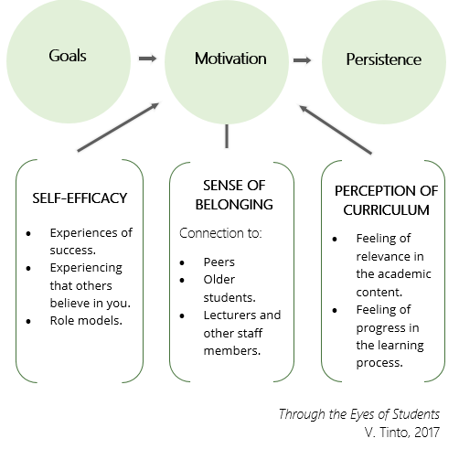

Note. Incorporating Theories and Models of Research (Tinto, 2017) Permission to use Figure 1 Can Be Found in Appendix O.

## Review of the Literature

Researchers have used many theories to study student retention. Vincent Tinto research addresses retention through the eyes of students. Tinto (2017) addressed the need for goals as they promote motivation. Having strong motivation sooner aids persistence. Importantly, the underlying promotion of goals, motivation, and persistence concerns the student’s self-efficacy, their sense of belonging, and their perception of the curriculum. The following section describes each of these six areas and how prior researchers have used these concepts to describe these attributes in educational settings. Tinto stated that persistence can be described with this model, however there are additional forces that potentially work against African American experience. This strong and relevant theorist focused the work on the whole student population which is Predominantly White. This may not allow for the voice of the Black experience to be heard. Considering the African American experience, these students also have to endure microaggressions challenges with peer mentoring, and the challenges with a lack of African American faculty representation. These variables will be addressed within the literature review.

### History of African American Experience in Education

African American experiences within higher Education has been a topic of research for many years (Shuford & Flowers, 2016). Higher education has been historically reserved for White Americans. African Americans were excluded from higher learning because of discriminatory practices, government mandates, and institutional racism (Karkouti, 2016). In 1799, John Chavis was the first African American to attend an American college or university (JBHE Research Department, 2019). In 1823, Alexander Twilight was the first African American to receive a degree from Middlebury College and in 1833, Oberlin College was the first university to admit African American students (JBHE Research Department, 2019). Historically, research has shown that diversity has become an area of increasing importance in communities. HBCUs have been a beacon of light for African American students for academic success in higher education. In 1954, the year of Brown v Board of Education, many US schools were segregated, and most Black students had Black teachers (Hornick-Lockard, 2021). After Brown v Board of Education, many all-Black schools closed in the southern states. The desegregation decision of Brown v Board of Education made PWIs accessible for African Americans to attend higher education. Desegregation brought a decline in enrollment at HBCUs. The brown decision helped to increase diversity by allowing African American to attend PWIs. (Johnson, 2013).

By 1900, across the United States, the average teacher was a middle-class White woman. The start of the 21st century showed an increase of African American students enrolled in PWIs (Johnson, 2013). It is critical for minority students to have positive student and faculty relationships in college (Houston et al., 2010). Hiring African American faculty can increase a student chance to learn in a PWI as well as help with the development of student -faculty relationships for African American students (Johnson, 2013). To create more diversity in teachers, colleges and universities should consider hiring more African American faculty positions at colleges and universities (Foster, 2018). Hiring African American faculty will help with diversity especially in the education department.

Before the Civil Rights Act of 1964, HBCUs were established as institutions of higher learning for African Americans (Wooten, 2015). Most HBCUs were in the Southern United States. During segregation, the majority of American institutions of higher learning served Predominantly White students and limited the enrollment of Black students (Wooten, 2015). During and after slavery, African Americans were prohibited to attend PWIs in the Southern United States (Wooten, 2015). HBCU were established to provide higher learning to African American Students.

After the Civil Rights Act and Higher Education Act, African American students started attending PWIs however, obstacles were faced for African American faculty and students teaching and working in this now diverse environment. Representation of African Americans in higher education at PWIs do not mirror the diversity of the US population. Throughout the century between 1971 and 1986, the percentage of African American faculty decreased from 8.1% to 6.9 % (Carrol, 2017). This percentage continues to decrease into the 1900’s and through the 21st century (Carrol, 2017).

Colleges and universities have found it challenging to recruit African American faculty due to not finding a sense of belonging and community (Goodwill et al., 2022). According to the National Center for Education Statistics, in the fall of 2017, out of 1.5 million faculty in post-secondary institution, less than 3% of the faculty were African American males or females. Having low number of African American faculty has an impact on African American population at PWIs due to not being able to identify role models or mentors that look like them (Edwards & Ross, 2018).

### Goals

Most students who attend a college or university have a goal to graduate.

Students who have available resources at their academic institution are more likely to meet their goal of graduation. Students are more likely to graduate from college when they perceive they have sufficient support from faculty, staff, and peers at their institution (Ellis, 2014). Lau et al. (2018) stated that students need access to faculty for setting and attaining educational goals. Jorgenson et al. (2018) stated that students who are satisfied with their social and academic environments, feel connected to their institution, and have a peer relationship are impacted to attain the goal of persisting and graduation from college. Students who are uninterested and disengaged will not achieve their educational goals (Wells et al., 2014).

Smith (2017) conducted a study that measured goal commitment and academic success of African American student at a PWIs. The study consisted of African Americans college students ages 18-53. Smith study suggested that there are contributing factors that influences the goals and success of African American students. Research conduct by Smith and Ransom (2017) both showed the influence of involvement in campus organizations influences motivation and persistence in African American students. Smith & Ransom research both supports factors of goals and campus involvement are factors that contribute to the success of African American students at PWIs.

### Motivation

American Psychological Association define motivation as a force that gives purpose or direction that operates at a conscious or unconscious level. Research has been done that defined internal and external motivating forces. Researchers show that people who have high academic aspirations are inclined to being motivated to succeed (Eccles & Wigfield, 2002; Whiting, 2009). Motivation is important in determining success and failure of students (Opdenakker & Maulana, 2011). African American students’ have various factors of motivation such as relevance of learning materials, interactions with the school, and school environment, and (Dowson & McInerney, 2001; Oyserman et al., 2006). Whiting (2009) research shows that people who have internal motivation believe that they are capable of achieving success and are aware of external and social inequalities in school environment (Whiting, 2009).

According to Fong et al. (2021) and Frey et al. (2018), motivation is a predictor of students’ academic success and persistence to graduate. African American students are likely to be motivated when they feel that they have meaning relationships with African American faculty and peers as well as internal desires to complete their goals. Davison and Worrell (2016) research show that students who feel autonomous in a certain context are likely to be motivated, feel a sense of belonging, and experience academic success in that context. African American students are more aware of racial prejudice within their educational institution which has led to distrust with the systems and in those that attended PWIs (Locust, 2017). African American student’s motivation for success depends on positive life outcomes and degree completion for academic success. Garland (2021) study shows African American Students are less motivated and put less effort in their pursuit for academic success compared to White students that attend PWIs. and affects the performance of African American students.

Isik et al. (2018) conducted qualitative inductive research to examine factors that might influence the motivation of ethnic minority students from their own perspective. Researchers show that there are several factors that can have a positive or a negative influence on academic motivation due to individual, family-related, school-related, and social factors (Isik et al., 2018). This study shows that more research is needed to show what motivates ethnic minority students.

### Persistence

Persistence includes reflecting on faculty teaching methods. Students need to feel the material learned is of a quality that warrants their time and effort. Persistence helps students to be motivated to be engaged in their curriculum (Turner & Waterman, 2019). Persistence in college among African American students continues to remain low compared to persistence among White students (Bourke & Bray, 2012). Persistence increases as a student feel connected to the social environment of the institution (Braxton et al., 2004). There is a positive correlation between how students persist and faculty interaction. Involvement with faculty is related to student satisfaction more than student involvement (Astin, 1999). Zerquera et al. (2018) stated that faculty is the primary point of contact for college students and the faculty-student relationship. Zerquera et al. (2018) also stated that faculty plays an important role in shaping students’ experience in college and out of college which helps with students’ retention, persistence, and attaining goals.

Stewart (2012) research shows that student and faculty interactions have a positive impact on graduation rates. Lundberg (2014) research shows that African American faculty and administrators are strong predictors in program completion of African American students. African American faculty helps in the persistence of African American students at PWIs. Hiring African American faculty increases completion rates for African American students.

Himelhoch et al. (1997) did research that examine the factors that predict persistence for African American students attending PWIs. Himelhoch study suggested that faculty mentoring was a significant factor for African American students’ persistence at PWIs. Faison (1996) study showed the effects of mentoring African American students. Mentoring is crucial for African American students’ well-being and over persistence at PWIs. González and Meling (2018) examined the effectiveness of faculty -student relationships as it relates to student persistence. Faculty and student interaction are predictors of student commitment and persistence.

Anumba (2015) qualitative research explored the experiences of African American males’ persistence. Anumba research showed that support from peers, teachers, and community members were important factors for the persistence of African American males. Anumba research did not focus on African Americans at Predominantly White institutions. Anumba research had a sample of 8 African American males college students.

### Self-efficacy

Self-efficacy is the experience of success, that others believe in you and being and role models (Tinto, 2017). A person’s belief in the ability to succeed in specific situations or tasks. Self-efficacy is how a person sees themselves from their experiences and interactions with others. Having a sense of self efficacy influences how a person addresses tasks and challenges which leads to goal attainment (John, 2019). Same race role models influence academic self-efficacy of African American college students (Pajares, 2003). Self-efficacy beliefs are shaped by personal performance as success in academic increases a person’s self-efficacy. If a student feels confident about their ability to perform academically, they have a high self-efficacy regarding their learning goals (Beatson et al., 2021). In contrast, low self-efficacy can impact a student’s motivation to learn. In essence, a student’s self-efficacy influences students’ academic performance, African American students who enter PWIs with a high level of self-efficacy and make internal attributions, upon the first experience of failure, may question their abilities which could result in a negative effect on the academic self-efficacy and academic positive outcomes (van Laar, 2005).

History of Self-Efficacy. Bandura’s foundational framework for self-efficacy started in 1977 which Bandura stated is the self-perception and belief in a person’s own ability and skill to keep their goal. Self-efficacy helps a person engage, persist, execute behaviors, obstacles, and experiences (Bandura, 1997). When students have self-efficacy, they can create and manage circumstances in their life. This is important for African American students to help with having confidence and self -worth in situations that arise White attending PWIs. Whiting (2009) states the importance of the perception of African Americans students to see themselves as leaders to help with their self -confidence and achievement.

Current Studies of Self-Efficacy in African American Students. Robertson and Chaney (2017) researched the experiences of African American males attending PWIs. Robertson & Chaney examined factors that fostered a positive campus environment and academic experience by looking at racism and microaggression and African American experiences at PWIs. Robertson and Chaney (2017) researched showed that African American males experience was not significantly important relating to the lack of African American classes, faculty not engaging as it relates to African American studies, and no mentorship for African American males. This study was limited as it only looked at African American males at one PWI in a small sample. Regis (2019) study shows how student engagement, self-efficacy, and mentoring are related to retention of students at PWIs. This research studied African American males and the relationship between self-efficacy, student engagement, mentoring, and retention of undergraduates at a PWI. This study used a web-based survey on perceptions of self-efficacy, engagement, mentoring, and retention.

### Sense of Belonging

One of the key elements to academic success and student retention is a sense of belonging. African American students that attend PWIs stated their campus was not friendly and welcoming (Kane, 2019). Museus et al. (2018) conducted a study at a PWI on the east coast that showed White peers have a higher sense of belonging that African American at the same institution. This study examined racial difference and experiences of White students and African American students. White students have a higher sense of belonging than African American students on a diverse campus. Relationships help African American students sense of belonging and can affect their academics and social experience.

Students should see themselves as members of their community of students. Sense of belonging increases when students’ participation is valued, and students share common interest. Sense of belonging drives student motivation to persist within the institution and engages others to persist (Brooms, 2019). Race impacts the sense of belonging of African American students at PWIs (Kane, 2019). The experiences of African American students resulted in a struggle to develop a sense of belonging (Hunn, 2014). Interaction between peers and faculty has an impact on a student’s sense of belonging. Booker (2016) stated that peer and faculty engagement is important for the sense of belonging for African American students.

Guiffrida (2005) conducted a qualitative study that examined student -faculty relationships. This study involved nineteen undergraduate students that attended a PWI in the Northeastern Region. Guiffrida (2005) researched used high achieving African American students Guiffrida research showed that African American students that attended this PWI had less faculty contact and engagement in academic than White students. Guiffrida research also showed that African American students had difficulty with building positive relationships with White faculty.

Tinto (2017) model shows that sense of belonging is important to students. It is crucial for African American students to connect with other African American students which helps to increase self-efficacy (Guiffrida, 2005). Guiffrida and Douthit (2010) research show that student -faculty relationships that are positive result in high satisfaction with college, retention, and academic success. African American students do not see White faculty as role models and feels that White faculty are culturally insensitive (Guiffrida & Douthit, 2010).

Griffith et al. (2017) study showed that mentors help with sense of belonging by increasing the sense of acceptance and support. Sense of belonging can filter outside of the classroom. Gloria et al. (1999) conducted research that addressed social and environmental issues that affect the persistence of African American students that attend a PWI. Gloria et al., research was done at a large PWIs that had only 2.9% of African Americans in the student population. Gloria et al. (1999) research supports that social support and university environment contribute to higher persistence. The African American students in this research viewed their campus environment as being positive and culturally fit. The social support identified in this research consisted of mentors, family and peers with mentoring having the strongest effect on persistence (Gloria et al., 1999). The PWI in this research conducted annual reviews on the faculty to recruit and retain minorities. The research concluded with showing how positive effects of support networks give African American students a sense of belonging at the large PWI.

The commitment to the African Americans students in this research proved that PWI can increase the persistence in African American students. Campus environment is crucial for African Americans at PWIs. Museus et al. (2018) research showed the importance of campus environment as it relates to sense of belonging.

Research has shown that belonging to a group or organization with cultural identities is beneficial to African American students that attend PWIs. Allen and Joseph (2018) investigate the experiences of women in the Sistah Network which is an affinity group at PWIs. The Sistah Network offers mentoring and peer relationships for minority women. Eighteen women that consist of faculty, staff, and student were interviewed and observed to get insight on the academic and social experiences of women. The theoretical framework used was Critical Race Theory and Black feminist to interpret the findings. The results of the research reveal four main themes: the Sistah Network advances identity and empowerment, it contributes to social advantages, and it affords emotional benefits and promotes academic success. The promotion of the network to expand to other universities and colleges is great because the positive outcomes have proven to be beneficial to all involved Allen and Joseph (2018). This study is relevant in identifying that African American need a sense of belonging when attending PWIs.

Higher education should create inclusive environments for minority specifically African American student to ensure fairness and equity and to make the students feel welcomed on the campus. Although current research is needed to examine to African American sense of belonging attending PWIs, sense of belonging can be established by connecting with likeminded students. Sense of belonging is influenced by college peers, faculty members, and membership is organizations.

Johnson et al. (2022) examines concerns about physical and psychological safety of African American students that attend elite predominantly White Ivy League colleges and universities by looking at racial bias. This study shows the impact of experiencing racially motivated incidents on African American students’ sense of belonging. Researchers show that leaders should continue to strategize and address racial tensions to benefit diversity in higher education (Johnson et al., 2022).

Research shows that one of the key elements to academic success and student retention is a sense of belonging. African American students that attend PWIs stated their campus was not friendly and welcoming (Kane, 2019). Museus et al. (2018) conducted a study at a PWI on the east coast that showed White peers have a higher sense of belonging that African American at the same institution. This study examined racial difference and experiences of White students and African American students. White students have a higher sense of belonging than African American students on a diverse campus. Relationships help African American students sense of belonging and can affect their academics and social experience.

Sense of Belonging through Black Greek Life. Some PWIs have African American student organizations on their campus to help African American students feel a sense of belonging. African American student organizations at PWIs such as Black Greek Letter Organizations and other Black organizations at help improve African American students’ academic achievement and persistence (Guiffrida & Douthit, 2010). Cultural relevance helps with students’ sense of belonging. Sororities, fraternities, and other cultural organizations should be established at PWIs to help African American student shape perceptions of belonging. Guiffrida and Douthit (2010) research show that African American students join Black organizations for networking, mentoring and support.

Research shows that Greek-lettered organizations help foster peer relationships and a sense of belonging (Gillen-O’Neel, 2021). Strayhorn (2012) defined sense of belonging as having social support on campus, sense of being connected, and feeling valued or respected by faculty and peers. Students should feel that they are valued. A sense of belonging is developed by campus experiences, participation in extracurricular activities, and students’ interactions with others (Fernandes et al., 2017). Hunn (2014) research shows the importance of mentoring connections for males, but these connections could be applied for male and females. Hunn research specifically talks about African American students finding mentoring opportunities through African American fraternities. Being a part of Black Greek life help African American students with the retention, graduation, and mentoring from faculty and peers.

Current Research on Impact of Sense of Belonging in African American Students. Current research shows the effects of developing peer-mentor programs (Akinla et al., 2018; Arellano, 2020). Akinla et al. (2018) research shows that peer-mentor has been effective for first-year minority students. African American students seeking a friendly community at PWIs may gravitate to fraternities and sororities that have a similar cultural worldview ideal that satisfy their need for sense of belonging and academic success (Garcia, 2020). Fraternity and sorority mentoring programs have been instrumental in the undergraduate collegiate experience (Arellano, 2020).

American student experiences increase the understanding of groups like fraternities and sororities (Walker-DeVose et al., 2019). Black Greek life fraternities and sororities members impacts the collegiate experience for students attending PWIs by improving campus environment and negative perceptions through active and social engagement (Walker-DeVose et al., 2019). Black Greek life and other Black organizations serve as a way for students to perceive a sense of belonging while attending PWIs.

### Perception of Curriculum

The value of a student curriculum is important in persisting in college. The perception of the quality and relevance of the curriculum shapes the perception of students (Tessema et al., 2012). Curriculums are a collection of facts and values that influence faculty teaching methods, institutional quality, and student learning styles.

Perceptions of the quality and relevance of the curriculum reflect a complex interplay among a variety of issues including faculty teaching methods, perceived institutional quality, and the preference of student learning styles and values (Zepke, 2015).

In order to constitute quality and relevance of curriculum, students need to feel the material that they are learning is sufficient quality for their time and effort (Maksić, 2018). It is vital for students to understand and see themselves in their academic material so that it is beneficial for students’ goals. Having perception in curriculum helps to retain students so that students will not view the curriculum as irrelevant to their goals. Research has shown that perception of curriculum is rewarding when students are motivated to engage in material.

Motivation influences perception of curriculum. African American students have variables that influence sense of accomplishment such as perceptions of the relevance of their curriculum (Amrai et al., 2011). The quality of student-faculty interactions predicts academic perception of curriculum in African American students at PWIs. African American students’ motivation to succeed is rooted in their interactions with the school environment and cognitive and affective learning experiences (Tan et al., 2006). Institutions need to effectively look at objectives and relevance in the curriculum. Learning institutions should have a curriculum that will motivate students to want to learn.

African American teachers and faculty can foster a good learning environment by involving personal and cultural experiences into the student’s curriculum. The impact of having an African American teacher can be influential as early as elementary school through college. This study shows the importance of having teachers that look like you. In this study, African American students admitted that they felt more comfortable in an educational setting where the teacher looked like them. Students highlighted the importance of similar beliefs, stories of upbringings and experiences.

### Mentoring and Retention

History shows that in ancient Africa mentoring guided cultural learning and behavior of youth with kinship and rites of passage (Warfield-Coppock, 1992). Mentoring is considered a foundation for African Americans. Mentoring programs in higher education helps African Americans through unfamiliar academic settings (Parker et al., 1994). Research conducted on mentoring over the last 20 years shows the positive correlation and improvement of retention rates of students’ participating in mentoring programs and their academic success and persistence in their degree program. (Campbell & Campbell, 2007; González, 2001; Kelly & Llacuna, 2000). Mentoring of African American students at PWIs helps by getting support from alumni that have already been through the similar experiences.

Pope (2002) research shows that African American and other minority students need mentoring to help with integrating academic and social systems of institutions of higher education. Mentoring leads to retention of students in higher education. Past research on retention among African American males shows that the negative affect of the lack of interaction with faculty and the positive affect from faculty mentorship (Strayhorn & DeVita, 2010; Tinto, 1975, 1987, 1988, 2017). African American students need connections on campus to increase chances for success by connecting African American students with faculty and other students and alumnus,

Tinto’s (1993) theory on student retention shows how mentoring can effectively help the social adjustment of African Americans in an academic setting. Tinto’s research supports institutions’ positive impact on social, academic, and sense of belonging when a connection is made with students. African American faculty members help with the retention of African American students at PWIs. African American students need assistance with the challenges of the academic environment. Mentors help students succeed in college environments. African American faculty and peers mentoring African American students at PWIs is a topic that needs to be addressed for retention and persistence.

Mentoring is important to African American students in higher education (Booker & Brevard, 2017). Mentoring outside of the classroom with a faculty member is vital for academic success (Britt-Stevens, 2014). Student retention is predicated on student and faculty engagement, within the classroom, which can foster a relationship to create mentoring opportunity (Tinto, 2017).

African American Teachers and Mentoring. It is vital for African American student that attends PWI to have mentors and a diverse faculty. Reddick (2011) conducted a study of African American students who were mentored by African American faculty. Reddick showed that African American students who shared cultural backgrounds with their mentors had a better rapport than their interaction with White faculty. Ghee and Grant (2015) conducted a similar study that showed mentoring was effective for academic achievement in women that attended PWIs and shared the same cultural background as their mentors.

Davis and Fry (2020) research found that support from African American faculty was more influential than support from White faculty at PWIs. Davis research used faculty members who have first-hand experiences of understanding how African American students feel when are surrounded by White students at PWI. It is difficult for students to adapt to a new college environment. Having support from African American faculty enhances African American students’ ability to go through college (Sinanan, 2016). Effective mentoring is beneficial to African American students for academic success.

Papageorge (2018) stated that African American students who had just one African American teacher had a higher likelihood of graduating. Previous research has shown that African American students matched to African American teachers have higher test scores (Papageorge, 2018). John Hopkins researchers studied about 100,000 African American 3rd grade students in North Carolina Public Schools. The study revealed that having a Black teacher can be beneficial for Black students. Papageorge (2018) found that race makes a difference in how teachers judged a student’s abilities. This study was limited to younger children, but it argues the fact that African American teachers can be beneficial to African American students at PWIs.

Mentoring is important in persistence and retention. Griffith et al. (2017) conducted a qualitative comparison design study to explore African American students’ experiences of race-related stressors, coping responses, and the role of natural mentors with 12 African American students and ten natural mentors from a Predominantly White university. Researchers found that race related stressors caused African American students to feel anxious, hopeless, excluded, irritated, and outraged at PWIs (Griffith et al., 2017)**.** Data was taken from students in their third and fourth year at a PWI in the southeastern United States. This study allowed students to define what they perceived as race related stressors.

Brooms (2019) researched how African American teachers serve as role models for African American students which allows African American students to see themselves in the reflection of those who educate them. Broom research shows that there is a lack of African American faculty representation at PWIs which results in African American students being at a disadvantage for peer mentoring. This study reflects on the study of Griffith et al. (2017) that shows having at least one African American teacher can make a difference in the academic performance of African American students attending PWIs (Griffith et al., 2017).

Mentoring is important to academic resilience and excellence for African American students. Academic institutions should support mentoring programs and recruiting of African American faculty to serve as mentors to foster a sense of belonging. PWIs can foster supportive environments of mentoring opportunities by addressing the needs of their African American students (Sinanan, 2016). Kelly et al. (2017) recommended that PWI recruit and retain African American faculty and staff members. African American students benefit from having adult mentors that can help with improving academic achievement, self-efficacy, and student engagement (Booker & Brevard, 2017).

Peer Mentoring. Paulo Freire was an educator and theorist who promoted peer mentoring during the late 60’s (Freire, 1997). College campus establish peer mentoring to help transition for new students and to help student establish boundaries and college interactions based on mentoring experiences (Abney, 2020). Wright (2010) conducted a study at a PWI in Florida that examined mentoring programs for African American students.

In a study of PWIs in Florida, Wright (2010) examined mentoring programs for African American students. The results indicated that there was a positive correlation between mentoring and the retention of African Americans. In a similar study, Abney (2020) examined the experiences of undergraduate African American female college at a PWI. This study showed that African American female alumni enhanced and impacted the college experience of African American female students. The mentoring of students by alumni with the same cultural background helped facilitate personal development and career connections (Abney, 2020).

Conrod (2012) conducted a study of African American male at a PWI that mentor and mentee programs are important. The results from this study suggested that mentoring programs are important and necessary for students to have a sense of belonging and academic success. Green et al. (2017) studied African American graduate students attending PWIs. This study showed that mentoring is effective in closing the achievement gap between African American students and White students. Green et al. (2017) study showed the importance of having African American mentoring programs at PWIS that supports retention and graduation.

### Campus Climate at PWI

Most students attend college tours to determine the climate of a college campus. Current news and events help university leaders determine campus climate. Racial incidents affect the social interaction of African American students attending PWIs. Campbell-Whatley et al. (2021) conducted a study of African American students at PWIs and HBCUs. This research showed that race does matter to African American students at PWIs, and the campus climate can impact the students (Campbell-Whatley et al., 2021). How ‘s students develop and feel on a campus matters.

McCoy et al., (2015) conducted a qualitative study that compared student and faculty STEM diversity experiences at HBCUs and PWIs in Mid-Atlantic States. This study showed that diversity and inclusion mattered to African American students. The students that attended the PWI experience felt exclusion. The students that attended HBCU described their experience as supportive (McCoy et al., 2015). The result from this study shows that creating an inclusive campus climate will help African American students feel more welcomed at PWIs.

### History of Microaggressions

Chester Pierce is an African American psychiatrist that discovered the term microaggression to help describe interactions between Black and White individuals as well as relations between oppressed and privilege groups (Harwood et al., 2012). Microaggression can happen with behaviors with African American students particularly those that attend PWIs. African Americans feelings involve internal conflicts of feeling inferior and proving your self-worth (Davis et al., 2004). Micro aggressive behaviors with African American attending PWIs can cause students to be fearful of confronting situations that could be race related microaggressions. Davis (1994) research shows that African American students who encounter professors with micro aggressive behaviors usually avoid addressing them for fear of retaliation by tampering with their grades. African American students had deceased class participation which affected the student’s academic performance.

Microaggressions at PWIs. Some African Americans have experience some form of racial or environmental microaggressions at PWIs. Mills (2020), looks at **microaggressions experienced** by African American women faculty at a **PWI** of higher education. Mills research focuses on invisibility, a specific type of microaggression, which emerged as a prominent finding. The population from this study came from Midwestern University which is a large PWI with a population of 47,000 students. African American students who were 18 year or older were able to participate in this study. African American participants gave examples of racial microaggressions, lack of support from faculty, such as low expectations, avoidant behaviors, and invalidation of experience. The purpose of this examined the experience oof environmental racial microaggression of African American students attending PWIs. This study supports the different factors that hinder persistence of African American student persistence.

Lewis et al. (2021) explores the racial microaggression experiences of students of color (i.e., African American, Asian American, Latinx, and Multiracial students) at a historically White university using the critical race theory. Researchers explored the relationship between the frequency of racial microaggressions and sense of belonging. Researchers concluded that African American students reported experiencing a greater frequency of racial microaggressions and lower sense of belonging than Asian American, Latinx, and Multiracial students. The authors suggested future research on students of color at historically White universities.

Research shows racial microaggressions affect retention and graduation rates of African American students attending PWIs. Ingram and Wallace (2019) mixed method research show the association between experiences of racism affect African American College students’ college students that attend PWIs. This study used live experiences of 252 African American college students that suggests enhancing the academic environment of minority college students. This study shows the benefits that can enhance academic achievement for African American students by having more diversity in their campus.

### Interpersonal Challenges of African American Students

Most research look at African American male and female students when researching experiences at PWIs. Goodwill et al. (2022), examines the interpersonal challenges that effect African American on college campuses. Goodwill et al. (2022), shows how Black men, and their lived experiences are underrepresented in higher education. Goodwill research seeks to answer questions regarding African American college men receiving social support or needing support. African American men enrolled at a PWIs in the United States were used in this research. Goodwill et al. (2022) applied thematic analysis of the data in this study. This study concluded that African American college men rely upon their peers, campus student groups, fraternities, and family members for social support. This study supports the need of support from peers for African American males attending PWIs.

Jackson and Hui (2017) did similar research that examines African American male bonding at a predominantly White university. Research shows that Black students seek social connections with other Black students at PWIs. The researchers how the importance of emotional and social bonding with Black men to help acclimate them to the new environment of college. This research supports the need for African American peer relationships at PWIs.

### African American Faculty Representation

According to the National Center for Education Statistics (2020), 76% of the postsecondary faculty members were Whites, and 55% were undergraduate’s faculty. In 2018, only 6% were African American Faculty that include both male and female. White faculty hold more than 80% of faculty positions (National Center for Education Statistics, 2020). African American are unrepresented in the rank of professor, which is a highly valued, powerful status. Hiring African American faculty members helps in invading diversity on campus in higher education. Research shows that Black faculty felt hopeless and invisible on campus and only being used by their institutions when needed (Davis & Fry, 2020). Although there is improvement in African American faculty members working in PWIs, there is still an issue with promoting diversity in higher education.

More African American students are enrolling in PWIs. Faculty and student relationships are critical for academic success in students. African American faculty increases the willingness to learn in African American students attending PWIs (Johnson, 2013). Jackson (2018) conducted qualitative research that shows the enrollment of minority students has increased, but the minority full-time professors has not increased. Jackson study of six full-time African American female professors at predominantly White community colleges in Maryland showed the emotional burnout and emotional toll of these female professors with the lack of diversity in the workplace.

African American full-time faculty teaching in Maryland community colleges was 13% and 15% over several years (Maryland Higher Education Commission, 2017). The African American faculty in this study stated they needed to be an advocate for other African American students and faculty by representing themselves the best way possible. This literature supports the negative feedback received from African American faculty working at PWIs in the form of questioning their credentials and showing disrespect. This research shows how the lived experiences of African American faculty can be emotionally damaging to African American faculty and student that attend PWIs and shows a need for diversity and mentoring.

In a similar study, Danzer (2012) research discussed trauma related to racial prejudice experience at PWIs. Danzer shows further research needed that looks at relationship of African Americans faculty and students working and studying at PWIs. Benitez et al. (2017) researched the success rate of African American students when they have African American faculty. This article examines the experiences of faculty of color and the differences they face from other faculty. African American faculty face unwelcoming campus climates and usually spend more time than other faculty in mentoring African American students.

African American students understand on the level of lived experience of African American faculty which helps their sense of belonging on predominantly White campuses. African American faculty are more likely to incorporate collaborative learning and peer interactions that contribute to an inclusive climate for majority and minority students which helps to foster the persistence rate for students of color (Benitez et al., 2017). Research by Edwards and Ross (2018) shows the lack of African American faculty at PWIs impacts African American student populations as they do not have cultural backgrounds or role mole models that looks like them. The lack of African American faculty effects retention efforts of African American students. African American faculty at PWIs engage in other support activities for African American students that White faculty may not engage (Jayakumar et al., 2009). African American faculty members are underrepresented but work to handle minority issues diversity programs for African American students at PWIs (Louis et al., 2016). African American faculty understands the racial imbalances but accept their societal duty in higher education (Cooke & Odejimi, 2021).

African American faculty in higher education promotes academic success for African American students. Alexander & Moore, 2008 research shows that African American feels that White faculty attitudes of being polite and friendly can devalue their work provide only casual mentoring, and minimize their views, and perspectives (Alexander & Moore, 2008). African American faculty helps to promote retention for African American students and job satisfaction for African American faculty. Joseph (2012) researched African American faculty who transitioned from teaching at historically Black college and universities to PWIs. These women described their experience as being isolating which questioned their academic abilities and professional identities (Joseph, 2012). African American faculty in this study had feeling of nurturing, support, and sense of belonging at historically Black college and universities. (Joseph, 2012). African American women faculty faced challenges working at PWIs (Henderson et al., 2010).

Research from Brown (2020) suggests that African American faculty who taught White students find that some students are engaged and enthusiastic however some students who has never been taught by an African American view African American faculty as not being qualified to teach a White person. Diversity in education will help to eliminate the stigma of having an African American faculty**.** Throughout history research has shown the need for support and representation of African American students at PWIS. Eakins & Eakins (2017) discusses the dissatisfaction of African American students with their treatment and presence at PWIs. African American students’ perspectives are examined which shows the lack of student and faculty representation at PWIs. This research will help to examine recruitment and hiring practices at PWIs. This research supports diversifying faculty representation at PWIs.

### Diversity

In recent years, research has shown efforts in increasing diversity for African American students attending PWIs. The statistic for diversity shows that there are 1.5 million faulty working in higher education which includes adjunct, associate, full time, and interim professors as well as lecturers and instructors (National Center for Education Statistics, 2020). This data shows that 75 percent of the faculty are fill-time White male or female with majority being male faculty (National Center for Education Statistics, 2020). Three percent of the faculty is identified as African American male or female (National Center for Education Statistics, 2020). These statistics show the disparity of diversity regarding race in colleges and universities.

Institutional change is important in diversity and inclusion at PWIs. Chun and Evans (2018) research show African American students encountering negative reaction from White college administrators when requesting change in the agenda for diversity and inclusion (Chun & Evans, 2018). Having diverse students and faculty will help PWIs with developing mandatory courses for students (Wallace, 2000). Chun and Evans (2018) research findings show that diversity is needed for African Americans to have a safe space to discuss their experiences at PWIs (Jones et al., 2018). African American faculty is vital to provide mentoring and support to African American students that attend PWIs.

Diversity is critical in hiring African American faculty to help facilitate change at PWIs. African American faculty can give African American students a sense of belonging which can impact the retention of students attending predominantly White institutions. African American faculty will be beneficial to African American students when serving as role models, mentors, and advisors. Research shows that African American students will attend institutions with more of a diverse faculty to help with intellectual environment, student counseling, and mentoring (Gasman et al., 2011). Maton et al. (2011) conducted a study that examined the lived experiences of African Americans. This study consisted of 1,219 African Americans that described mentorship, academic support, and diversity as being factors for satisfaction. The finding in this study shows that colleges and universities should invest in ensuring diversity on their campus by having African American faculty, students, and staff (Maton et al., 2011).

Current Study on Diversity at PWIs. Campbell-Whatley et al. (2021) studied daily experiences, enrollment, self-report scores, academic success, and satisfaction of African Americans attending PWIs and historically Black colleges and universities. Campbell-Whatley et al. (2021) research showed that individually race and campus climate impacted each group differently. African Americans attending PWIs had social alienation This study helps by showing the importance of satisfaction, academic success, and diversity in higher education.

Strunk et al., (2018) conducted a mixed method study of 32 African American graduate students that focused on their lived experiences while attending a PWIs. African American students in this study discussed learning barriers related to learning and diversity. The qualitative data shows lack of diversity and lack of cultural dynamics from African American students, faculty, and peers as a barrier to learning. The quantitative data shows the same with a correlation between racial differences and resistances. Strunk et al., (2018) research supports that African American student feels that their peers viewed them negatively as it relates to experiences of learning resistance.

Recommendations from this study include an increase in cultural skill and in hiring for a more culturally diverse population. Majority of current research shows a comparison of African American students attending PWIs and HBCUs. Research shows a connection between campus climate and student’s academic achievement for African American students. Hurtado & Alvarado (2015) research argues the effects of campus racial conflicts and the relationship between African American students and their White peers and faculty. This research shows these relationships affect the interaction of academic achievement, social mobility, and student persistence of African American students. Colleges and universities should understand the lived experience of African American student attending a PWIs and the importance of hiring racially and ethnically diverse faculty. Hiring a diverse faculty helps institutions to have cultural representation for African American students. There is a cultural mistrust as it relates to African American students that attend PWIs. African American experiences of cultural mistrust may motivate PWIs to hire diverse faculty for retention of their students.

Throughout this literature it is evident that diversity in higher education is important for the retention, motivation, sense of belonging, and persistence in African American students attending PWIs. Thelamour et al. (2019) looks at diversity in higher education. Thelamour et al. (2019) used mixed methods to examine racial identity and campus connections in a diverse sample of African American students. Findings from the research support that African American students that have a strong racial identity feel less connected on the campus. Students who feel connected give them a greater sense of belonging. Leath and Chavous (2018) research examined racial climate and academic motivation among racially diverse women attending a PWI. Leath and Chavous (2018) shows African American women’s experiences compared to White women and concluded that African American women experienced a more hostile racial climate and less academic satisfaction than White American women.

Chapter 3 will describe qualitative methodology that was selected to describe the contributions of African American faculty and peers on African American alumni goal setting, self-motivation, and on-going persistence. This methodology and design will address the purpose of this research. This design will also answer the problem statement of this research.

## Problem Statement

It is not known how African American faculty and peers contributed to goal setting, self-motivation, and ongoing persistence in the college experiences for African American alumni of predominantly White institutions from the South Atlantic Region of the United States. There is still a need to further study the impact of the diversity in faculty and peers at PWIs because it pertains to the overall persistence of African American students. Colleges and universities were racially integrated, but there is still a difference in the graduation rates of African American and White student (Griffith et al., 2017) as this concern relates to the goals that are set by the students, their internal motivation to engage this experience, and the persistence that can ensue if the other internal mechanisms are strong for African American students.

Higher education is available to all students but there was a time that African American students were banned from any form of education. According to National Center for Education Statistics (NCES, 2022) the six-year graduation rate of college students in the United States is 62%. The national graduation rate for African American students is 42% (NCES, 2022). This challenged success rate for African American students suggests that there are other systemic challenges that must be addressed to improve this number. In a study by Bourne-Bowie (2000), one third to one half of African American students will graduate with a degree from a PWI. Student retention is a problem in higher education as African American students do not persist and they drop out of PWIs (Bourne-Bowie, 2000).

Retention initiatives for African American students attending PWIs need to be studied. Grier-Reed et al., (2011) stated that African American students have a better chance of thriving if they are provided a safe, encouraging, and supportive space for reflecting on their experiences. This study attempts to verify that this claim is accurate and will also seek to determine additional factors that could contribute to an overall better and emotional healthier experience.

## Summary

Although there is a substantial amount of research regarding African Americans college student, there is limited current research that examines the contributions of African American faculty and peer networks as they relate to goals, motivation, and persistence of African American students enrolled at PWIs. It is important for African American student to have African American faculty representation at PWIs. Edward & Ross research shows that PWIs that have a low representation of African American faculty has an impact on African American students. The lack of diversity diminishes the sense of belonging for African American students attending PWIs (Benitez et al., 2017).

Eakins & Eakins (2017) research shows that retention plans are needed to understand obstacles that hinder African American students from being successful at PWIs. This study seeks to expand upon existing research by examining the contributions of African American faculty and peers on African American Alumni goal setting, self-motivation, and on-going persistence at PWIs. African American students are more likely to persist and graduate when they have faculty and peer support while attending PWIs.

Griffith et al. (2017) research showed that there is disparity between the graduation rates of African American students and White students. Stewart (2012) states that faculty and student relationship and interactions have a positive impact on retention and graduation. Self-efficacy leads to goal attainment (John, 2019) and goal attainment leads to retention.

Tinto (2017) Retention Model of Motivation provides information self-efficacy, a sense of belonging, and perception of curriculum. A student with high self-efficacy has a positive influence on students’ academic performance which leads to persistence. Sense of Belonging leads to persistence. Persistence is maintained through the perception of curriculum when students feel that the curriculum serves their needs and goals.

Tinto framework is used in this study to show lived experiences of African American alumni that attended Predominantly White institutions. In review of the literature, African American faculty and African American peer support are important factors for retention on Predominantly White institutions. Allen and Joseph (2018) showed the relevance of African Americans having a sense of belong at PWIs. Sense of belonging is a factor in retention of African American students.

There are various factors that can impact the progression of African American students at a PWI. Research shows that African American students must feel a sense of belonging while attending PWIs to help them be academically successful towards degree completion. A sense of belonging help motivates students to persist. Additional research is needed to examine factors that contribute sense of belonging in African American students that attend PWIs.

African American Faculty and peer relationships can affect African American students’ academic performance at PWI. Mentoring from African American faculty and peers are equally important to student success. PWIs should implemented programs to provide support for African American students. Research have shown there is a need for sense of belonging, mentoring relationships, and diversity for African American students’ academic achievement at PWIs.

This research will use a descriptive design to allow alumni participants to tell their narratives and experiences while attending a PWI. This research will use a descriptive design based on direct descriptions from alumni African American participants who have attended PWIs in the South Atlantic region of the United States. This design is a suitable approach to address the research problem: It is not known how African American faculty and peers contributed to goal setting, self-motivation, and ongoing persistence in the college experiences for African American Alumni PWIs in the South Atlantic Region of the United States.

A descriptive design will be used with open-ended questions and one-on-one interviews to collect data from at least 20 -30 participants. The research questions emerged from the theme regarding African American Alumni attending PWIs and factors that contribute to African American students’ academic success. The them topic includes goals, motivation, persistence, self-efficacy, sense of belonging, and perception of curriculum. Future research recommendations were addressed. From the synthesis of the literature, it is evident that diversity is needed for African Americans attending PWIs for retention motivation, sense of belonging, and persistence.

This chapter summarized sections and subsections that give the introduction to the chapter, background of the problem, and identification of the problem space. The theoretical foundations and review of the literature was also be addressed in this chapter. The methodology for this study will be shown in Chapter three.

# Chapter 3: Methodology

## Introduction

The purpose of this qualitative descriptive study was to explore how African American alumni describe the contributions of African American faculty and peers on goal setting, self-motivation, and ongoing persistence at PWIs in the South Atlantic Region of the United States of America. Chapter 3 provides an overview of the methodology used for this study. It is important to understand how the contributions of African American faculty and peers help in the academic success of African American students. African American students have faced issues at PWIs that relate to self-efficacy, perception of curriculum, and their sense of belonging. This review of the literature in Chapter 2 revealed the need to explore the contributions of African American faculty and peers’ goal-setting and self-motivated behavior to the ongoing persistence of African American students at PWIs. Further examination shows how African American faculty also affect student relationships and peer engagement while at PWIs. African American students have the lowest rate of college degree attainment. 39% of African American students have earned a bachelor’s degree (Anumba, 2015). This research shows how retention relates to African American students’ sense of belonging and motivation at PWIs. Sense of belonging, motivation, and African American experiences are important in the graduation rate and overall success of African American students at PWIs.

It is not known how African American faculty contributed to goal setting, self-motivation, and ongoing persistence in the college experiences for African American Alumni of PWIs from the South Atlantic Region of the United States. Research has shown that there is a lack of diversity in African American representation at PWIs which results in a disadvantage for students with shared culture (Griffith et al., 2017). The disadvantages experienced are race-related stressors with the lack of representation and racial discrimination which negatively influence their self-esteem (Nadal et al., 2014), mental health (Hurd et al., 2014; Pascoe & Smart Richman, 2009), physical health (Hill et al., 2007; Nadal et al., 2017), sense of belonging (Hurtado & Alvarado, 2015), and degree completion (Museus et al., 2008).

There is still a problem space in research on the effects of African American faculty and peers on African American students at PWIs. Further research could highlight the contributions of African American faculty and peers at PWIs. This research shows how teachers and peers of the same race (African American) can benefit African American students and have a lasting effect on college completion.

Chapter 3 includes a statement of the problem, research questions, and a description of the phenomenon. The methodology is supported by empirical studies. The data collection, data, trustworthiness, data analysis, and management is described for each research question. Chapter 3 addresses safeguarding participants, data, and any potential ethical issues with the researcher.

## Purpose of the Study

The purpose of this qualitative descriptive study was to explore how African American alumni describe the contributions of African American faculty and peers on goal setting, self-motivation, and ongoing persistence at PWIs in the South Atlantic Region of the United States of America. This study considered factors that describe the ability of African American students to remain motivated. This study also looks at the factors that describe African American students’ ability to persist while attending these schools.

As described in Chapter 2, African American students faced many obstacles that hindered their success at PWIs. African American students’ sense of belonging diminishes with the lack of diversity among faculty and peers (Benitez et al., 2017). Tinto’s (2017) model of motivation and persistence was used to consider African American students’ self-efficacy, sense of belonging, and perceptions of curriculum on the student motivation at PWIs.

This study used a descriptive approach to explore the contributions of African American faculty and peers from the lived experiences of African American alumni at their schools. This research addressed how these relationships inform the experience of African American students. This research also answered the research questions of how African American college alumni from the South Atlantic Region of the United States describe the contributions of their African American faculty and peers on goal setting, self-motivation, and on-going persistence.

Qualitative research was used to describe real life and interpretation of phenomena. This qualitative study was conducted with open-ended questions and interviews. This study provided valuable information from African American alumni about how African American faculty and peers contributed to their retention. Prior research addresses African American student retention at PWIs, however; this research offered personal views and insight on how diversity of African American faculty and peers at PWIs contributed to their retention.

This qualitative study focused on a small number of African American alumni to obtain data needed to answer the research questions. Based on the problem space, this researcher asked the African American alumni participants predetermined research questions to address the problem statement and explore the phenomenon. The phenomenon is how African American college alumni from the South Atlantic Region of the United States describe the influence of their African American faculty and peers on goal setting, self-motivation, and ongoing persistence. This phenomenon relates to the purpose of this qualitative descriptive research.

The population for this study was African American alumni who attended a PWI in the South Atlantic Region of the United States of America. The target population consisted of African American alumni in the South Atlantic Region of the United States and employed a sample size of over 2,000 participants with 20 being the sample for this research. This researcher used convenience sampling to select participants who can contribute information related to the phenomenon studied and are members of a similar group (Etikan, 2016). African American participants was found by posting the recruitment flyer on various Facebook social media groups and the researcher personal Facebook page. The criteria for participating in the study consisted of African American alumni who attended a PWI in the United States of America. One-on-one interviews and questionnaires were used as a qualitative data collection tool to explore African American alumni experiences at PWIs. This researcher ensured effective transcribing of the data. A third-party coding service (MAXQDA) was used for transcribing the data. The goal of this study was to explore the phenomenon detailing how African American faculty and peers contributed to African American students’ goal setting, self-motivation, and ongoing persistence at PWIs.

## Research Questions and Phenomenon

The focus of the research questions was to help guide the discussions and to show how the semi-structured interview questions were developed for the participants to describe his or her experiences. The research questions for this study consisted of open-ended exploratory questions. Each question provided each participant the opportunity to express their perceptions and experiences. A descriptive design was used to answer the following research questions:

RQ1: How do African American college alumni from a PWI located in the South Atlantic Region of the United States describe the contributions of their African American faculty and peers on goal setting?

RQ2: How do African American college alumni from a PWI located in the South Atlantic Region of the United States describe the contributions of their African American faculty and peers on self-motivation?

RQ3: How do African American college alumni from PWI located in the South Atlantic Region of the United States describe the contributions of their African American faculty and peers on ongoing persistence?

The phenomenon studied through this research was the lived experiences of African American alumni who graduated from schools within the South Atlantic Region of the United States.

### Nature and Sources of Data to Answer Research Questions

The goal of this researcher was to understand contributing factors around African American retention and to answer the questions of African American faculty and peers to encourage their goal setting, self-motivation, and ongoing persistence. This study used a qualitative method with a descriptive design by collecting data via interviews, and questionnaires. The data supplied narratives and descriptors. The instrument used for collecting the data was the researcher. The two data sources answered the three research questions using interviews and questionnaires.

## Data Collection Methods

Data collected through interviews and questionnaires addressed the problem statement. Semi-structured interviews were virtual. A link and QR code for participation was on the flyer for participants to self-select. The researcher developed the questions based on the theoretical foundation of the Tinto Model of Retention and information from peer-reviewed articles. A notebook-format journal was used to assist the researcher with reminders during the interview process and data collection methods (Ortlipp, 2008). This descriptive study included interviews with African American alumni using open-ended questions. The interviews lasted 45 to 60 minutes. Structured questions allowed the participants the opportunity to describe the contributions of African American faculty and peers at PWIs. The questionnaires consisted of open-ended questions that addressed goal setting, self-motivation, persistence, self-efficacy, sense of belonging, and perception of curriculum. All data collected was recorded.

Quantitative methods have been used for studying large groups, however, this research employed a qualitative approach as an appropriate choice to gain descriptors for the proposed research questions. The sampling method describes choosing members of a similar group that can provide data for the study (Etikan, 2016). The data gained aligned with the research questions and the problem statement of the research study. Zoom videoconferencing was used to conduct pre-scheduled interviews with each participant.

## Rationale for a Qualitative Methodology

The methodology for this study was qualitative research. Qualitative research is suited for describing real life, interpreting phenomena, and generating theories (Maxwell, 2019). Qualitative research focuses on things that are impractical to measure accurately and precisely (Sanders, 2019). Qualitative methods included open-ended interviews and questions (Maxwell, 2019). The purpose of this research was to examine how African American alumni describe how their African American faculty and peers contribute to goals, motivation, and persistence at Predominantly White institutions. The goal of qualitative research was to explore how life experiences can affect the phenomenon of the study (Sandelowski, 2000). Based on the purpose of this research, problem space, problem statement, and research questions, qualitative methodology was best for this research to explore the life experiences of African American graduates from PWIs. Using a qualitative method seeks the answer to the questions using words not numbers to understand the phenomenon. In qualitative research, reality is viewed through a dynamic framework (Yilmaz, 2013). Qualitative research describes the phenomenon and understands the participant’s experiences (Yilmaz, 2013). Qualitative methodology was best suited to address the problem statement “It is not known how African American faculty and peers contributed to goal setting, self-motivation, and ongoing persistence in the college experiences for African American Alumni of Predominantly White Institutions.” A qualitative method was best because it addressed the problem statement and explored the main goal of the study which was to explore the phenomenon based on the lived experiences of the participants.

In the literature review, it was observed that researchers use qualitative methodology to address key characteristics that focus on processing, understanding, and meaning (Merriam & Tisdell, 2016). Qualitative studies are often used to conduct educational research. Qualitative design explores how people interpret their experiences, make meaning of their world, and make sense of their lived experiences (Merriam & Tisdell, 2016). The persistence of African American alumni was focused on in this study. Persistence is the action of a student to stay in higher education from the beginning through degree completion as stated in another qualitative research (Berger et al., 2012).

Researchers that used qualitative methodology research are Almond (2014) and Hill (2019). Hill (2019) conducted descriptive qualitative research that provided described how families living in the Southeastern United States experienced military deployment and how the perceived parental deployment influences their pre-kindergarten through twelfth-grade children's academic performance. This research was not a focused problem space for this research but identified a recent qualitative method relating to education.

In review of the literature in Chapter 2, the literature showed that diversity in higher education is important for the retention, motivation, sense of belonging, and persistence of African American students attending PWIs. Current research shows researchers using qualitative and mixed methods. Thelamour et al. (2019) researched diversity in higher education. Thelamour et al. (2019) used mixed methods to examine racial identity and campus connections in a diverse sample of African American students. The findings from this research support that African American students who have a strong racial identity feel less connected on campus. Although this research aligns with this research study, qualitative research was chosen to obtain rich data that describes the individual’s experiences within PWIs in the South Atlantic Region of the United States.

Leath and Chavous (2018) used qualitative research to examine racial climate and academic motivation among racially diverse women attending a PWI. Leath and Chavous (2018) researched African American women’s experiences compared to White women and concluded that African American women experienced a more hostile racial climate and less academic satisfaction than White-American women. This methodology used open-ended questions and questionnaires for the findings which aligned with this researcher’s study.

Quantitative methodology was not the appropriate design for this study. Quantitative studies describe the numerical correlation between variables, consisting of measurable variables, close-ended questions, and generalized outcomes (Moraga et al., 2020). Quantitative research is exploring a problem and testing theories that are analyzed using statistics which is not the basis of this proposed research. Quantitative research uses a lot of numerical data to make generalizations which are based on rejecting or accepting the hypothesis (Seeber, 2020). Quantitative research is based on numbers to find relationships between variables which was not the basis of this research which seek the live experiences of African American alumni from PWIs.

## Rationale for Research Design

The design that was used for this research is a qualitative descriptive design. A descriptive design gives the characteristics of the phenomenon (Atmowardoyo, 2018). Descriptive design gives the phenomenon in a natural setting with an emphasis on exploring new meanings from participants (Doyle et al., 2020). A descriptive design helps to summarize experiences with the phenomenon (Atmowardoyo, 2018). It tells more of what happened than why. Data can be gathered using observation, interviews, and surveys (Archibald et al., 2019). While reviewing the literature, it was determined that a descriptive design was appropriate to address the research questions. A descriptive design is used in studying a phenomenon in its natural context (Stake, 1995). Descriptive designs allow researchers to analyze interventions, relationships, communities, or programs (Yin, 2009). The methodology for this research is a qualitative descriptive research design that describes a phenomenon as a lived experience (Groenewald, 2004). All the definitions used show that a qualitative descriptive describes the perceptions and experiences of African American alumni participants from PWI which was the basis of this study.

A descriptive design was selected for the data collection of the contributions of African American faculty and peers to African American students at PWIs. A design specifies the units of analysis to be studied (Patton, 2002, p. 228). This research unit of analysis was defined as African American faculty and peers’ contributions as described by African American alumni. The unit of observation was the alumni descriptions of the contributions of African American faculty and peers on their goal setting, self-motivation, and ongoing persistence at PWIs.

Other research designs were considered but did not seem to be the appropriate choice for this research. Phenomenological design was highly considered and evaluated. Phenomenology is the study of development in human consciousness and self-awareness to gain an understanding of a phenomenon of interest or lived experience (McNarry et al., 2019). Phenomenology emphasizes the experiences and perceptions of individuals from their perspectives. Phenomenology allows for intense exploration of sensory perceptions, viewing the difference from abstract perceptions, and gaining understanding (van Manen, 2021). All participants experienced the phenomenon in this study but with different experiences. Phenomenology allows for intense exploration of sensory perceptions. For this reason, phenomenology was not appropriate for this study. Narrative design was also considered for this research. A narrative design is when a participant gives insight into the phenomenon and uses a narrative to explain their experience within their lives (Bruce et al. (2016). The narrative design provides insight however the structure was not the best fit for the study.

African American alumni experiences was based on their own words using semi-structured interviews. The answers to the questionnaire provided descriptive data that assisted the researcher in understanding their experiences. The data collection process was from digitally recorded face-to-face interviews on Zoom using open-ended questions. The interviews lasted 45 to 60 minutes. This descriptive design was best for this qualitative research to describe African American alumni experiences at PWIs.

Based on the literature, a qualitative descriptive design was the best fit for this study. The use of this design produced the data needed to describe how the phenomena influenced the participants and allow participants to describe their experiences and relationships while attending PWIs. The descriptive design gave in-depth data when describing the influences and what is impactful to the participants.

## Population and Sample Selection

A population presents an entire group of individuals that fits the inclusion and characteristics criterion (Banerjee & Chaudhury, 2010). The population are individuals who could be affected by this research. The population for this study is African Americans who graduated from a PWI. In 2019, the degree attainment shows that 29% of African Americans between the ages of 25 to 29 have a bachelor’s degree and 53% of African Americans attend PWIs (U.S. Department of Education, 2021). The estimated number of African Americans who graduated from a PWI in the South Atlantic Region was not indicated in the research. The estimated number of African Americans who graduated from college in the South Atlantic Region of the United States averages 30% (Education Trust, 2014). The target population is the units from which the sample is to be drawn by establishing its size and defining the sampling frame (Zehnalová & Kubátová, 2019). The target population for this study was African Americans who graduated from a PWI in the South Atlantic Region of the United States. The target population came from African American members of the following Facebook Groups: Doctor of Education Network and Pretty EducAKAed Docs. The total number of members in the Facebook groups is over 32,000 members. The sample frame for this research was identified from the number of African Americans who graduated from a PWI which is estimated to be over 2,000 African American members for the target population. The participants were recruited via Facebook groups (Alumni Associations, Educators, and Professional Organizations) and a recruitment flyer on the researcher’s personal Facebook page.

Participants were recruited through a recruitment flyer that was distributed through social media groups. For qualitative descriptive research, the sample size must have a minimum of 10 participants (Korstjens & Moser, 2017). Researchers should have a minimum of 20 participants to account for attrition. The target population was large enough to meet the goal of the target sample size.

Selection criteria were based on the characteristics of the participants. For the inclusion criteria the participants identified as African American, graduated from a PWI, and graduated from a PWI located in the South Atlantic Region of the United States which includes Delaware, Florida, Georgia, Maryland, North Carolina, South Carolina, Virginia, and West Virginia. Graduates who do not meet the criteria were excluded. A detailed recruitment flyer was used that listed the criteria for participating in the study. Site permission forms were required for social media as they were used to collect data. Permission was obtained from the moderator of the Facebook groups that was used to distribute the recruitment flyer and obtain data. The moderator of the Facebook group was contacted to ask for permission to post flyers within the group. Documentation of the conversation served as proof of site permission. African American alumni participating in the study had the required technology and time commitment for the study. There were no geographic constraints because the one-on-one interviews were virtual.

### ***Qualitative Sample Size***

Researchers estimate between 10 and 50 participants as being a sufficient sample size for data collection in qualitative research (Creswell & Creswell, 2018). 20 participants were the minimum sample size for a qualitative descriptive study. Qualitative research requires smaller samples than quantitative research (Park & Park, 2016). A sample was the subset of the population that was included in the study. The samples of this study consisted of 20 African American alumni who attended a PWI and who belong to an online social media group. Participants’ permanent residence is in the South Atlantic Region of the United States of America. To account for attrition, this researcher reached out to African American alumni who belong to Facebook social media groups that attended PWIs. The researcher recruited the first twenty people who responded, self-select to the inclusion criteria, and agreed to participate in the research. The participants that met the criteria completed an Informed Consent Form (See Appendix D). Due to knowing the number of members in the targeted Facebook groups for Plan A versus the projected sample size, the assumption of being sufficient sample frame was considered reasonable sample frame that that found the participants for this study.

### ***Recruiting and Sampling Strategy***

Convenience Sampling Plan A. The first recruiting sampling strategy was convenience sampling. Etikan (2016) defines convenience sampling as a group that is easily accessible, non-random, and at times members of a similar group or geographic location. Sampling steps include sending the survey link to the target population in Pretty EducAKAed Docs and Doctor of Education Facebook groups which is Plan A. The informed consent form was the first page of the survey link. This researcher accepted anyone who responded by self-selecting according to the participation criteria. Invitations to participate in the interviews were sent to all self-selected participants along with the informed consent. The informed consent contained inclusion criteria to ensure participants are African American alumni of a PWI located in the South Atlantic Region of the United States.

Convenience Sampling Plan B. If convenience sampling (Plan A) does not produce the minimum sample required from the authorized sites of Pretty EducAKAed Docs and Doctor of Education, Plan B will be used with convenience sampling to recruit additional participants from Qualitative Study Groups, PhinisheD/FinishEdD (Drs/Future Docs), and Grand Canyon University Doctoral Student Facebook Group. Invitations to participate in the questionnaire will be sent to participants along with informed consents. Recruitment will continue until twenty are collected or data saturation is reached. Participants from Plan B will receive an invitation to the interview portion of the study.

Snowball Sampling Plan C. The researcher will use convenience sampling as the primary and secondary sampling strategy for Plan A and Plan B. If the convenience strategy does not provide the required sample size, the snowball sampling strategy will be used as Plan C. Snowball sampling is used when the participants have traits that are potentially hard to find. Existing participants are used to recruit other participants into the study (Noy, 2008). Sampling steps include identifying potential subjects (normally a very small number). Asking those subjects to recruit other people (Noy, 2008). Sampling selection criteria are based on no pre-calculations of the targeted population.

Due to the size of the targeted population, convenience sampling was utilized for the Facebook groups in Plan A to get the required minimum participants. This researcher used convenience sampling due to having an accessible population (Jager & Putnick, 2017) with the easiness of finding participants that are convenient and easy to contact. The sampling criteria was based on accessibility, availability, and proximity. The researcher’s personal Facebook page was used to post the recruitment flyer.

### Demographics

The participants of this study are African Americans alumni who graduated from a PWI. Demographic information was collected to ensure that the participants meet the requirements of the target population for this research. Demographic data was collected before the questionnaire and semi-structure interviews. A demographic questionnaire was collected via Survey Monkey (see Appendix D). The demographic questions captured information such as age, gender, ethnicity, location of PWI, and if the participant graduated from a 2-year or 4-year college or university. The collection of demographics was not used to analyze the data. The demographic collection was used to profile the sample to support transferability and allow future researchers to build on the researcher’s findings.

### Inclusion Criteria

The participants of this study are African American alumni and have graduated from PWI within the South Atlantic Region of the United States which includes, Delaware, Florida, Georgia, Maryland, North Carolina, South Carolina, Virginia, Washington, DC, and West Virginia. The participants in this study graduated from a PWI because this study looked at how African American students worked through racial microaggressions, mentoring, and a sense of belonging at the institution. This research looked at participants who graduated from Predominantly White institutions in the South Atlantic Region of the United States because this is the region of familiarity for this research. The informed consent contained the inclusion criteria to ensure that the participants are African American alumni of a PWI located in the South Atlantic Region of the United States.

### Site Authorizations

Site authorization was needed for the recruitment of research participants due to social media being used as a platform to collect data. This researcher obtained permission from the administrator or moderator of the Facebook groups that distributed the recruitment flyer through the Facebook group page. AQR and IRB approvals were needed to conduct recruitment for each authorized site. The recruitment flyer discussed the criteria, explanation of the research, and informed consent. Information about the research was announced via the researcher personal Facebook page and other social media platforms with a recruitment flyer. Site administrators disseminated the flyers with the research information. The flyer provided the purpose of the study, the intent, and the criteria for the study. Recruitment material that was posted on the researcher’s social media page did not require site authorizations per Grand Canyon University procedures and guidelines in the DC Network.

Research that involves social media outlets such as Facebook required site authorizations via email or messenger due to being a closed social media that is moderated by a group administrator (See Appendix B). The researcher communicated with African American alumni participants the purpose, procedure, duration of the research. The risks, benefits, and how confidentiality will be maintained was also discussed with the participants.

## Sources of Data

Before any data is collected for this research, Institutional Review Board (IRB) approval must be obtained from Grand Canyon University. After receiving approval, the work of research begins. Potential participants who are African American alumni was contacted through the recruitment flyer inviting them to participate in the study. In qualitative research, the instrument for the collection is the researcher (Merriam, 2009). It is the researcher who establishes rapport with the participants to help for meaningful reflection throughout the study. Critical thinking skills were used to understand and clarify data and provide a structured presentation of the data (Patton, 2015). To complete this study, two data collection methods were used which are one-on-one interviews, and questionnaires. The collection methods had questions that explored the perceptions of the participants in Appendix E. Detailed protocols were followed for the use of one-on-one interviews and questionnaires.

### ***Research Data***

This study explored the phenomenon of the contributions of African American faculty and peers on goal setting, self-motivation, and ongoing persistence. To complete this qualitative descriptive study, this researcher used two sources of data collection methods: questionnaires via Survey Monkey and one-on-one semi-structured interviews (See Appendix E). This researcher used these data collection methods to explore the phenomenon of the study and the perceptions of the participants. This researcher followed a detailed protocol for the use of questionnaires and one-on-one interviews. The questionnaire gathered information about the participant’s experience, academic goals, social goals, and persistence at PWIs. The interview questions were guided through semi-structured questions and follow-up questions to allow the participant to express personal feelings, memories, and experiences that relate to goal setting, self-motivation, and ongoing persistence while attending PWIs (See Appendix E). The instruments used in this research are researcher-developed based on peer-reviewed articles and the theoretical foundation of the Tinto Retention Model of Motivation that focuses on goals, motivation, and persistence. Sources of qualitative data such as the questionnaire, interview questions, and interview protocols were developed by the researcher. All questions were researcher-constructed to support and align with research questions RQ1, RQ2, and RQ3.

Demographics Questionnaire. The researcher only surveyed African American participants. Participants disclosed the location of their PWI which determined that the participants graduated from a PWI located in the South Atlantic Region of the United States. To complete this study this researcher used a demographic questionnaire. Demographic data was collected before the questionnaire and semi-structured interviews. A demographic questionnaire was collected via Survey Monkey (see Appendix E). The demographic questions captured information such as age, gender, ethnicity, location of PWI, and whether the participants graduated from a 2-year university or a 4-year university. The demographic questionnaire was used to ensure that the sample represents the targeted population. The collection of demographics was not used to analyze the data. The demographics were used to profile and support the reader’s determination of transferability and to allow for future research from the results.

The study explored the phenomenon of how African American college alumni describe the contributions of their African American faculty and peers on goal setting, self-motivation, and ongoing persistence. The research included two sources of data for this qualitative descriptive study: semi-structured interviews and a questionnaire via SurveyMonkey® (see Appendix E). A notebook-styled journal was used to record information during each interview. The journal was not considered a source for data collection but for researcher notes only which was discarded via shredder. This researcher used these data collection methods to describe the contributions that the participants described in detail. This researcher followed a detailed protocol for the use of one-on-one interviews and questionnaires. Each participant signed an informed consent. Semi-structure interviews were held virtually using Zoom. Participants were asked open-ended reflective questions. The researcher developed the interview questions to specifically address the academic experience, personal background, and social involvement while attending PWI. Participants were allowed to tell the story of their experiences. Interviews aligned with the problem, purpose, protocol, and research questions. A follow-up for clarification and detail was held if needed.

One-on-One Semi-Structured Interviews.The first data source was the semi-structured one-on-one interview (Appendix E). The interviews were conducted through Zoom. The instruments used in this research were researcher-developed based on the review of peer-reviewed articles and the theoretical foundation of the Tinto Retention Model of Motivation which focuses on goals, motivation, and persistence. Sources of qualitative data such as the questionnaire, interview questions, and interview protocols were developed by the researcher. All questions were researcher-constructed to support and align with research questions RQ1, RQ2, and RQ3. Participants were sent the informed consent which covers the demographics, one on one semi-structure interviews, and the questionnaire (Appendix D). The participant indicated if they are willing to participate in the interview process after the questionnaire was completed. The researcher communicated with those who self-selected through the link on the flyer to schedule the day and time for the interview.

Probing questions were used to guide the participants and to give more detailed information. The interviews lasted 45-60 minutes and consisted of nine open-ended questions to produce transcribed data consisting of 1 page for every 3-5 minutes of participants’ discussion until data saturation was reached. The interview guide was created by using the research questions. The interview protocol consisted of information that allowed the participant to give detailed answers. The interview questions addressed the research questions and reflected the theoretical framework that allowed the participants to expound and express their experiences while attending PWIs. A copy of the interview transcript was sent to the participants to ensure that no error was made and to provide the participants with the opportunity to correct their information if needed. Coding commenced when a final transcript was approved.

Research questions allowed for unrestricted responses and focused on the personal experiences of the participants. The main interview questions included all aspects of the research problem (Rubin & Rubin, 2012). An interview guide was created from the main research questions, the tenets of the theory, and the connection with the research questions. (See Appendices D and F). The interview questions aligned with the research design and addressed the research questions and problem statement. The interview questions were developed and constructed by the researcher. The information from the interviews reflected the research questions and theoretical framework. The interviews helped the participants to express themselves and their experiences at a PWI. A combination of critical, evaluative, and practical thinking was utilized throughout the research process. Participants were debriefed at the end of their interviews.

Questionnaire. Another source of data was a questionnaire of 12 questions. The questionnaire took approximately 15-30 minutes to complete. GCU guidelines state that the questionnaires are used in various qualitative research designs (Grand Canyon University Core Designs, 2023). The questionnaire helped to give the researcher a better understanding of the journey of African American students at PWIs. The questionnaire was geared toward understanding the involvement and interactions with other African American students and African American faculty. The questionnaire used in this research was researcher developed based on reviewing peer-reviewed articles and the theoretical foundation of the Tinto Retention Model of Motivation which focused on goals, motivation, and persistence. Sources of qualitative data such as the questionnaire, interview questions, and interview protocols were developed by the researcher. All questions were researcher-constructed to support and align with research questions RQ1, RQ2, and RQ3. The questionnaire was a source of data collection for exploring the phenomenon and used to gather more information from the participants for the interview. The interview protocol and questionnaire were formulated to align with the research design to address the research questions and problem statement (see Appendix E).

The questionnaire was aligned to provide additional information to the research questions (see Appendix E). The interview questions and questionnaire questions were developed and constructed by the researcher who provided alignment for the answers to the research questions and problem statement. The interview questions are aligned with the research questions as provided in Appendix E.

## Trustworthiness

Trustworthiness was created by adhering to the requirements of IRB addressing credibility, transferability, dependability, and confirmability with the participants. Information from this study was gathered from the participants. Merriam (2009) discussed methods for qualitative researchers for qualitative research such as using thick descriptions of the participants’ experiences and explanation of the researcher’s bias that discusses past experiences, assumptions, or biases in the research. In this study, the researcher explored how African American alumni describe the contributions of African American faculty and peers on goal setting, self-motivation, and ongoing persistence at PWIs in the South Atlantic Region of the United States of America. Multiple data sets were used within the study to increase validity, reliability, credibility, dependability, transferability, and confirmability which were all aspects of trustworthiness (Adams et al., 2016). Trustworthiness was enhanced by adhering to all the requirements of IRB regarding credibility, transferability, dependability, and confirmability.

### ***Credibility***

Credibility is the level of confidence in the truth of research results. The researcher determined that the study measured what it was intended to measure by making sure that the research questions were worded to address the purpose of the study and that the data analysis used was appropriate for the goal of the study (Kyngäs et al., 2020). Data must be of value and verifiable to be credible (Hill, 2019). Sources of data represented the participants’ experiences which helped to show credibility. The interview and questionnaire functioned as data sources to obtain the information. To enhance credibility, the researcher represented the experiences of African American participants with the implication that the data collected were credible by having an established data collection plan. Credibility was enhanced by building a rapport with the participants. This study required participants to share personal information with this researcher. Sharing personal information requires a level of trust. As an African American Alumna of a PWI, the researcher had lived the experiences being addressed, so this adds credibility to the questions in this research.

One threat to credibility is having biases. Researchers should minimize potential threats to credibility by having detailed planning, and preparation, and not introducing researcher/observational bias (Mackieson et al., 2018). Participants received an informed consent that ensured that participation was voluntary and that the participant can discontinue the study at any time. After data collection, credibility was strengthened by reviewing the transcripts.

### ***Dependability***

When the findings are consistent and can be easily replicated, this refers to the dependability of the findings (Kyngäs et al., 2020). Research that is conducted in the same setting with the same participants should have the same results. Dependability was increased during coding and data analysis by reviewing the data. If the data is reviewed multiple times and the same codes are regenerated, then the dependability was increased. To increase dependability, this researcher produced full transcripts, documentation of data gathering sessions, media (audio/video), copies of data sources, qualitative data collection protocols, codebooks, site authorizations, questionnaires for demographics, and a methodological description of how data was collected and analyzed.

The threat to dependability was addressed between the researcher and the dissertation committee. The committee ensures research alignment in the methodological description, the problem space, the problem statement, the research questions, and the design (Gonzalez, 2019). To lessen the threats of dependability, the researcher documented steps to collect and analyze the data. Data collection was consistent with research protocols for questions and interviews. Member checking is also known as participation validation. Braun and Clarke (2022) stated that member checking allows participants to comment on the transcript to ensure the accuracy of the participant’s experience. Participants will be confidential. Participants were allowed to analyze the data which helps to improve credibility, validity, and transferability (Braun & Clarke, 2022). Collecting and analyzing data was documented step-by-step to ensure dependability and transparency in data analysis.

To maintain a high level of dependability, all research procedures were documented. An in-depth methodological description was provided through detailed documentation of the data collection and analysis procedures. The researcher’s study can be useful for future studies and dependability by showing alignment of the problem space, problem statement, research questions, methodology, and research design.

### ***Transferability***

Transferability is when the result of the study is applied in other areas and generalized (Kyngäs et al., 2020). In qualitative research, generalizability is a threat due to the smaller sample sizes. A thick description of the phenomenon helps to prevent the threat to transferability (Yin, 2009). A thick description is a detailed account of field experiences to include aspects of human behavior. Transferability is when the results of this qualitative study can be applied to other people or environments (Yin, 2009). Transferability is limited when a small sample size is used for a qualitative descriptive study. The anticipated population and the variety of site authorizations provided enough sampling sufficiency.

To have a high level of transferability, the research must be able to have future studies. Researchers should be able to describe the experiences in a manner that the behavior is understandable and can be applied in other areas (Korstjens & Moser, 2017). Results from this study can be applied to future studies. The threats to credibility and transferability lie within the design of the study, sampling strategies, data collection, sources of data, and data analysis. The possible threats of credibility to this study lie within strategies or methodologies. These threats were minimized by utilizing a qualitative descriptive design which used the participants’ perspectives in their own words to describe the contributions of African American faculty and peers on goal setting, self-motivation, and ongoing persistence.

Transferability was verified through interviews and questionnaires. Two sources of data were used to get a better understanding of the contributions of African American faculty and peers on goal setting, self-motivation, and ongoing persistence. For sampling sufficiency, the researcher pursued 20 participants from a sample of over 2,000 to answer the questionnaire and semi-structured interviews. The sample size helped to provide data on the phenomenon. Findings from this study will help with increasing the diversity and retention at PWIs.

### ***Confirmability***

Confirmability is defined as how the results, opinions, and perceptions reflect the participants (Kyngäs et al., 2020). Confirmability confirms the findings of the study. In confirmability, the researcher avoided bias by ensuring that the participants guided the finding, not the researcher. If researchers show their personal biases, this would have comprised and affected the results of the study. Research design, data collection, data analysis, and methods were conducted to avoid biases. The role of a qualitative researcher is to analyze and interpret data to conclude (Saldana, 2009). The researcher collected in-depth data that helped to increase confirmability by using audio recordings with fully transcribed data that was shared with the participants for member checking. Researchers should list procedures for checking and rechecking the data for confirmability. Using direct quotations helps to show that the data came from the participants (Korstjens & Moser, 2017). The foundation of research is trust.

Quality research is produced when credibility, dependability, transferability, and confirmability are assured (Korstjens & Moser, 2017). Building trustworthiness requires the research to be applied to other research, be replicable, and have a level of confidence. For this study, a copy of the transcribed interviews was sent to the participants to increase dependability. Participants was allowed to check the data for accuracy by reading through the transcriptions and providing comments. Participants was given 5 business days to review and return transcriptions. If the transcripts were not returned within 5 days, the transcripts were deemed as correct. These strategies were used to demonstrate confirmability of the research.

## Data Collection and Management

Data collection for this study started when the researcher received approvals from AQR and the final approval from IRB. The researcher completed the Collaborative Institutional Training Initiative (CITI) modules. CITI modules outline ethics in research and guidelines for IRB approval. Data was collected from two data sources. The researcher used semi-structured one-to-one virtual interviews and questionnaires. Permission was received from Facebook group administrators to conduct the surveys (Appendix B). The Facebook group administrator allowed researchers to post recruitment flyers on their social media page. A link and QR code were provided on the flyer for those who self-select and meet the inclusion criteria. Participants clicked on the link or scanned the QR code which sent the participant to the informed consent, the demographics, questionnaire, and the scheduling of the one-on-one semi-structure interviews.

Participants in this study were confidential. If 20+ participants were not collected within 2 weeks, the administrator was asked to resend the invitation. Field testing was not used or required for this research. Due to the researcher’s familiarity with this research topic, the researcher opted not to do a field test.

Participants participated in one-on-one interviews using Zoom Video Conferencing. Participants completed an electronic consent form and a verbal consent for the interview recording. Zoom transcription was used to transcribe the one-on-one interviews. Transcriptions were reviewed for accuracy. Participants used the participant identification number instead of names, and password-protected transcripts to protect their privacy. Participants had an electronic folder containing their signed consent, recorded interview, and transcription.

The steps for data collection were as follows:

1. Obtain Site Authorization: Obtained permission from the moderator of the Facebook group where the participants were recruited.
2. Obtain IRB Approval: Approval was received from the GCU Institutional Review Board (IRB) before conducting research. Site approval is in Appendix B.
3. Location: All data was collected using online social media groups and the researcher’s personal social media page. The Facebook group administrator was asked if the researcher can post a recruitment flyer on their social media page. A link and QR code were provided on the flyer to the participants who self-select to be in the study, signed the informed consent, completed the demographic questions, questionnaire, and selected a time and date for the one-to -one interview.
4. Population: African American alumni who attended a PWI in the South Atlantic Region of the United States of America.
5. Recruiting Participants: Distributed a recruitment flyer to African American alumni belonging to the Facebook social media group and distributed the recruitment flyer to the researcher’s social media page. African American alumni who were interested in participating in the study clicked the link or scan the QR code on the flyer, filled out the informed consent form, completed the demographic questions, questionnaire, and selected a time and date for the one-to -one interview. Participants volunteered to participate in a one-on-one interview and questionnaire. The flyer (Appendix L) was distributed continuously until enough participants were recruited. If 20+ participants were not collected within 2 weeks, the administrator was asked to resend the invitation. Participants were anonymous to other participants. Participants information was confidential with the researcher. Questions were asked at the end of the questionnaire for volunteers to agree to participate in the interview by scheduling a date and time through a link.
6. Participant Informed Consent: All participants signed an informed consent before data collection. Participants could discontinue participation at any time.
7. Interviews: The interviews were scheduled with each participant. The interviews lasted 45-60 minutes and consist of open-ended questions. Data was transcribed with one page for every 3.5 minutes of participants’ discussion. Data was completed when data quality that addressed the research question was achieved. Video and audio recordings were used to capture accurate transcription and coding. The interviews were transcribed using a third-party transcription service MAXQDA. Data was stored on an external password-protected hard drive, One Drive Cloud Space, and stored in a waterproof/fireproof safe. Data will be deleted after three years of storage. The external hard drive will be erased and destroyed by shredding to ensure the data cannot be retrieved. The external hard drive was password-protected and being kept in a locked fireproof safe.

### Recruitment Procedures and Sampling

Recruitment and interview protocols were used by researcher (see Appendix E). Recruitment consisted of participants who self-identified as African American alumni who attended a PWI. For this research, the first 20 individuals who self-selected and met the criteria was accepted to participate in the questionnaire and virtual interviews. The interviews were audio recorded. Researchers estimate between 20 and 50 participants as being a sufficient sample size for data collection in qualitative research (Creswell & Creswell, 2018). The researcher pursued a minimum of 20 participants for the interviews and questionnaire. Grand Canyon University guidelines also require two sources of data, five pages or more of transcribed data that is single-spaced and that uses 12 pt. Times New Roman (Grand Canyon University Core Designs, 2023). Site administrators approved posting recruitment flyers. The researcher presented the recruitment protocol, criteria, and informed consent (see Appendix D and E) to the participants. Participants were contacted via email or text for the scheduling of the questionnaires and interviews. Participants signed the informed consent before completing the questionnaire and interviews. Interviews lasted 45-60 minutes. Data was transcribed with one page for 3.5 minutes of participants’ discussion. Data was completed when data quality that addresses the research question was achieved. After the interviews, the recordings were stored in a secure storage cabinet.

Informed Consent. Participants who have met the criteria for the study was allowed to address concerns regarding the consent form and given an explanation of their rights as a participant. Participants had the right to withdraw from the study at any time. The consent form allowed the researcher to interview and audio-record the participants. Participants who do not meet the criteria were excluded from the study. Participants who have signed the informed consent form received the demographic questions, questionnaire, and the link to schedule the interview meetings via Zoom.

Questionnaire and Interview. The initial source of data was from the questionnaire with open-ended questions. The questionnaire took five to 10 minutes to complete. The demographic survey was used as support in collecting data to determine ethnicity, graduation status, location of PWI, and if they graduated from a 2-year or 4-year PWI. The researcher created an audio/video recording of the participant’s responses to the interview questions. Notes was taken to provide additional insights missed from the recording. The participants were allowed to take a short break if needed. The interview ended with the researcher thanking the participant for participating in the study.

Data Saturation.Data saturation is a concept used in qualitative research to show if there is a sufficient sample for the validity of the content (Francis et al., 2010). Validation of saturation can be done from data collection procedures used in previous research to show that saturation has been reached (Porte, 2013). Research data reached saturation through the interview process. Researchers should ask participants the same questions in the same manner (Fusch & Ness, 2015). In qualitative data collection, saturation is reached when no new information is revealed (Francis et al., 2010) and no new codes emerge. In qualitative studies, data can be transferred for further testing and used as the basis for policy and procedures (Francis et al., 2010). The researcher looked for data saturation when no new information was received and when the data appeared to repeat itself. Recommendations for future research and implications was made from the completion of this research.

## Data Analysis Procedures

The data analysis that was used for this study was thematic analysis. Thematic analysis is an integral concept in qualitative research (Braun & Clarke, 2016) and it helped this researcher to reach conclusions through the formation of themes and patterns from the research participants’ information. Data collection and data analysis both works simultaneously. The purpose of this descriptive qualitative study was to explore how African American alumni describe the contribution of African American faculty and peers on goal setting, self-motivation, and ongoing persistence at PWIs in the South Atlantic Region of the United States of America. The phenomenon of this study explored how African American college alumni described the contributions of their African American faculty and peers on goal setting, self-motivation, and ongoing persistence. The research questions were designed to address the purpose of the study that emerged from the problem space in the literature. The interviews addressed the research questions. The following research question was the focus of the qualitative descriptive study:

RQ1: How do African American college alumni from the South Atlantic Region of the United States describe the contributions of their African American faculty and peers on goal setting?

RQ2: How do African American college alumni from the South Atlantic Region of the United States describe the contributions of their African American faculty and peers on self-motivation?

RQ3: How do African American college alumni from the South Atlantic Region of the United States describe the contributions of their African American faculty and peers on ongoing persistence?

For this study, data was collected using one-on-one semi-structured interviews and questionnaires. Semi-structured interviews were used for data collection through Zoom. Video/audio was recorded and transcribed using a third-party transcription service MAXQDA. Transcription consists of detailing an account of a person’s spoken words. Transcription occurs in qualitative research during a group or individual interview. Zoom full verbatim transcription were used to transcribe word-for-word, body language, and non-verbal cues (Poland, 1995). Zoom video transcription service was used to transcribe the audio part of this research. Non-verbal cues and changes in body language was noted by researcher and through Zoom full verbatim transcription. The video interviews are being stored securely in an encrypted file on a password-protected computer. Participants was identified using a number with documentation matching their number. Participants had five business days to review and provide any needed corrections. If the researcher did not receive any response, then it was evident for this researcher to move forward.

### Braun and Clarke’s (2022) Thematic Analysis Steps

Data analysis was not completed until the researcher reviewed all the data. For this study, data was collected using one-on-one semi-structured interviews and questionnaires. Semi-structured interviews were used for data collection through Zoom. Video/audio were recorded and transcribed using Zoom. Transcription consists of detailing an account of a person’s spoken words. Transcription occurs in qualitative research during a group or individual interview. Zoom full verbatim transcription was used to transcribe word-for-word, body language and, non-verbal cues (Poland, 1995). Zoom video transcription service was used to transcribe the audio and track non-verbal cues and changes in body language. The video interviews are being stored securely in an encrypted file on a password-protected computer. All data collected will be destroyed three years after completion of the study. Any notes taken will be shredded and electronic data will be permanently deleted three years after completion of the study. Participants were identified using a number with documentation matching their number. Member checking was used to help increase the trustworthiness of the study. Participants had five business days to review and provide any needed corrections. If the researcher did not receive any response, then it was evident for this researcher to move forward.

After the final responses are completed, the researcher analyzed the data collected using Braun Six Phases of Thematic Analysis (MAXQDA) which consists of the following:

1. Dataset Familiarization: The researcher read and became familiar with all aspects of the data from the one-on-one interviews and questionnaires. This requires transcription of the data.
2. Dataset Coding: The researcher generated initial codes by highlighting meaningful portions of the data from the interviews. Coding was done throughout the data set.
3. Initial Theme Generation: The codes were transitioned into potential themes. All data that was meaningful and relevant to that theme was listed.
4. Theme Development/Review: Identified themes was reviewed and corresponded to the codes and data set.
5. Theme Refining, Defining, Naming: Ongoing analysis to identify theme and tell a story. Researcher determined the names and definitions.
6. Writing Up: The researcher transformed the data into a report that had excerpts of the transcripts with information from the literature and research questions.

The first step was the researcher becoming familiar with the data which begins with transcribing the data with the details of the participant’s spoken words. Transcription occurs in qualitative research during group or individual interviews. The type of transcription that was used for the proposed research study was Zoom full verbatim transcription. With this transcription, not only is the speech transcribed word for word, but body language and nonverbal cues were also taken into consideration (Poland, 1995). This researcher used Zoom video transcription service to transcribe the audio portion. Nonverbal cues and changes in body language was also tracked by Zoom.

The second step was coding the transcribed data. Coding in a qualitative study consists of categorizing data to find themes or patterns from previous transcription. Coding allows information to be gathered from in-depth interviews and analyzed for themes and patterns from the data (Blair, 2015). Inductive coding was used for this study by creating codes based on the data collected. Inductive coding was used for exploring new phenomena or previously existing phenomena. When the researcher was familiar with the data, themes then emerged.

The third step was generating categories and themes. Codes were developed and sorted into categories and themes. Themes are analytic outputs that are built from codes (Braun & Clarke, 2022) which will be organized into themes. To help organize the data, the researcher reviewed transcripts and any notes taken during the interview. The researcher utilized a coding process. Coding was used to find categories and to generate themes (Saldana, 2009). Transcripts were reviewed, and specific excerpts or text was highlighted based on significance. The codes were grouped into categories and then grouped into themes. This helped the researcher to organize the data and to develop the meaning and themes. The researcher used an inductive method approach to analyze and group categories based on similarity that will show patterns that answer the research questions. Codes was sorted into categories. Categories were grouped into themes that relate to the research questions.

The fourth step was reviewing the themes. This researcher chose themes that support the research that were considered an actual theme that formed a pattern. The researcher reviewed themes to determine if the data supports what needs to be considered as actual themes and if the theme is forming a pattern. The researcher evaluated each theme to determine if the data collected was from the participants and added to the current research. The researcher reviewed themes to determine if the theme has enough data.

The fifth stage was defining and naming of the themes to determine if there was a direct correlation between the theme and the research questions. Braun and Clarke (2016) stated that in the fifth phase, broader evaluations of data and themes are done. In the fifth stage, the names of each theme were identified, created, and linked to the research questions.

The sixth stage was writing up the final analysis of the data. The theme was an accurate depiction of the data from the participants. This researcher discussed how the data was collected and analyzed. Each theme was discussed by describing its meaning using examples from the data. A third-party transcription service was used to help in the coding process. Data was synthesized from multiple data sources.

Thematic analysis can be separated into three categories which are coding reliability, codebook, and reflexive (Braun & Clarke, 2019). Reflexive thematic analysis was used to analyze the data. In reflexive thematic analysis, the pattern within the data comes from the researcher being familiar and consistent with the data through analytic work (Braun & Clarke, 2019). Reflexive thematic analysis is more natural and does not use a codebook or code frame (Braun & Clarke, 2019). Reflexive thematic analysis is based on the reflective and thoughtful engagement of the researcher with their data and with the analytic process (Braun & Clarke, 2019).

Thematic analysis was best for this study because it is qualitative and subjective. Thematic analysis helped with interpreting the data, generating codes/themes, and identifying theoretical influences within the study. This study captured responses and patterns from the participants. Using a structured codebook or coding frame could have caused limits within the study. Byrne (2021) used reflexive thematic analysis to conduct a study on mental health in an educational context. This study used the participants’ interviews to explore their perceptions about their own mental health and well-being.

### Coding

A coding process was utilized during Step 2 of data analysis. Coding consists of categorizing excerpts from previously transcribed interviews to find themes or patterns. Coding allows the researcher to take the information gathered from in-depth interviews and analyze the data for themes and patterns (Blair, 2015). Inductive coding was used to create codes based on the data collected.

All participants completed an informed consent. The informed consent and video recording was stored in an encrypted file. The length of storage is a minimum of five years after the publication date (Mainz & Olesen, 1997). Three years of data storage is required from Grand Canyon University. Secure storage of the data was used. All data were stored on an external hard drive and One Drive Cloud Space. After the data is collected and analyzed, the data were reported in text and table format, summarized, and results presented. Clarity and readability were completed for the reader.

## Ethical Considerations

Ethical considerations must be addressed when researchers are conducting research with humans. The Belmont Report is a document that is used for the protection of human subjects during any type of research. The Belmont Report uses concepts such as respect for people, justice, and beneficence (National Commission for the Protection of Human Subjects of Biomedical and Behavioral Research [NCPHS], 1979). All aspects of this research adhered to the principles within the Belmont Report. Each participant gave their written informed consent and fully understood what it was they were consenting to regarding respect for people. All information from the participants remains confidential. Participants had the right to opt out of the study at any given time.

Participants must be put in the least harmful environment (NCPHS, 1979) and not subjected to any physical or mental harm throughout the study. Participants were made aware of the overall goal of the study, the expectations of the study, and the benefits and risks of the study. All participants were treated equally regardless of differences in demographics (NCPHS, 1979). The researcher ensured that all aspects of ethical considerations were addressed by obtaining approval from the GCU Institutional Review Board (IRB). IRB was used for approval, reviewing, and monitoring of all research protocols by the IRB members of Grand Canyon University.

Before data collection began, a proposal for this research based on the completed prospectus was approved by the IRB to ensure the ethical treatment of human subjects. Ethical principles and guidelines for the protection of Human Subjects of Research was reviewed. Ethical considerations that could pose a problem for participants were those who encountered racial microaggressions when discussing their experiences at a PWI. Recruitment of any potential participants was not done before IRB approval. This study required the researcher to obtain approval, get signed informed consent, inform participants that participation is voluntary, and explain all expectations before the collection of data. The informed consent was explained to ensure participants understood the document. Informed consent was given to all participants explaining the reason for the study, what was expected of the participant, the recording of interviews, and any possible risks associated with their participation. Anonymity was explained to ensure the understanding of the use of the participant’s identification number.

The protection of the privacy and confidentiality of participants was important. Participants were assigned a number to ensure the privacy of the participants. All participants were informed that all information was confidential and would be stored in an encrypted folder on a password-protected computer. All data was stored on an external hard drive and One Cloud Drive.

Each participant completed the informed consent. All recorded video conferences have been stored in an encrypted file (Mainz & Olesen, 1997). Most published research requires that the data be stored for a minimum of five years in secure storage (Mainz & Olesen, 1997). Grand Canyon University requires a minimum of only three years of data storage. This researcher ensured secure storage of the data. An external hard drive was used to store data. All data was stored securely. All forms of storage were password-protected. This researcher is the gatekeeper for passwords and confidential information. Data will be destroyed with no chance of recovery. After three years have passed, the external hard drive will be erased and destroyed to ensure data cannot be retrieved. Tangible information was destroyed using an office shredder.

## Delimitations and Assumptions

### ***Delimitations***

*Delimitations* are definitions that are used as boundaries within a study to ensure that the study does not become impossible to complete (Pemberton, 2012). Delimitation decisions that are made by the researcher can affect the population, setting, or even data collection instruments (Pemberton, 2012). Researcher delimitations were from the sample, data collection, and data analysis. Sample delimitations for this research were due to all participants being African Americans who have graduated from a PWI. This delimitation was impactful for data analysis in the final chapter and for transferability because it will provide recommendations for future research for other researchers. Instrumentation for this research was the questionnaire generated from the research and the semi-structured interviews. The delimitation within this instrumentation was from the data sources that helped to provide information for the research questions due to being limited to the questionnaire and interviews. Possible delimitations from this study included the following:

1. The participants were recruited from Facebook groups and the researcher’s personal Facebook page. This could have delimited the study because Facebook has been used as a source of support among various communities. Everyone is not on Facebook which could have been a delimitation to the sample in this study.
2. The researcher used African American alumni who graduated from a PWI in the South Atlantic Region of the United States of America which correlates to the study and research questions possibly limiting the scope of the study.

**Assumptions**

Assumptions are factors in a study that is as true by the reader. One assumption is for a researcher to assume participants will tell the truth when they answer the questionnaire and interview questions. Pemberton (2012), stated that participants may not tell the truth when the questions are personal which then causes limitations to the study. Questions that are not truthfully answered threaten the validity and transferability of the research.

*Transferability* is the degree to which the results of qualitative research apply to policy, practice, and future research (Denzin & Lincoln, 2011). The population and site authorization provided the study with the appropriate sampling sufficiency. The following transferability was addressed in this research:

1. Interviews and Questionnaires: The two data sources were used to develop an understanding of the contributions of African American faculty and peers to African American alumni who attended PWIs as described by the participants.
2. Sampling Sufficiency: For attribution, the researcher pursued 20 participants. The sample size provided enough data to give insight into the phenomenon. To minimize the threats to credibility, a qualitative descriptive design was used that allows African American alumni participants to use their own words to describe the contributions of African American faculty and peers at their PWI. The following assumptions could have been made about this research:
   1. Possible assumptions for this research consisted of assuming all participants being truthful when answering the questionnaire and interview questions. Data collected was kept confidential which helped with truthfulness and trust within the research and participants.
3. Another assumption was the data that was transcribed was accurate and true. Member checking was done to promote truthfulness. Member checking is when participants are given the chance to check the accuracy of the data and the results (Brear, 2018).
4. It was assumed that all methodologies and data collection tools align with the purpose of the study.
5. The researcher assumes that the information in the data analysis section allowed for transferability for future research to show evidence that the findings in this study applied to PWIs in other locations.

The participants in this study were African American alumni who attended a PWI in the South Atlantic Region of the United States. Negative consequences associated with methodological assumptions and delimitations should be avoided to keep the integrity of the research. Themes were coded and presented into categories which helped to identify conflicts in the research (Adams et al., 2016). Some of the participants may have been known to the researcher due to the various community organizations that the researcher is involved in.

To avoid selection bias, the researcher adhered to all the IRB requirements. To minimize or mitigate the potential negative consequences of methodological assumptions, limitations, and delimitations, this researcher documented that the delimitations that are present in this study do not affect the integrity of the study. This researcher ensured the objectivity of the results by finding themes from each data source and sorting the themes into categories.

## Summary

Chapter 3 gave details and the rationale behind the use of the methodology, the research design, the population, and the sample selection. The purpose of this descriptive qualitative research was to explore how African American alumni describe the contributions of African American faculty and peers on goal setting, self-motivation, and ongoing persistence at PWIs in the South Atlantic Region of the United States of America. The phenomenon being explored was how African American college alumni describe the contributions of their African American faculty and peers on goal setting, self-motivation, and ongoing persistence. Using qualitative methodologies helped to show themes and patterns in the data that was collected.

All African American alumni who were experienced in the characteristics and phenomenon of the study and who attended a PWI in the South Atlantic Region of the United States of America was the specific population addressed in this study. The target population for this study consisted of African American alumni from PWIs who was experienced in the characteristics and phenomenon of the study. The sample for this study consisted of 20 participants for the questionnaire and one-on-one interviews.

Chapter 3 described the research questions that were used, data collection, and data analysis. A qualitative descriptive design was the most appropriate due to exploring the perceptions of the African American participants. Data was collected using one-on-one interviews and questionnaires. The data were analyzed using thematic analysis. Chapter 3 showed the level of trustworthiness and shows that all ethical considerations such as beneficence, respect for persons, and justice were met (National Commission for the Protection of Human Subjects of Biomedical and Behavioral Research, 1979).

Chapter 4 of this study describes the results of the study. Chapter 4 gives a brief overview of the research questions and research problems. Chapter 4 addressed the results and the data collected from the one-on-one interviews. The results of the study addressed the research questions and other influences by the researcher.

# Chapter 4: Data Analysis and Results

# Introduction

The purpose of this qualitative descriptive study was to explore how African American alumni describe the contributions of African American faculty and peers on goal setting, self-motivation, and ongoing persistence at PWIs in the South Atlantic Region of the United States of America. This study was conducted to find a problem space on how African American alumni describe the influence of African American faculty and peers on their experiences at Predominantly White institutions. The phenomenon is how African American college alumni describes the contributions of their African American faculty and peers on goal setting, self-motivation, and ongoing persistence. The relationship with African American faculty and peers is important in the success of African American students at PWIs. This phenomenon was explored using qualitative research methods and the following research questions which guided the research study:

RQ1: How do African American college alumni from PWIs located in the South Atlantic Region of the United States of America describe the contributions of their African American faculty and peers on goal setting?

RQ2: How do African American college alumni from PWIs located in the South Atlantic Region of the United States of America describe the contributions of their African American faculty and peers on self-motivation?

RQ3: How do African American college alumni from PWIs located in the South Atlantic Region of the United States of America describe the contributions of their African American faculty and peers on ongoing persistence?

This chapter will detail the data analysis procedures used by the researcher. The results of the data analysis will be used to answer each of the research questions. The original plan for data collection and analysis was detailed in Chapter Three. The original plan was maintained throughout the completion of the research study except for having 26 participants instead of 20 participants. A description of the sample consisted of African Americans alumni recruited using a recruitment flyer via social media. Twenty-six participated in this research. Ten participants completed a one-on-one interview, and 26 participated in the questionnaire. Data analysis was completed using thematic analysis described by Braun and Clarke (2022). Thematic analysis was applied to the data that was obtained from the one-on-one interviews and the questionnaires. MAXQDA was the data analysis software used to analyze the data which includes data coding, generating categories, generating themes, storing data, and organizing all the data that was transcribed. 95 codes were generated from the data analysis. The themes are supported through narratives and quotes from the participants. The themes are detailed in the results section of the dissertation.

### Important Changes and Updates to Information in Chapters 1-3

One change was made during the data collection process. The researcher aimed to recruit 20 African American alumni for this study but was able to recruit 26 African American alumni who met inclusion criteria. The target population was revised to only include Pretty EducAKAted Docs and Doctor of Education Facebook groups as recommended in must address conditions for AQR 2. No other changes were made.

| **Criterion**  \***(Score = 0, 1, 2, or 3)** | **Learner Score** | **Chair Score** | **Methodologist Score** | **Content Expert Score** |
| --- | --- | --- | --- | --- |
| **INTRODUCTION (TO THE CHAPTER)**  (Minimum two to four paragraphs or approximately one page) | | | | |
| Provides a summary of the study including research problem, methodology, design, research questions and phenomena. | 2 | 2 | 2 | **X** |
| Provides an orienting statement about what will be covered in the chapter. | 2 | 2 | 2 | **X** |
| Learner discusses important changes between original plan presented in the proposal (Chapters 1-3) and what actually occurred.  Learner updated Chapters 1-3 to reflect what actually occurred OR clearly presents the important changes that occurred between the original plan and what actually occurred in this section and in the Study Limitations section of Chapter 4 | 2  2 | 2  2 | 2  2 | **X** |
| Section is written in a way that is well structured, has a logical flow, uses correct paragraph structure, uses correct sentence structure, punctuation, and APA format. | 2 | 2 | 2 | **X** |
| **\*Score each requirement listed in the criteria table using the following scale:**  0 = Item Not Present or Unacceptable. Substantial Revisions are Required.  1 = Item is Present. Does Not Meet Expectations. Revisions are Required.  2 = Item is Acceptable. Meets Expectations. Some Revisions May be Suggested or Required.  3 = Item Exceeds Expectations. No Revisions are Required. | | | | |
| **Reviewer Comments:** | | | | |

## Preparation of Raw Data for Analysis and Descriptive Data

The data collection process began with collecting raw data from open-ended questionnaires and semi-structured interviews. All participants were recruited through Facebook social media groups through the approved recruitment flyer. The flyer had a link to the questionnaire that allowed participants to scan the QR code or click on the link provided on the flyer. The questionnaire included the informed consent, demographic questions, and open-ended questions. All participants completed the demographic survey. Once the participants completed the questionnaire, theywere given the option to provide an email address to schedule a time for the semi structure one to one interview.

The open-ended questionnaire was used to collect qualitative data from the written responses from the participants. To ensure confidentiality, all participants’ identifying information was removed. The participants were labeled and identified as participant (QP) 1-26. The responses were organized based on the date the participant completed the questionnaire. The questionnaire was completed using Survey Monkey. Out of the 26 questionnaire participants, all 26 self-selected to participate in the questionnaire, and 10 opted to participate in the semi-structured interview.

The one-on-one interviews were recorded with each participant’s consent. The one-on-one interviews were recorded using Zoom transcription service. MAXQDA software was used to transcribe and analyze the data from the interviews and questionnaires. The data from the interviews and questionnaire was organized by an assigned participant number. The participants informed consent, transcripts, and questionnaire were stored under their assigned folder. Upon completion of the one-on-one interviews, the audio recording was uploaded to MAXQDA and labeled according to the date that the interview took place. The interview participants were labeled and identified as participant (P) 1-10.

The interview transcripts were corrected for information that disclosed names or locations. The names or locations that should not be disclosed were changed, and square brackets were used to include a word that was not a part of the original quote. Participants were sent a copy of the transcript for member checking. Participants were given ten business days to respond back to member checking. Only two participants responded back and were satisfied with the quality of the transcripts except for having to take out names as identifiers that were used during the interview. Due to low participation, member checking was found to be ineffective.

The transcripts and questionnaire were uploaded into the MAXQDA qualitative coding software. The transcripts were read to ensure all errors were corrected and the transcripts were cleaned. The transcripts were uploaded into MAXQDA for analysis and storage. MAXQDA was used to code, organize, and separate the data. The data were prepared by selecting portions of the text and applied a code using MAXQDA. A narrative summary was provided of the population and demographics of the participants in the research.

Table 2 shows the data collection method, duration of interview, and the length of the transcript. The data sources consisted of one-on-one interviews and questionnaires. The duration of the interviews ranged from 20 minutes to 60 minutes and provided transcript lengths ranging from 4 to 10 pages. Table 2 details the data from the interview participants, the length of their interviews, and the number of pages from the interview transcript. The length of the interviews varied due to the participants sharing and elaborating on questions and giving historical information regarding their PWI experience. For example, Participant 2 provided an interview lasting only nineteen minutes due to personal crisis whereas Participant 8 provided an interview lasting 60 minutes. Each participant offered valuable data that contributed to the study regardless of the length of the interview. The length of the interviews varied, but each interview provided sufficient data that answered the interview questions as shown in Table 2.

Twenty-six participants completed the questionnaire through Survey Monkey. Ten of the twenty-six participants completed the one-on-one interview. The questionnaire had 12 questions that help to answer RQ1, RQ2, and RQ3. The data gathered detailed insights into the experiences of African American participants at their PWI. On average, participants spent 14 minutes and 8 seconds completing the questionnaires. The questionnaires were uploaded into MAXQDA. Coding was done by highlighting and adding comments from the coding system in MAXQDA. The questionnaire provided sufficient data and a significant number of codes. Table 3 shows the data characteristics from the questionnaire.

The data pulled from the interviews and questionnaires contributed greatly to the results of the study. A total of 95 codes emerged from the one-on-one interviews and questionnaires. From there, codes were developed and sorted into categories and themes. Seven categories were grouped into five themes that relate to the research questions and the aligned codes. A detailed sample of coding is included in Appendix F.

**Table 2**  
  
*Descriptive Information for Interviews*

|  |  |  |  |  |
| --- | --- | --- | --- | --- |
| Participant | Data Collection Method | Interview  Date | Duration | # Transcript Pages (Time New Roman, Font size 12, single spaced) |
| Participant 1  Participant 2 | Zoom conference.  Zoom conference | 11/27/2023  11/28/2023 | 54 minutes  19 minutes | 9  3 |
| Participant 3 | Zoom conference | 11/29/2023 | 25 minutes | 5 |
| Participant 4  Participant 5  Participant 6  Participant 7  Participant 8  Participant 9  Participant 10 | Zoom conference  Zoom conference  Zoom conference  Zoom conference  Zoom conference  Zoom conference  Zoom conference | 11/30/2023  11/30/2023  12/05/2023  12/05/2023  12/19/2023  12/20/2023  05/05/2024 | 37 minutes  42 minutes  37 minutes  58 minutes  60 minutes  33 minutes  48 minutes | 8  7  7  9  9  7  10 |
| MEAN | N/A | N/A | 41 minutes | 7.5 |
| TOTAL | N/A | N/A | 413 minutes | 75 |

**Table 3**  
  
*Data Collection Characteristics for Questionnaire*

|  |  |  |
| --- | --- | --- |
| Participant | Data Collection Method | Date of Survey |
| Participant 1 | Questionnaire | 11/17/2023 |
| Participant 2 | Questionnaire | 11/17/2023 |
| Participant 3 | Questionnaire | 11/19/2023 |
| Participant 4 | Questionnaire | 11/17/2023 |
| Participant 5 | Questionnaire | 11/18/2023 |
| Participant 6 | Questionnaire | 11/18/2023 |
| Participant 7 | Questionnaire | 11/18/2023 |
| Participant 8 | Questionnaire | 11/18/2023 |
| Participant 9 | Questionnaire | 11/18/2023 |
| Participant 10 | Questionnaire | 11/19/2023 |
| Participant 11 | Questionnaire | 11/19/2023 |
| Participant 12 | Questionnaire | 11/20/2023 |
| Participant 13 | Questionnaire | 11/20/2023 |
| Participant 14 | Questionnaire | 11/21/2023 |
| Participant 15 | Questionnaire | 11/21/2023 |
| Participant 16 | Questionnaire | 11/22/2023 |
| Participant 17 | Questionnaire | 11/23/2023 |
| Participant 18 | Questionnaire | 11/25/2023 |
| Participant 19 | Questionnaire | 11/25/2023 |
| Participant 20 | Questionnaire | 11/26/2023 |
| Participant 21 | Questionnaire | 11/28/2023 |
| Participant 22 | Questionnaire | 12/16/2023 |
| Participant 23 | Questionnaire | 12/16/2023 |
| Participant 24 | Questionnaire | 12/17/2023 |
| Participant 25 | Questionnaire | 12/18/2023 |
| Participant 26 | Questionnaire | 01/04/2024 |

### Descriptive Data

Data collection was conducted virtually through Zoom for the one-on-one interviews and through Survey Monkey for the questionnaires for participants who fit the inclusion criteria. All participants met the inclusion criteria: (a) identified as African American, (b) graduated from a PWI, and (c) graduated from a PWI located in the South Atlantic Region of the United States which includes Delaware, Florida, Georgia, Maryland, North Carolina, South Carolina, Virginia, and West Virginia. Participants also completed a brief survey that shows their demographic characteristics. The demographic questions that were asked are (1) Age of participant? (2) Graduate from a 2-year or 4-year PWI? (3) Geographical location of your PWI?

A sample of 26 participants completed and signed the informed consent and completed the demographic questions. Participants were given the opportunity to participate in either a one-on-one interview or a questionnaire. Ten participants successfully completed a one-on-one interview, and 26 participants completed the questionnaire. Table 4 contains the data derived from the completion of the demographic survey. Participants were only asked to disclose their age to analyze how the phenomena may vary across different age groups.

**Table 4**  
  
*Participant Demographic Characteristics from Questionnaire*

|  |  |  |
| --- | --- | --- |
| Participant Age | Age Frequency | 2-year or 4-Year PWI |
| 25 | 1 Participant | 4-Year PWI |
| 27 | 1 Participant | 4-Year PWI |
| 30 | 1 Participant | 4-Year PWI |
| 31 | 1 Participant | 4-Year PWI |
| 32 | 1 Participant | 4-Year PWI |
| 33 | 1 Participant | 4-Year PWI |
| 34 | 1 Participant | 4-Year PWI |
| 36 | 2 Participants | 4-Year PWI |
| 37 | 1 Participant | 4-Year PWI |
| 38 | 1 Participant | 4-Year PWI |
| 40 | 2 Participants | 4-Year PWI |
| 42 | 1 Participant | 4-Year PWI |
| 52 | 1 Participant | 4-Year PWI |
| 54 | 1 Participant | 4-Year PWI |
| 56 | 4 Participants | 4-Year PWI |
| 58 | 1 Participant | 4-Year PWI |
| 60 | 1 -Participant | 4-Year PWI |
| 62 | 1-Participant | 4-Year PWI |
| 66 | 1-Participant | 4-Year PWI |
| 67 | 1-Participant | 4-Year PWI |
| 70 | 1-Participant | 4-Year PWI |

All the participants were graduates of a 4-year PWI. The researcher did not ask the participants the location of their PWI during the interview. The study includes participants between the ages of 25 to 70 years of age with most of the participants being between 30 and 40 years of age. The findings from Table 3 indicate that most of the participants were 56 years of age. Appendix G is a sample of the transcripts that summarize the participants’ data.

| **Criterion**  \***(Score = 0, 1, 2, or 3)** | **Learner Score** | **Chair Score** | **Methodologist Score** | **Content Expert Score** |
| --- | --- | --- | --- | --- |
| **PREPARATION OF RAW DATA AND DESCRIPTIVE DATA**  (Number of pages as needed) | | | | |
| Describes how raw data were prepared for analysis. | 2 | 2 | 2 |  |
| Provides a narrative summary of the population or sample characteristics and demographics.  Presents the "sample (or population) profile," may use descriptive statistics for the demographics collected from or retrieved for the actual sample or population. | 2  2 | 2 | 2 | X |
| Includes a narrative summary of data collected (e.g., examples of collected data should be included in an Appendix). | 2 | 2 | 2 | X |
| Uses visual graphic organizers, such as tables, histograms, graphs, and/or bar charts, to effectively organize and display coded data and descriptive data. For example:  Discuss and provide a table showing number of interviews conducted, duration of interviews, #pages transcript; #observations conducted, duration; #pages of typed-up field notes; # of occurrences of a code; network diagrams; model created, etc. | 2 | 2 | 2 | X |
| Section is written in a way that is well structured, has a logical flow, uses correct paragraph structure, sentence structure, punctuation, and APA format. | 2 | 2 | 2 | X |
| **\*Score each requirement listed in the criteria table using the following scale:**  0 = Item Not Present or Unacceptable. Substantial Revisions are Required.  1 = Item is Present. Does Not Meet Expectations. Revisions are Required.  2 = Item is Acceptable. Meets Expectations. Some Revisions May be Suggested or Required.  3 = Item Exceeds Expectations. No Revisions are Required. | | | | |
| **Reviewer Comments:** | | | | |

## Data Analysis Procedures

It is not known how African American faculty and peers contributed to goal setting, self- motivation, and ongoing persistence in the college experiences for African American Alumni of PWIs. The data collected from the interviews and questionnaires were used to create a description of how African American alumni described the contribution of their African American faculty and peers in their success at their PWI. The study was conducted by interviewing 10 African American alumni in semi-structured interviews and 26 African American alumni completing questionnaires for a total of 26 participants. The questions in the interview and questionnaire were guided by the following three research questions:

RQ1: How do African American college alumni from PWIs located in the South Atlantic Region of the United States of America describe the contributions of their African American faculty and peers on goal setting?

RQ2: How do African American college alumni from PWIs located in the South Atlantic Region of the United States of America describe the contributions of their African American faculty and peers on self-motivation?

RQ3: How do African American college alumni from PWIs located in the South Atlantic Region of the United States of America describe the contributions of their African American faculty and peers on ongoing persistence?

Data collected from this study were comprised of semi-structured interview transcripts and questionnaire survey. The information collected from the demographic questionnaire was used for descriptive information of the participants. Data analysis was used to identify, analyze, and report themes in this study.

Braun and Clarke’s (2022) were the data analysis procedure used for this qualitative study. The procedures used were six phases of thematic analysis using an inductive approach to determine themes from data. The preparation for coding the data involved a full and comprehensive review of each downloaded transcript to ensure accuracy of the transcript. Some of the words had to be deleted and square brackets for direct quotes were used to indicate that the word inside them was modified because it was not part of the original quote. The participants were allowed to speak freely to enhance the flow of the conversation. Upon completion of the one-on-one interviews, the researcher emailed the participants a copy of their transcript for review.

To accurately analyze the data that emerged from the one-on-one interviews and the questionnaires, the researcher used thematic analysis by Braun and Clarke (2022). The qualitative coding software MAXQDA was used to code, categorize, and form themes from the data. Inductive data analysis was used by starting with raw data extracted from interview transcripts and questionnaire responses. This data approach enabled an openness to unforeseen discoveries and insights. Initial codes were developed to capture emerging ideas and patterns from the interviews. These codes were defined using quotes extracted from both transcripts and questionnaire responses. Throughout the transcripts, sections were highlighted, and comments were added to capture these initial codes from the data.

Potential themes were done by grouping the codes with similar meanings. The sections of data were coded with words and phrases to understand the meaning of the text. Each section was highlighted and assigned a code. The initial code group generated 328 coded segments as shown in Figure 2. A final total of 735 coded segments were generated that were grouped into 95 codes that helped to create a category. See Table 5 for a sample of codes and Appendix F for the full codebook with descriptions and transcript quotes.

The codes and categories were clustered together where the researcher developed the themes. After reviewing the data, themes were refined and identified. When defining and naming the themes, definitions were developed for the theme. Additionally, the researcher ensured that the names accurately described and represented each meaning. A narrative of the thematic analysis was written, supported by quotes that were highlighted within the text, and the significance of the themes was discussed.

The responses from the open-ended questionnaire were retrieved from the Survey Monkey website and stored for data analysis. All 26 participant questionnaires were reviewed to ensure completion. Prior to filling out the questionnaire, participants were provided with the informed consent, and they confirmed their rights through electronic signature and by clicking the agree button. After entering the site, participants completed a four-question demographic survey (see Appendix E). Questionnaire responses were securely saved on a password-protected removable hard drive and are being stored in a locked filing cabinet.

The semi-structured interviews were renamed and saved based on the numerical order when the interview was scheduled to ensure privacy and confidentiality. After the interview, the participants were informed that they would receive a copy of their transcripts to ensure accuracy for member checking. The files were renamed on the Zoom platform with the participants’ numbers. The interviews were recorded using Zoom and the transcription through MAXQDA. The audio file of the interview was uploaded into the transcription service and was converted into text.

The recordings were listened to for each transcript, and corrections were made before downloading it to ensure accuracy and to become familiar with the data. While reading the transcripts, the conversation was corrected to clarify the speaker and match the researcher's and the participants' words. To ensure trustworthiness, member checking was used to confirm accuracy and validity. Once downloaded into a Word document, the transcript was emailed to the participants for the purpose of verification. Member checking enhances the trustworthiness and credibility of the information and research findings. The participants were given 10 business days to review the transcript. Two participants responded to member checking and were satisfied with the accuracy of the transcripts except for having to remove names or places that were mentioned during the interview and included in the transcript. Due to the limited number of participants who responded, the procedure was ineffective. The Word document has been saved on a password-protected removable hard drive and will be kept in a locked cabinet for at least five years in accordance with APA ethical standards.

**Figure 2**  
  
*Example of Code Groupings*

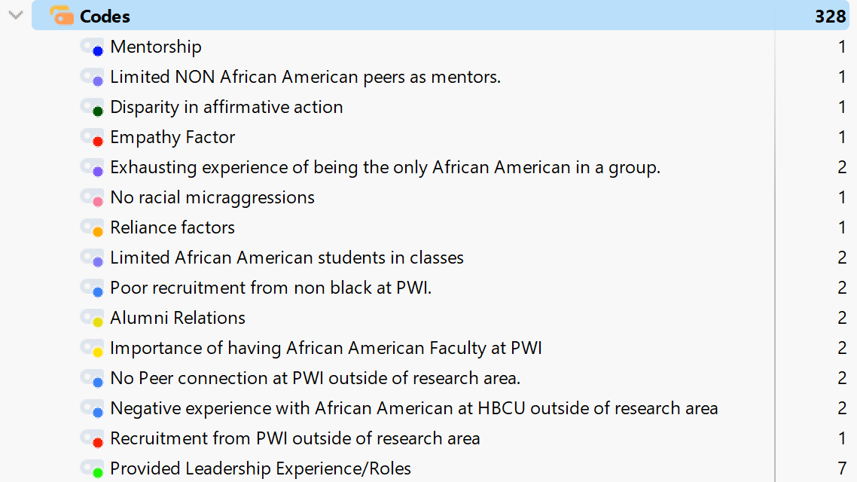

### Reflexivity Protocol

Reflexivity protocol ensures that the researchers’ judgement and beliefs do not affect the data collection process (Meyer & Willis, 2018). Reflexive thematic analysis was used to start the process of coding. During the coding process, a process was created to organize reading the data from the transcripts. Notes were taken that were documented after data collection that show the process of creating codes, categories, and themes. Notes were taken after the one-on-one interviews to help with memorizing any instances that needed to be recorded. The notes were not used as a part of the coding process. The notes were only used to assist the researcher with additional information.

### Braun and Clarke’s (2022) Thematic Analysis Steps

Step 1: Data Familiarization. For the coding process, the researcher reviewed the transcripts from the one-on-one interviews and from the questionnaire responses from African American alumni discussing their experiences with faculty and peers at PWIs. The reviewing of the transcripts was done multiple times which is the first phase of Braun and Clarke’s (2022) steps to thematic analysis. Reviewing the transcripts multiple times helps with becoming familiar with the data. For this research study, inductive coding was done by the researcher to create the codes based on the data that were collected. The transcripts were uploaded into MAXQDA. Each line of the transcript was read and coded by the researcher. The researcher based the coding on reoccurring patterns within the text on the transcript. The researcher read each transcript five times to become familiar with the data. The researcher created a handwritten chart to organize the researched question and make notes from the reading of the transcripts. The chart was used to give a visual depiction of key concepts as well as to keep the data organized.

Step 2: Generating Codes. Dataset coding is the next step to thematic analysis. According to Braun and Clarke (2022), after the researcher has become familiarized with the data, the researcher must generate initial codes. Codes were assigned such as mentorship, peer support, and sense of belonging. The codes showed patterns in the data and potential themes. The text was reviewed, and interesting portions of the data were highlighted since it seemed meaningful to the research. The coding occurred from the data set for all of the one-on-one interviews and questionnaires. MAXQDA high level coding was used to highlight data that is valuable and related to the research question. Low level coding was used to help organize the data. All the text that seemed relevant to the research was assigned a code. A total of 95 codes were derived from the one-on-one interviews and questionnaires. Refer to Appendix F for a complete list code and the coding system. Refer to Table 5 for an example of codes, their description, and an exemplary quote from the data.

**Table 5**  
  
*Example of Generating Initial Codes from the interviews*

|  |  |  |
| --- | --- | --- |
| Code | Code Description | Exemplary Quote |
| Mentorship | Participants describe the influence of their African American mentor during their time at their PWI and the professional network. | “My mentor and faculty/staff (African Americans) were continuously supportive and found opportunities that best fit me (personally, socially, professionally, etc.” (Q16) |
| Goal setting through Curriculum | Participants describe how the curriculum at the PWI contributed to career aspirations and skill acquisition. | “The curriculum there really supported my long-term goals of being an attorney because they also had a legal assistance studies minor” (P6) |
| Racial Microaggression Experience | Participants describe verbal assumption regarding when a White friend from an on-campus job at PWI found out she was African American. | “Thankfully there weren’t many awful experiences, but a few microaggressions” (Q1) |
| Alumni Relations | Participants describe how they give back to other students at their PWI. | “Provide support however I can to those I know at PWIs, even if it is just lending a listening ear” (Q16) |
| Provided Leadership Experiences/Roles | Participants describe opportunities to be leaders or have leadership roles through Black organizations at PWI. | “These Black organizations we were in, you could be leaders in them. You could be on the front; you could be in the pictures representing them” (P5) |
| African American Faculty Support | Participants describe the importance of African American faculty support. | “There were so few AA faculty, but I remember that the ones that were there made an effort to get to know me” (Q1) |
| Peer Support/Connections | Participants describe peer connection and support at PWI. | “I believe my friends and social groups helped a lot. They motivated me, and we shared a common goal” (Q9) |
| Self-Motivation | Participants describe self-motivation motivated to accomplish their goals at PWI. | “If you're willing to put in the effort, then everything else will be what it is supposed to be in a time that it is supposed to be” (P1) |
| Support Family/Friends | Participants describe the importance of support from family and friends during time at PWI. | “I stayed because of the support from my family and friends” (P21) |
| Sense of Belonging | Participants describe the importance of organizations that provided a sense of belonging at PWI. | “My friendships and sisterhood are what helped me to persist at a PWI” (P4) |

*Note.* Coding (Braun & Clarke, 2022).

Step 3: Theme Generation. The third step in thematic analysis is the formation of initial themes or categories. Categories or initial themes are created by linking codes that are similar to one another (Braun & Clarke, 2016). An example of the transition from codes to categories is detailed in Figure 3. Participants were asked questions regarding the positive influence of faculty and peers on alumni experience. Codes emerged that showed the importance of having a sense of belonging. The researcher noticed that every participant discussed the importance of having a sense of belonging. Participants discussed being members of campus organizations, community, and having diversity for understanding. The researcher found that regardless of whether the participant had experiences with African American faculty or peers, or non-African American faculty, having someone or being a part of an organization that shares the same culture and values as you and who supports you significantly impacted the way that the participant persisted at their PWI. These findings led to the transition from codes to the defined category of Sense of Belonging. Figure 3 shows a sample of codes to categories.

**Figure 3**  
  
*Example of Codes to Category*

Seven categories were identified that emerged from the data. Table 6 shows a sample of categories and their meaning as well as codes that are aligned with the sample list of categories. The seven categories were developed into five themes, and the aligned codes were transitioned into categories as shown in the example in Table 6. For example, codes such as organizations, community and diversity for understanding all came together to create the category “Sense of Belonging.” This category provided one of the largest numbers of aligned codes. Most of the participants described the importance of belongingness and inclusion. The frequency of the codes as well as the correlation to what the participants described as being one of the best aspects of their college experience at their PWI, influenced the way in which the codes were categorized. A full example of codes to categories is listed in Appendix N.

**Table 6**  
  
*Example Codes to Categories*

|  |  |  |
| --- | --- | --- |
| Category | Category Meaning | Aligned Codes |
| Sense of Belonging | The feeling of inclusion with the campus and community involvement that contributes to persistence. | Organizations  Diversity for understanding  Community |
| Faculty Representation | Having someone that looks like you or who shares your cultural values. | Limited African American faculty  African American Faculty Mentorship  Importance of having African American faculty |
| Experiences of Racism | Intentional and racial microaggressions that contributed to success. | Only African American in classes.  Code Switching  Negative College Experiences |
| Curriculum Influences | Curriculum that reflects diversity and helped influenced success | Curriculum influence success  Curriculum relevance  Faculty influenced success through the curriculum |
| Motivational Influences | Factors that help shape student motivation and that contribute to student success. | Family Support  Self-Motivation  Peer support/Connections  Personal Ambition  African American Faculty Support  Faculty of Non-African descent Support |
| Recruitment Strategies | The importance of cultural representation and efforts to attract African American students by having a diverse population at PWI. | Recruited for PWI  Taking risk to attend PWI.  Disparity in Affirmative Action  Leadership Opportunities |
| Persistence through obstacles | Obstacles that could have caused student to drop out but persisted regardless. | Negative life events  Being the only African American student in the program  Negative experiences with faculty |

Step 4: Analyzing Themes. The fourth stage of thematic analysis is where the researcher reviewed and defined themes for clarity Braun and Clarke (2022). Some of the themes needed more details and needed to be more specific. For example, the theme, Racial Microaggressions at PWI was used, and even though this was an important aspect of the findings, the theme was not detailed enough to describe the participant’s racial experience of being intentional or nonintentional at their PWI. This theme was then redeveloped into African American alumni described their motivation despite racism and racial microaggression while attending a PWI. Each theme was supported by the codes, categories, and corresponding research questions as shown in the codes to theme example in Table 7. Table 8 shows the example of how the themes were analyzed. The final themes and definitions that relate to the research questions are list in Appendix P.

Themes were reviewed and evaluated based on the importance and relevance to the research questions and based on whether the themes aligned with the research questions. The data were reviewed to confirm that the themes were relevant to the research question. A codebook was used that included the research question, theme, theme definitions, and aligned categories. Table 9 - Themes, Theme Meanings, and Aligned Categories shows a sample of aligned categories, research questions and themes.

The alignment between the seven key categories and five themes derived from the qualitative research on the contributions of African American faculty and peers on alumni goal setting , self motivation, and ongoing persistence at PWIs. The seven categories are sense of belonging, faculty representation, experiences of racism, curriculum influences, motivational influences, recruitment strategies, and persistence through obstacles. The five themes explore the role of curriculum diversity, mentorship, positive and negative experiences, role models, and a sense of belonging in the persistence and success of African American students at PWIs.

**Theme 1** emphasizes the importance of a diverse curriculum that supports academic and career development in helping African American students set goals and persist. **Theme 2** highlights the significance of faculty and peer mentorship, support, and guidance in motivating and sustaining African American students. **Theme 3** describes positive experiences of representation and negative experiences of exclusion and racism that impact African American students. **Theme 4** focus on the influence of African American role models and mentors on student persistence. **Theme 5** describes the effects of a sense of belonging through various forms of campus and community involvement on ongoing student persistence. See Appendix O for the table visualizing the alignment of the seven categories to the five themes.

**Table 7**  
  
*Example of Codes to Category to Themes*

|  |  |  |
| --- | --- | --- |
| Codes | Category | Aligned Theme |
| Organizations  Community  Diversity for understanding | Sense of belonging | African American Alumni described the effects of having a sense of belonging through campus involvement, fraternities, sororities, community involvement. being in leadership roles or having leadership experience for ongoing persistence while attending a PWI. |
| Limited African American Faculty |  |  |
| African American Faculty Mentors  The importance of having African American faculty | Faculty Representation | African American Alumni described having faculty and peers who serve as mentors, who offer support and guidance with motivation, personal ambitions, peer support, mentorship and guidance while attending a PWI. |
| Curriculum influence success  Curriculum Relevance  Faculty influenced success through the curriculum | Curriculum Influences | African American Alumni described that having a curriculum that reflects diversity, academic, and career development contributed to African American students’ goal setting and persisting at their PWI |

**Table 8**  
  
*Analyzing Themes*

|  |  |
| --- | --- |
| RQ | Final Themes |
| RQ1: How do African American college alumni from PWIs located in the South Atlantic Region of the United States describe the contributions of their African American faculty and peers on goal setting? | African American Alumni described that having a curriculum that reflects diversity, academic, and career development contributed to African American students’ goal setting and persisting at their PWI. |
|  | African American Alumni described having faculty and peers who serve as mentors, who offer support and guidance with motivation, personal ambitions, peer support, mentorship and guidance while attending a PWI. |
| RQ2 How do African American college alumni from PWIs located in the South Atlantic Region of the United States describe the contributions of their African American faculty and peers on self-motivation? | African American Alumni described the positive experience of being chosen by faculty or singled out to represent African Americans in diversity discussions and negative experiences endured of being excluded in social and academic settings of racism and racial microaggressions while attending a PWI. |
|  | African American Alumni described how having African American faculty and peers as role models and mentors contributed to their ongoing persistence of African American students while attending a PWI |
| RQ3: How do African American college alumni from PWIs located in the South Atlantic Region of the United States describe the contributions of their African American faculty and peers on ongoing persistence? | African American Alumni described the effects of having a sense of belonging through faculty and peer relationships, campus and community involvement, fraternities, sororities, being in leadership roles or having leadership experience for ongoing persistence while attending a PWI. |
|  |  |

*Note.* (Braun & Clarke, 2022).

**Table 9**  
  
*Themes, Theme Meanings, and Aligned Categories*

|  |  |  |  |
| --- | --- | --- | --- |
| Research Question | Theme | Theme Meaning | Aligned Categories |
| Research Question 1: How do African American college alumni from PWIs located in the South Atlantic Region of the United States describe the contributions of their African American faculty and peers on goal setting? | Theme 1 - African American Alumni described that having a curriculum that reflects diversity, academic, and career development contributed to African American students’ goal setting and persisting at their PWI. | African American alumni described the contributions of having a curriculum that focused on goal setting and having African American mentors while attending PWI. | Curriculum influences  Recruitment Strategies |
|  | Theme 2 - African American Alumni described having faculty and peers who serve as mentors, who offer support and guidance with motivation, personal ambitions, peer support, mentorship and guidance while attending a PWI. | African American alumni described the contributions of their self-motivation, personal ambitions, peer support, mentorship and guidance from faculty and peers while attending a PWI. | Motivational influences |
| Research Question 2: How do African American college alumni from PWIs located in the South Atlantic Region of the United States describe the contributions of their African American faculty and peers on self-motivation? | Theme 3 - African American Alumni described the positive experience of being chosen by faculty or singled out to represent African Americans in diversity discussions and negative experiences endured of being excluded in social and academic settings of racism and racial microaggressions while attending a PWI | African American alumni described their motivation despite racism and racial microaggressions while attending a PWI. | Persistence through obstacles  Experiences of racism |
|  | Theme 4 - African American Alumni described how having African American faculty and peers as role models and mentors contributed to their ongoing persistence of African American students while attending a PWI | African American alumni described having faculty serve as mentors and offer support and guidance for African American students while attending a PWI | Faculty Representation |
| Research Question 3: How do African American college alumni from PWIs located in the South Atlantic Region of the United States describe the contributions of their African American faculty and peers on ongoing persistence? | Theme 5 - African American Alumni described the effects of having a sense of belonging through faculty and peer relationships, campus and community involvement, fraternities, sororities, being in leadership roles or having leadership experience for ongoing persistence while attending a PWI. | African American alumni described experiences and relationships that contributed to their academic, social, and ongoing persistence while attending a PWI. | Sense of belonging |

Step 5: Refining and Interpreting Themes. The fifth stage in Braun and Clarke’s (2022) steps to thematic analysis is naming and defining themes. Themes that were initially developed in Stage 4 had to be reviewed and refined until the refined themes showed a pattern of the data set and the results of the research study. The five themes from the data connect back to the three original research questions. Inductive coding and the six steps of thematic analysis by Braun and Clarke (2022) was used to help define the purpose of the study. The themes created during data analysis supports the narrative that details how African American alumni describe the contribution of their African American faculty and peers on goal setting, self-motivation, and ongoing persistence at PWIs.

Step 6: The Write Up. The sixth step of thematic analysis is to write the report. In this final phase, the researcher created a detailed report derived from the data from the research. The reports identified themes that include excerpts from the data set that related back to the research questions. Charts were used to depict the data and gave a detailed summary of the findings that contributed to understanding the research of the contributions of African American faculty and peers on African American alumni at PWIs.

### ***Data Analysis Steps***

The presentation of themes is listed in the results. The presentation consists of themes, definitions, and direct quotes to support and align with the results. The results revealed that African American alumni described the contribution of their African American faculty and peers on goal setting, self-motivation, and ongoing persistence in multiple different ways. The contributions were grouped into codes such as the contributions of goal setting, curriculum, self-motivation, personal ambitions, peer support, mentorship, guidance, racism, racial microaggression, role model, and sense of belonging through campus involvement and community. The themes identified in the research were related directly to the research questions involving goal setting, self-motivation, and ongoing persistence.

The final codes and definitions are presented in Appendix F. Out of the 95 codes, two of the codes did not align to a theme or answered the research questions. The two codes that did not answer the research questions due to aligning more with area outside of the research area. This information will be addressed in Chapter 5 because it suggests further research is needed in how African American students persisted when facing obstacles at HBCUs. As shown in Table 8, the theme African American alumni described the positive experience of being chosen by faculty or singled out to represent African Americans in diversity discussions and negative experiences endured of being excluded in social and academic settings of racism and racial microaggressions while attending a PWI. Racial disparity and circumstances involving affirmative action influenced this group of participants to persist through the adversity that faced. The information presented was an important part of the research study because it was the basis for persistence with some of the participants in this study.

The process of getting codes to themes was completed using the same codes from the example such as having an African American faculty at a PWI, having a sense of belonging at a PWI, and having the support of family and friends. Regardless of whether the participant had an African American faculty or peer that contributed to their success at a PWI, having a sense of belonging significantly impacted the way that the participant viewed and described their college experience. The frequency of the code that transitioned from codes to the category was used as a starting point. The category was transitioned into a theme.

The process of creating themes was formulated by the three research questions that detailed goal setting, self-motivation, and ongoing persistence. Themes were created using participants support due to themes being supported by a significant number of participants using direct quotes. The direct quotes were gathered from one-on-on interviews and the questionnaires. The themes were formulated to express African American participants’ experience and contributions from African American faculty and peers at PWIs as listed in Table 7.

The same data analysis process was used across the one-on-one interviews and the questionnaire. Code generation started with the formation of a code system organized by research questions. The researcher went through each individual interview five times to generate codes. Once finished with the one-on-one interviews, the transition to the questionnaire began. The same coding system was used, and additional codes were added as they presented themselves throughout the coding of the questionnaire. The codes were combined into one coding system. The codes were categorized and separated by the three different research questions to produce a theme that answers the research question.

| **Criterion**  **\*(Score = 0, 1, 2, or 3)** | **Learner Score** | **Chair Score** | **Methodologist Score** | **Content Expert Score** |
| --- | --- | --- | --- | --- |
| **DATA ANALYSIS PROCEDURES**  (Number of pages as needed) | | | | |
| Describes in detail the data analysis procedures.  Coding procedures must be tailored to the specific analytical approach; they are not generic.  Start discussion of data analysis procedures by identifying and describing the analytical approach (e.g., thematic analysis, type of phenomenological analysis).  Describes coding process, description of how codes were developed, how categories or clusters of codes were developed, how these are related to themes. Provide examples of codes and themes with corresponding quotations, demonstrating how codes were developed or synthesized into themes. Provides evidence of initial and final codes and themes in text or an Appendix.  Detail the specific kinds of analytic units appropriate to the design and analytic approach. | 2  2  2  2  2 | 2  2  2  2  2 | 2  2  2  2  2 | X  2  2  2  2 |
| Explains and justifies any differences in why data analysis section does not match what was approved in Chapter 3 (if appropriate). | 2 | 2 | 2 | X |
| Discusses the reflexivity protocols used (such as bracketing and peer debriefing) and how these protocols complement the data analysis strategy. | 2 | 2 | 2 | 2 |
| Describes approaches used to ensure trustworthiness for qualitative data including expert panel review of questions, field test(s)/ practice interviews, member checking, and triangulation of data, as appropriate. | 2 | 2 | 2 | X |
| Justifies how the analysis aligns with the research question(s), and how data and findings were organized by chronology of phenomena, by themes and patterns, or by other approaches as deemed appropriate.  Develops a description of the phenomenon by synthesizing the data across the research questions. The synthesis approach used to develop the description of the phenomenon should be specific to the design used, | 2  2 | 2  2 | 2  2 | X  2 |
| . Section is written in a way that is well structured, has a logical flow, uses correct paragraph structure, sentence structure, punctuation, and APA format | 2 | 2 | 2 | X |
| **\*Score each requirement listed in the criteria table using the following scale:**  0 = Item Not Present or Unacceptable. Substantial Revisions are Required.  1 = Item is Present. Does Not Meet Expectations. Revisions are Required.  2 = Item is Acceptable. Meets Expectations. Some Revisions May be Suggested or Required.  3 = Item Exceeds Expectations. No Revisions are Required. | | | | |
| **Reviewer Comments:** | | | | |

## Results

### Presenting the Results

The results are presented with the presentation of themes along with their definition and direct quotes. The themes and quotes help support the results. The theme emerged from the categories that detailed meaningful data, and the categories emerged from the codes after becoming emerged in the data. The results revealed that African American alumni described the contributions of their African American faculty and peers in multiple ways. The contributions can be grouped into themes such as having a curriculum that focuses on goal setting, mentors, the contributions of self-motivation, personal ambitions, peer support, mentorship, guidance, ongoing persistence despite racism and racial microaggressions, the effects of having a sense of belonging through campus and community involvement, and leadership roles. Data saturation was reached because no new information or themes were emerging. These themes related directly back to the research questions which involved goal setting, self-motivation, and, and ongoing persistence:

RQ1: How do African American college alumni from PWIs located in the South Atlantic Region of the United States of America describe the contributions of their African American faculty and peers on goal setting?

RQ2: How do African American college alumni from PWIs located in the South Atlantic Region of the United States of America describe the contributions of their African American faculty and peers on self-motivation?

RQ3: How do African American college alumni from PWIs located in the South Atlantic Region of the United States of America describe the contributions of their African American faculty and peers on ongoing persistence?

Research Question 1.For RQ1, the goal was to determine how African American college alumni from PWIs located in the South Atlantic Region of the United States describe the contributions of their African American faculty and peers on goal setting. The theme that emerged from this question was African American alumni described having a curriculum that reflects diversity, academic, and career development contributed to African American students’ goal setting and persisting at their PWI which answered the aligned research question. This theme described the contributions that African American faculty made towards students who helped influence their career choices and made relevance of the curriculum.

Participants who described having an African American faculty that guided them in their curriculum and career choices also described the mentorship they received from their African American faculty and peers that contributed to goal setting as shown in the interview from Participant 3, who stated, “I became a sociology major because of him. It eventually led to me wanting to pursue more degrees.” Some participants described that some of them had only a few African American faculty. Some participants did not have faculty that was African American, but they had African American staff that gave them the support that they needed. Participants also described having African American peers as mentors while attending PWIs.

Participant 2 described how a Black male faculty recognized other African American students’ leadership ability by intentionally empowering African American students by giving them leadership responsibility. The action of this faculty suggests promoting inclusivity by leveraging the leadership abilities of African American students at this PWI. Participant 2 stated, “I had a Black male professor who called out our leadership abilities. He would assign us groups and leadership roles for the Black students in his class. Seeing my talents attributed to the change in my major.”

Participant 3 described one African American male faculty who played a significant role in motivating and supporting the academic growth of this participant by providing guidance and by fostering a supportive environment. The actions of this faculty lead the participant to explore their academic interest. Participant 3 stated, “It was a race and ethnicity class. He really wanted us to succeed. He made me want to learn more about sociology. I became a sociology major because of him.”

Participant 4 described the first African American faculty she encountered was during her Junior year at her PWI. Some African American faculty may have high expectations for their African American students. The faculty showed support for the participant by providing mentorship and guidance by fostering a sense of accountability to achieve academic success. Participant 4 stated,

My semantics professor set the tone by holding me at a higher level of accountability. He was the first person to talk to me about my major, what my goal was, and what the end game was. He said there is a difference between a goal, a dream, and a wish and how to get there.

Participant 6 described how her professor played an important role in supporting her academic growth. Participant 6 mentioned a male peer whom she feels relationship was paramount to her success at her PWI. The information given from this participant highlights the significant of supportive relations for African American students at PWIs. Participant 6 stated,

An African American male professor was involved in student government with her, and he encouraged her to do things that she was passionate about. When she did not do well, he always insinuated that I could do better. The analysis from this interview suggests that this faculty had high expectation for the student personal and academic development. This faculty was supportive and showed that he believes in the participant abilities in achieving academic success. Questionnaire participant 16 stated the following: “My African American mentor and faculty/staff were continuously supportive and found opportunities for me that best fit me personally, socially, and professionally. I developed a great professional network because of them.” The information gathered from this participant suggests that Participant 16 gained a lot of insight from her faculty. This participant had an African American faculty who supported her success by providing mentorship, guidance, and support as well as fostered a sense of belonging with networking.

Twenty-three codes were found that supported the main theme that were derived from the participants’ experiences regarding goal setting. Based on the theme that emerged, African American alumni described the contributions of faculty and peers on goal setting. African American alumni described factors that contributed to their goal setting as well as how African American faculty influenced their decision on their career goals based on the curriculum.

Research Question 2.For RQ2, the goal was to determine how African American college alumni from PWIs located in the South Atlantic Region of the United States describe the contributions of African American faculty and peers on self-motivation. The emerged theme was African American Alumni described having faculty and peers who serve as mentors offer support, guidance with motivation, personal ambitions, peer support, and mentorship while attending a PWI. The second theme was African American Alumni described the positive experience of being chosen by faculty or singled out to represent African Americans in diversity discussions and negative experiences endured by being excluded in social and academic settings of racism and racial microaggressions while attending a PWI.

Participant 1 described how there were very few African American faculty at her PWI. The African American faculty tried to get to know the students and made them feel safe. Participant 1 stated the following: “There were few African American faculty, but I remember the ones that were there that made an effort to get to know me. They became guardians to the Black students.” The acknowledgement by Participant 1 of having few African American professors shows the importance that representation matters in academia. Having African American professors offers students a sense of belonging in the environment where they may feel underrepresented.

Participant 4 described how motivation influenced her and how her family and peers played an important part in motivating her to finish college. The drive from her family and peers contributed to her self-motivation. Participant 4 stated, “The support of my family and peers, the drive to finish, and make something of myself contributed to my self-motivation.” This participant shows the importance of family and peer support for African American students at PWIs by highlighting family and peer support as a motivator for African American students. Having family and peer support helps to affirm and preserve cultural identity as well as give students encouragement to persevere through obstacles and to stay focused on their end goal.

Participant 9 described how African American faculty and peer motivation contributed to the success at PWI. Participant 9 had few faculty and students at her PWI. Participant 9 described motivation by stating the following: “My African American peers were very helpful and motivational. African American faculty members were very supportive and acted essentially as mentors. The emphasis of having supportive peers and faculty suggests the importance of meaningful relationships at PWIs. Having faculty that actively engage in mentorship, and who provides support, help African American students feel value and supported.

Questionnaire Participant 19 described self-motivation through her upbringing with family and peer relationships. Most of the members of her family have a college degree, and she had sorority sisters as peer mentors. Usually in African American families where the majority of the family members are college educated, there is no other choice but to go to and succeed in college. Participant 19 stated in her questionnaire: “At a very young age, it was instilled in me to go to college and graduate. There were many sorority sisters in the graduate chapter who were educators. They inspired, influenced, and encouraged me.” Family and peer support fosters intergenerational success as shown through Participant 19. African American students strive to fulfill the dreams of their families by becoming college graduates. African American families or peers that have a legacy of college graduates reinforce the importance of education and serve as a foundation for the academic success of African American students.

In addition to support experiences, another theme that emerged in response to RQ2 was African American alumni described their motivation despite racism and racial microaggressions while attending a PWI. For example, Questionnaire Participant 1 did not experience racism at her PWI; however, she described a racial microaggression that made her think about race at her PWI as well as described peer connection at her PWI. Participant 1 described a racial microaggression experience in the questionnaire: “I had made a friend, and we only chatted via instant message, and when she finally met me, she was shocked that I was Black and actually verbally expressed that shock.” Participant 1 also stated “Connecting with Black students at my school was life changing. It brought a sense of community I had been longing for.” The quote from Participant 1 suggests her friend may have had an assumption or preconception about what African Americans look like or sound like and was shocked to find out her race. This quote highlights how race is perceived in online interactions which leads to implicit bias. The information from this participant regarding connecting with Black students shows the importance of peer relationships and fostering diversity and inclusion at PWIs.

Questionnaire Participant 7 described the motivation through race relations in the questionnaire. Things can happen in life that can either hold you back or push you into your destiny. Participant 7 described peer relationships and her time during the early 1980s at her PWI. She stated, “Race relations were challenging because the campus and students did not want to change with the times.” “I was a member of National Pan-Hellenic Council (NPHC), and we addressed issues of injustice on campus and developed lifelong friendships.” The information from Participant 7 highlights challenges surrounding race relations at PWIs and the importance of peer relationships and campus organizations. Ongoing research is needed to help create inclusive educational environments at PWIs.

Participant 8 described the most motivating things that forced her to finish school were her mother and her close peer relationships.

I was having trouble with anatomy and physiology. My mom took me outside and had me look in the sky. I am a stargazer baby. The farmers would come to hear about the signs and when to plant. Here I am struggling to get a C in anatomy and physiology, and I had all this knowledge and skills through my mom that had been suppressed or not allowed. The students in the Black Student League organization helped me to finish school. The Black men allowed me to rest and be me. I did not have to fight; they saw what I saw. This helped me to rest and study.”

Participant 8 attended her PWI in the 70s. She shares the testimony of family and peer support as other participants shared in this research. Family and peer support is a foundational pillar for African American students’ motivation and success by helping to achieve their personal and academic goals at their PWI.

Participant 21 described her self-motivation being a minority in the nursing program. She stated,

I was determined to be a part of the 99% passing rate for nursing state boards. My class started with 16 people of color, but only four graduated. My persistence came from the other black nursing students and my sorority sisters.

African American student sometimes face challenges that can impact their academic success and retention rates. The information gathered from Participant 21 shows the determination, motivation, challenges, and success of African American nursing students at PWIs. It also shows the importance of representation and disparities within the nursing department and peer relationships at this PWI.

Based on the theme that emerged, African American alumni described the contributions of self-motivation, peer, and faculty support as well as describing the positive and negatives influences of racism and racial microaggression. African American alumni described the factors of their motivation to persist through racism through various years of their college experience. The researcher found that these themes answered the aligned research questions because both themes describe motivational factors that contributed to their academic success.

Research Question 3.For RQ3, the goal was to determine how African American college alumni from PWIs located in the South Atlantic Region of the United States describe the contributions of African American faculty and peers on ongoing persistence. The results of the study found the first theme African American alumni describe how having African American faculty and peers as role models and mentors contributed to their ongoing persistence while attending a PWI. The second theme African American alumni described the effects of having a sense of belonging through campus involvement, fraternities, sororities, community involvement, being in leadership roles or having leadership experience at PWIs.

Based on the themes, the results of the study found that when it came to having a sense of belonging, all participants agreed that having a sense of belonging is key to persisting at PWI. The majority of the participants belong to a college organization such as a fraternity, sorority, or a culturally based organization. Some participants gained leadership roles through their organization or through faculty appointment. The themes answer the aligned research question because both describe factors of sense of belonging that caused African Americans to persist at PWIs. Having a leadership role can foster inclusion at PWIs.

Participant 2 stated that her Black professor assigned the Black students leadership roles that helped her realize her talent.

I noticed that when he assigned a leadership role, he actually assigned it to all the Black students in class. I don't know if that was on purpose or not, but it actually empowered us in those roles in that setting. And I think that was interesting because then I saw that something small like that can actually show the talents of those who are in that type of setting. This information from this participant indicates that the professor wants to promote inclusion and a sense of belonging at this PWI.

Participant 4 uses being a part of an organization and her leadership role to her advantage at her PWI so she could have access on campus and meet other influential people as well as having a voice on the campus. Participant 4 stated:

If you were on the executive board of the student government, you got access to the University Chancellor. You were able to meet and hear things, so you heard things first to figure out what that looks like, so for me it was a defining moment, too, because it taught me what true leadership was, and what active leadership is. You can join an organization, you can be actively involved, and you can literally put teeth to what you did. The information from this participant shows the importance of having representation at PWIs. Participant 5 also indicated the importance of having leadership roles at PWIs. Having African American student in influential roles at PWIs provides them with opportunities for involvement and leadership roles within their PWI.

Participant 5 discussed how being involved in Black organizations allowed African American students to be leaders. Participant 5 stated, “The Black organizations we were in, you could be leaders in them. You could be out in the front. You could be in the pictures representing them.” Participant 5 and Participant 9 discussed the significance of having a sense of belonging and leadership within their organizations at their PWI.

Participant 9 discussed how her organization gave her a sense of belonging but more importantly how her leadership role as President of her organization helped to grow her chapter and provide leadership training. Participant 9 stated, “So, it was supportive to have the organization, but it was also a good leadership training ground for me to be able to grow the chapter.”

Participants 2, 4, 5, and 9 all spoke on the significance of family, peer, community, and faculty support at PWIs. Having African American faculty and peer support gives a sense of belonging. African American professors help with feeling isolated and help foster a sense of belonging among African American students. All 26 participants stated the importance of having a sense of belonging at a PWI. All 26 participants were actively involved in their campus community, organization, and/or church. Most of the participants belonged to a sorority or fraternity. Having a sense of belonging at a PWI helped the students to persist, which supports the main theme and the research question.

Participant 5 described how being President of the Resident Hall Association allowed her to have fun as an undergraduate, “I was voted president of RHA which is Resident Hall Association. I helped implement different visitation policies for dorms. I made it fun for me, so I had a blast. As an undergraduate, I had so much fun.” The information from this participant can help with facilitating dialogue relating to diversity and inclusion in her leadership role as President of the Resident Hall which could help with addressing and implementing policies that address the needs and concerns of African American students at her PWI.

Participant 06 described how being involved in a sorority helped her persist at her PWI. “I was fortunate enough to be initiated into Alpha, Kappa Alpha Sorority Incorporated, and that really gave me a strong foundation in a lot of areas.” This quote shows the importance of having a sense of belonging. Being a member of a sorority has great benefits and offers opportunities for personal growth, leadership, and community development. Joining a sorority builds lifelong friendships and helps to develop networking skills.

Questionnaire Participant 17 described how being involved in organizations helped with persistence and being lonely at a PWI, “Being a member of National Association for the Advancement of Colored People (NAACP), AKA, choir, and a job prevented loneliness from creeping in.” Participants 17, 19, and 06 all discussed the importance of campus involvement as well as sorority involvement. This indicates the importance of having a sense of belonging at a PWI. Joining a campus organization that is culturally fitting such as NAACP, African American sorority, or fraternity at a PWI offers a sense of belonging and support for African American students who feel underrepresented on campus.

Participant 19 described peer connections that helped with persistence at a PWI, “Becoming a part of the Divine Nine and the everlasting friendships that were formed helped with persistence.” This quote relates to the information received from other participants regarding the importance of campus involvement and having a sense of belonging at PWIs. The quotes that were within the data set helped to support the theme. A full list of initial codes is listed in Appendix F.

The outcomes of the reflexivity protocol show that the approach used is effective in preventing biases in the study that could influence the process and outcomes. This study used reflexive thematic analysis. Reflexive thematic analysis allows the researcher to make sense of the data using their own personal experience (Braun & Clarke, 2022). Accountability and trustworthiness were accounted for through the use of note taking and reflection.

Notes were made on African American faculty and peers’ contributions and what made the participants persist at their PWI. Notes were also made on the procedures and how the meaning was built from the data. Using notes helped with organizing the study and with the review of decisions that were made within the study. For example, the researcher thought the results of the study would clearly show that the contributions from African American faculty and peers contributed to the persistence and success of African American alumni at PWIs. In fact, the results varied and showed that some participants had few or did not have any African American faculty. Their persistence came from a professor of non-African descent.

Participant 7 discussed how a White faculty member became her mentor. Numerous participants had non-White faculty that provided support and mentorship for them at their PWI. Participant 7 stated, “That particular professor has been very impactful for me, not only just in academic way, but you know, personally, cause like I said, I picked up a second mentor, and she's awesome. She is a White female, but she's amazing.” QuestionnaireParticipant 6 stated that “Believe it or not, it was my White advisor and another White professor who pushed me the most.” Participant 6 and 7 had quotes that show how impactful mentorship is regardless of racial boundaries. This shows that mentorship can be based on support and guidance rather than racial identity. The information received shows the impact of interpersonal relations at PWIs. Using the reflexivity protocol with the results of the study shows that the study was conducted without bias, with an open mind, and no preconceived expectations.

Overall, the quote from the participants shows the importance of having representation, mentorship, and support from African American professors and African American peers at PWIs. African American faculty help to enhance the experiences of African American students’ academic success and personal success. Having African American faculty can have an impact on the lives on African American students through mentorship, guidance, and support to help navigate the challenges and barriers African American students face at PWIs.

Data saturation was reached when no further insights emerged to address the research questions. This saturation point is important for ensuring research credibility and avoiding redundant data collection (Mwita, 2022). Throughout the process, continuous data collection methods were utilized via open-ended questionnaires and interviews. Engagement in reflexivity practices took place through taking notes during both data collection and analysis. As the study progressed, it became evident that the information provided by participants was consistently repetitive, leading the researcher to discern codes, categories, and emerging themes within the data.

| **Criterion**  \***(Score = 0, 1, 2, or 3)** | **Learner Score** | **Chair Score** | **Methodologist Score** | **Content Expert Score** |
| --- | --- | --- | --- | --- |
| **RESULTS**  (Number of pages as needed) | | | | |
| **Data and the analysis of that data are presented in a narrative, non-evaluative, unbiased, organized manner.**  In thematic analysis, the researcher should address saturation and the distribution of themes that emerged when themes were not present in all data sets. Qualitative, thematically analyzed data may be organized by theme, participant and/or research question.  In phenomenology the research should address the stability of the structure based on each constituent being essential, not merely frequent.  Note, this addresses volume and quality of the data collected as germane to the phenomenon under study, not to population representativeness.  Results of analysis are presented in appropriate narrative, tabular, graphical and/or visual format. If using thematic analysis, coding and theming process must be clearly evident in the results presentation. Integration of quotes in the results presentation to substantiate the stated findings and build a narrative picture is required.  For a case study design, include a summary of the case (how did the analysis inform the case?).  Learner describes thematic findings mostly in own words in narrative form as if they are telling their story or summarizing their experiences, and then use selected quotes (ideally one or few sentences, no longer than one paragraph) to illustrate. | 2  2  N/A  2  2  N/A  2 | 2  2  2  2  2 | 2  2  2  2  2 | X  2  2  2  2 |
| The outcome of the reflexivity protocol is reported in a way that helps the reader distinguish the learner’s preconceptions from the perspectives (and meanings) shared by participants. This discussion should touch on major preconceptions that may have biased the data analysis and what was done to mitigate these biases. | 2 | 2 | 2 | 2 |
| As appropriate, tables are presented for initial codes, themes and theme meanings, along with sample quotes. | 2 | 2 | 2 | X |
| Sufficient quantity and quality of the data or information appropriate to the research design is presented in the analyses to answer the research question(s). Evidence for this must be clearly presented in this section and in an appendix as appropriate.  Note: AQR reviewer may request to review raw data at any time during the AQR process. Additional data collection may be required if sufficient data is not present. | 2 | 2 | 2 | X |
| * Qualitative data analysis is fully described and displayed using techniques specific to the design and analytic method used. * Data sets are summarized including counts AND examples of participant’s responses for thematic analysis. For other approaches to qualitative analysis, results may be summarized in matrices or visual formats appropriate to the form of analysis. * Findings may be presented as themes using section titles for thematic analysis, as stories for narrative designs, as models or theories for grounded theory, and as visual models or narrative stories for case studies. | 2  2  2 | 2  2  2 | 2  2  2 | X  2  2 |
| Appendices must include qualitative data analysis that supports results in Chapter 4 as appropriate (i.e., source tables for coding and theming process or codebook, if not included directly in Chapter 4). | 2 | 2 | 2 | X |
| Section is written in a way that is well structured, has a logical flow, uses correct paragraph structure, sentence structure, punctuation, and APA format. | 2 | 2 | 2 | X |
| **\*Score each requirement listed in the criteria table using the following scale:**  0 = Item Not Present or Unacceptable. Substantial Revisions are Required.  1 = Item is Present. Does Not Meet Expectations. Revisions are Required.  2 = Item is Acceptable. Meets Expectations. Some Revisions May be Suggested or Required.  3 = Item Exceeds Expectations. No Revisions are Required. | | | | |
| **Reviewer Comments:** | | | | |

### 

### ***Limitations***

Limitations are described as weaknesses that could potentially affect the outcomes of a research study (Ross & Bibler Zaidi, 2019). Anticipated limitations described in Chapter 1 detailed possible issues with convenience sampling, limitations of data source, transferability of information, the use of semi structured interview questions, and the transcription of data using third party tools.

Two limitations that were present were the amount of time for each interview and the lack of funding. Participant 3 was actively teaching in her classroom since her kids came back early during her planning period. It was not determined if she would find another teacher to take over during the interview. This was the only available time she had for the interview. Zoom Business and Survey Monkey came with budgetary restrictions which caused a delay in data collection. Having additional funding could have potentially acquired the researcher to start data collection early as well as collected more data to contribute to the study. Self-reporting and transferability of information were a limitation due to participants giving vague details or not elaborating on their questions relating to their PWI experiences.

One of the most significant limitations in this study was the sample size of mostly female African American alumni. The sample size met methodology minimums; however, a sample size with the equal amounts of African American males and females could have been a more accurate sample of the population of participants that are alumni from PWIs. The number of one-on-one interviews could have possibly narrowed the amount of data given because only 10 of the 26 participantsparticipated. Fortunately, the two data collection tools that were used helped to increase the total number of participants that either participated in an interview or questionnaire.

A limitation that was present in the study was the use of social media groups that had majority female members. The recruitment flyer was posted; however, the social media groups were geared towards African American alumni in the South Atlantic Region which could have possibly limited the scope of male participants and prevented the researcher from reaching other African American alumni outside the South Atlantic area. Multiple participants belonged to the same social media group which also caused a limitation. Fortunately, the number of African American alumni in the social media groups were vast. A substantial number of participants were recruited which caused for conclusion of data collection within a short time frame.

This research met the overall goal of this study. The overall goal of the study was to see if having an African American faculty or peer contributed to the success of African American alumni at predominantly White institutions. Most participants reported having an African American faculty or peer that contributed to their success at their PWI. The sample proved the importance of the contributions of African American faculty and peers at PWIs.

| **Criterion**  \***(Score = 0, 1, 2, or 3)** | **Learner Score** | **Chair Score** | **Methodologist Score** | **Content Expert Score** |
| --- | --- | --- | --- | --- |
| **LIMITATIONS**  (Minimum one to two pages) | | | | |
| Lists limitations that emerged based specifically on data collection and data analysis, and how the interpretation of results may be affected by the limitations. | 2 | 2 | 2 | X |
| Discuss associated consequences for the transferability and applicability of the findings. | 2 | 2 | 2 | X |
| Discuss the current limitations in relation to the anticipated limitations originally presented in Chapter 1. | 2 | 2 | 2 | X |
| Section is written in a way that is well structured, has a logical flow, uses correct paragraph structure, sentence structure, punctuation, and APA format. | 2 | 2 | 2 | X |
| **\*Score each requirement listed in the criteria table using the following scale:**  0 = Item Not Present or Unacceptable. Substantial Revisions are Required.  1 = Item is Present. Does Not Meet Expectations. Revisions are Required.  2 = Item is Acceptable. Meets Expectations. Some Revisions May be Suggested or Required.  3 = Item Exceeds Expectations. No Revisions are Required. | | | | |
| **Reviewer Comments:** | | | | |

## Summary

Chapter 4 presents the results of the study that describe the contributions of African American faculty and peers on African American alumni at PWIs. This study addressed the purpose of this descriptive qualitative study which is to explore how African American alumni describes the contributions of African American faculty and peers on goal setting, self-motivation, and ongoing persistence at Predominantly White Institutions (PWIs) in the South Atlantic Region of United States of America. Data from 26 African American alumni were collected through the use of one-on-one interviews and questionnaires.

The data from the one-on-one interview and questionnaires were analyzed using thematic analysis from the works of Braun and Clarke (2022). This qualitative descriptive study aimed to explore how African American alumni describes the contributions of African American faculty and peers on goal setting, self-motivation, and ongoing persistence at Predominantly White Institutions (PWIs) in the South Atlantic Region of United States of America. Three research questions were used to guide the study, collect the data, and analyze the data using thematic analysis:

RQ1: How do African American college alumni from PWIs located in the South Atlantic Region of the United States of America describe the contributions of their African American faculty and peers on goal setting?

RQ2: How do African American college alumni from PWIs located in the South Atlantic Region of the United States of America describe the contributions of their African American faculty and peers on self-motivation?

RQ3: How do African American college alumni from PWIs located in the South Atlantic Region of the United States of America describe the contributions of their African American faculty and peers on ongoing persistence?

Chapter 4 shows the presentation of findings that detailed the formation of categories and themes. The themes were used to support the study and answer the research questions. For the first research question How do African American college alumni from PWIs located in the South Atlantic Region of the United States describe the contributions of their African American faculty and peers on goal setting? One theme emerged: African American alumni described having a curriculum that reflects diversity, academic, and career development contributed to African American students’ goal setting and persisting at the PWI. African American alumni described having a curriculum that reflects diversity and helped empower students in their academic and professional journeys. Having a curriculum that focused on academic and career development contributed to African American alumni’s persistence in college.

Two themes emerged from RQ2 (or “Two themes emerged from Question 2): (a) African American alumni described having faculty and peers who serve as mentors who offer support, guidance with motivation, personal ambitions, peer support, mentorship, and guidance while attending a PWI and (b) African American alumni described the positive experience of being chosen by faculty or singled out to represent African Americans in diversity discussions and negative experiences endured of being excluded in social and academic settings of racism and racial microaggressions while attending a PWI. African American alumni describe their ongoing persistence despite racism and racial microaggressions while attending PWI. African American alumni described the factors of their motivation while attending a PWI. Some African American alumni encountered racism and racial microaggression while attending a PWI. These African American alumni described the positive and negative contributions and influences. African American alumni were able to persist with the help of faculty and peer relationships despite facing racism and racial microaggression on campus.

Two themes also emerged from RQ3 (or question three): (a) African American alumni described how having African American faculty and peers as role models and mentors contributed to their ongoing persistence while attending a PWI; (b) African American alumni describe the effects of having a sense of belonging through campus and community involvement, fraternities, sororities, faculty and peer relationships, being in leadership roles or having leadership experience while attending a PWI.

African American alumni described how having African American faculty and peers serve as mentors helps by offering support and guidance for African American students at PWIs. African American alumni describe having a sense of belonging is the number one cause to persist at a PWI. Having a sense of belonging gave the students a feeling of being valued and accepted and gave a feeling of validation.

The limitations present in this study were based on short interview times during data collection, but also involved lack of funding, self-reporting, and the use of social media groups. The lack of funding was due to Survey Monkey and Zoom Business. Participants’ refusal to participate in the interviews could have narrowed the data collection as well as some of the interviews were under 45 minutes The use of certain social media groups and the recruitment of a majority female sample could have also limited the amount of data collected. All the listed limitations or weaknesses were important and addressed in Chapter 5.

The results of the study will be discussed in Chapter 5, which focuses on the findings in this research, and it could add insight and a new perspective to any existing research. A summary of how the themes relate to the theoretical framework, the findings, and the conclusion will be presented in Chapter 5.

| **Criterion**  \***(Score = 0, 1, 2, or 3)** | **Learner Score** | **Chair Score** | **Methodologist Score** | **Content Expert Score** |
| --- | --- | --- | --- | --- |
| **SUMMARY**  (Minimum one to two pages) | | | | |
| Presents a clear and logical summary of data analysis approach. | 2 | 2 | 2 | **X** |
| Summarizes the data and data analysis results in relation to the research questions. | 2 | 2 | 2 | **X** |
| Discusses limitations that emerged based on data collection and data analysis and how the interpretation of results may be affected by the limitations. | 2 | 2 | 2 | **X** |
| Provides a concluding section and transition to Chapter 5. | 2 | 2 | 2 | **X** |
| Section is written in a way that is well structured, has a logical flow, uses correct paragraph structure, sentence structure, punctuation, and APA format. | 2 | 2 | 2 | **X** |
| **\*Score each requirement listed in the criteria table using the following scale:**  0 = Item Not Present or Unacceptable. Substantial Revisions are Required.  1 = Item is Present. Does Not Meet Expectations. Revisions are Required.  2 = Item is Acceptable. Meets Expectations. Some Revisions May be Suggested or Required.  3 = Item Exceeds Expectations. No Revisions are Required. | | | | |
| **Reviewer Comments: I know you are waiting for an editor, and there are aspects of this that are just required before you hit the editor. It would be helpful to read this in its edited version throughout the chapter. I offer zero disrespect to that statement; it just makes it very difficult for everyone who has to review this. This last section, however, was much easier to manage.** | | | | |

# Chapter 5: Summary, Conclusions, and Recommendations

## Introduction and Summary of Study

Relationships with African American faculty have shown to serve an important role in the success of African American students. Previous research has shown that the lack of diversity among African American faculty decreases African American students’ sense of belonging and resilience (Benitez et al., 2017). Before completing the current study, it was unknown how African American faculty and peers contributed to goal setting, self-motivation, and ongoing persistence in the college experiences for African American alumni of Predominantly White Institutions.

The problem in current research is studies did not specifically address how African American faculty and peer relationships affect the retention and persistence of African American students at PWIs. Although there was not a lot of current research on this topic, similar studies needed additional research due to the existing limitations; for example, Lewis et al. (2021) described how African American students reported experiencing racial microaggressions which led to a lower sense of belonging. Lewis et al. (2021) stated that further research was needed on the impact of diversity in faculty at PWI and factors relating to a sense of belonging and faculty engagement.

This study added knowledge through a qualitative descriptive study of African American alumni and their descriptions of how African American faculty and peers contributed to their retention and persistence at PWIs. The population for the study was African American alumni that attended a PWI in the South Atlantic Region of the United States of America. The South Atlantic Region consists of the states of Delaware, Florida, Georgia, Maryland, North Carolina, South Carolina, Virginia, and West Virginia. This research was framed from Tinto (2017) who detailed that further research was needed to explore retention and students’ persistence. The qualitative methodology from this study allowed the exploration of the phenomenon from the personal experiences of the participants.

This qualitative descriptive study sought to explore how African American alumni describe the contributions of African American faculty and peers on goal setting, self-motivation, and ongoing persistence at Predominantly White Institutions (PWIs) in the South Atlantic Region of the United States of America. Tinto’s Retention Model of Motivation by Vincent Tinto (2017) was used for this research. The model is broken down into three facets: goals, motivation, and persistence. Tinto’s theory described three themes from the model: self-efficacy, sense of belonging, and perception of curriculum. Tinto showed how self-efficacy, sense of belonging, and perception of curriculum all lead to the motivation and persistence of students. Tinto (2017) stated that students want to persist. This research was developed to give an understanding how African American faculty and peers contributed to African American alumni goal setting, self-motivation, and ongoing persistence at PWIs.

The research study explored the phenomena of how African American college alumni from the South Atlantic Region describe the contribution of their African American faculty and peers on goal setting, self-motivation, and ongoing persistence at PWIs. To explore this phenomenon, the researcher explored the perceptions from African American alumni about how their college experiences with their African American faculty and peers caused them to persist at their PWI. The following research questions were created to address the phenomena:

RQ1: How do African American college alumni from PWIs located in the South Atlantic Region of the United States of America describe the contributions of their African American faculty and peers on goal setting?

RQ2: How do African American college alumni from PWIs located in the South Atlantic Region of the United States of America describe the contributions of their African American faculty and peers on self-motivation?

RQ3: How do African American college alumni from PWIs located in the South Atlantic Region of the United States of America describe the contributions of their African American faculty and peers on ongoing persistence?

The data sources for this research included one-on-one interviews and questionnaires. The data from ten one-on-one interviews and 26 questionnaires were analyzed using thematic analysis from Braun and Clarke (2022). To complete this type of analysis, the researcher became acquainted with the data, generating codes, generating categories, developing themes, refining themes, and writing up the data into a research study.

The themes from the data and the descriptive information describing the African American alumni population made the study essential because the findings described that the contributions from African American faculty and peers on goal setting, self-motivation, ongoing persistence, sense of belonging, and perception of curriculum all affected the retention and persistence of African American alumni at PWIs. Chapter 5 will continue with the discussion of the importance of this study by comparing and contrasting themes, summarizing the findings, alignment of the topic, and discussing practical and theoretical implications. Chapter 5 will offer a summary of the findings that will explain the phenomena through the research questions.

| **Criterion**  \***(Score = 0, 1, 2, or 3)** | **Learner Score** | **Chair Score** | **Methodologist Score** | **Content Expert Score** |
| --- | --- | --- | --- | --- |
| **INTRODUCTION and SUMMARY OF STUDY**  (Minimum two to four paragraphs or approximately one page) | | | | |
| Provides an overview of why the study is important and how the study was designed to contribute to our understanding of the topic. | 2 | 2 | **X** | 2 |
| Provides a transition, explains what will be covered in the chapter and reminds the reader of how the study was conducted. | 2 | 2 | **X** | 2 |
| Section is written in a way that is well structured, has a logical flow, uses correct paragraph structure, sentence structure, punctuation, and APA format. | 2 | 2 | **X** | 2 |
| **\*Score each requirement listed in the criteria table using the following scale:**  0 = Item Not Present or Unacceptable. Substantial Revisions are Required.  1 = Item is Present. Does Not Meet Expectations. Revisions are Required.  2 = Item is Acceptable. Meets Expectations. Some Revisions May be Suggested or Required.  3 = Item Exceeds Expectations. No Revisions are Required. | | | | |
| **Reviewer Comments:** | | | | |

## Summary of Findings and Conclusion

### Overall Organization

This chapter highlights the contributions to the body of knowledge and how the research was designed to understand the contributions of African American faculty and peers on African American student success at PWIs. The findings in this research supported previous literature and the theoretical foundation that supports this research. This research study increased the knowledge regarding the contributions of African American faculty and peers on African American alumni college experiences in terms of goal setting, self-motivation, and ongoing persistence at PWIs. It also advances the knowledge on the impact of diversity in faculty and peers relating to sense of belonging at PWIs. From the results, the findings from this research could potentially advance knowledge and practice on the retention and persistence of African American students at PWIs by showing how having a sense of belonging helps with persistence and showing that having African American faculty can help with the academic success of African American students. Three research questions were used to guide the study:

RQ1: How do African American college alumni from PWIs located in the South Atlantic Region of the United States of America describe the contributions of their African American faculty and peers on goal setting?

RQ2: How do African American college alumni from PWIs located in the South Atlantic Region of the United States of America describe the contributions of their African American faculty and peers on self-motivation?

RQ3: How do African American college alumni from PWIs located in the South Atlantic Region of the United States of America describe the contributions of their African American faculty and peers on ongoing persistence?

The population of interest for this study consisted of African American alumni who attended a PWI located in the South Atlantic Region of the United States. This study addressed recommendations for future research proposed by authors such as Benitez et al. (2017) and Eakins and Eakins (2017) who both stated that additional research in this field should be conducted in regard to lack of diversity and understanding obstacles that hinder the success of African American students. Themes were generated from the data to answer each research question.

Research Question 1. The first research question asks how do African American college alumni from a PWI located in the South Atlantic Region of the United States describe the contributions of their African American faculty and peers on goal setting? This question was developed in order to explore how African American faculty and peers contributed to the retention and persistence of African American alumni as it relates to goal setting at PWIs. One theme emerged that support the research question: (a) African American alumni described that having a curriculum that reflects diversity, academic, and career development contributed to African American students’ goal setting and persisting at their PWIs.

In reference to this theme the participant stated, “The curriculum there really supported my long-term goals of being an attorney because they also had a legal assistance studies minor, so I was able to take those sorts of courses and get exposure to the law prior to leaving” (Participant 6). “The reasons why I became a sociology major was because of him, and it eventually led to me wanting to pursue more degrees” (Participant 3).

Amrai et al. (2011) showed that African American students’ sense of accomplishment is influenced by various factors, including their perceptions of the relevance of the curriculum. Porter-Liddell (2023) discussed that culturally relevant curriculum can significantly impact students' development and academic success at PWIs. According to Amrai et al. (2011), integrating contextual information into the curriculum can enhance African American students’ engagement and sense of belonging, which helps to foster their academic achievement. In reference to this research, the participant stated, “The curriculum there really supported my long-term goals of being an attorney because they also had a legal assistance studies minor. So, I was able to take those sorts of courses and get exposure to the law prior to leaving” (P6).

In contrast, Jerome (2022) conducted research highlighting the role of faculty-student relationships in predicting high academic achievement among African American students. Jerome’s findings show the importance of the connections between African American students and African American faculty for fostering a supportive environment that supports academic success and that enhance African Americans’ overall sense of belonging on campus. Jerome’s study suggests that personal interactions and mentorship from faculty play a critical role in African American students’ academic experiences at PWIs. In reference with Jerome’s findings, this participant stated, “My mentor and faculty/staff (African Americans) were continuously supportive and found opportunities that best fit me (personally, socially, professionally, etc.). They also checked in on me. I developed a great professional network because of them and travel new places and experiences new things because of them (went on an immersive trip to NOLA and a gender-focus trip to Guatemala)” (QP16).

All three of these studies emphasize factors that contributes to African American students’ academic success and sense of belonging at PWIs; however, they differ in their focus and emphasis. Amrai (2011) and Portr-Liddell’s (2023) research prioritized the curriculum’s role in shaping students’ perceptions and academic engagement as well as show the integration of culturally relevant content. Jerome’s (2022) study highlighted the interpersonal dynamics between students and faculty and showed the importance of supportive relationships in facilitating academic achievement and enhancing campus integration.

Amrai (2011), Jerome (2022), and Porter-Liddell (2023) contributed insights to understanding the experiences of African American students at PWIs. Amrai et al’s. (2011) and Jerome’s (2022) studies emphasized curriculum relevance and structural changes within educational institutions. Jerome (2022) emphasis are on how the interpersonal dynamics are important for fostering supportive academic environments. The findings of this study show the importance of interpersonal dynamics in fostering supportive academic environments and aligning with the experiences of the participants. Faculty members played a crucial role in providing mentorship and information about scholarships, as evidenced by one participant stating, "Faculty members provided mentorship and information for scholarships" (Participant 7). Another participant highlighted the profound impact of faculty on their academic journey, noting, "The reason why I became a sociology major was because of him, and it eventually led me to pursue more degrees" (P3). These insights suggest that the results of this study could prompt college and university administrators at PWIs to engage in dialogues with African American faculty and peers on strategies to enhance cultural diversity and supportive academic environments within their institutions. Furthermore, the study can guide administrators on implementing cultural organizations on campus to foster a sense of belonging among students.

Future research should consider the potential outcomes if researchers from different racial or ethnic backgrounds, including White individuals or those of other nationalities, conduct similar studies. It should also ensure a balanced representation of male and female participants in research on African American experiences at PWIs. The current research and its findings contribute significantly to the existing literature and provide a foundation for future studies on the college experiences of African American students at PWIs.

Amrai et al. (2011) and Jerome (2022) emphasized the importance of curriculum relevance and structural changes within educational institutions. Amrai et al. (2011) argued that the curriculum must reflect the diverse experiences and histories of African American students to make their education more relevant and engaging. This aligns with Jerome (2022), who advocated for structural changes in educational institutions to create a more inclusive environment. These insights underscore the need for educational frameworks that are not only inclusive but also reflective of the students' cultural backgrounds.

Jerome (2022) highlighted the significance of interpersonal dynamics in fostering supportive academic environments. This involves creating spaces where African American students feel valued, respected, and understood. The emphasis on supportive relationships among peers, faculty, and staff is crucial for the academic and social success of these students. This perspective shows the structural and curricular changes proposed by Amrai et al. (2011), suggesting that both institutional and interpersonal factors are essential for fostering an inclusive educational environment. Porter-Liddell (2023) built on these foundations by providing a contemporary perspective on the challenges and successes of African American students at PWIs. This research highlights the ongoing struggles with racial microaggressions and the need for continuous support systems. By integrating the findings from Amrai et al. (2011) and Jerome (2022), Porter-Liddell (2023) offered a comprehensive framework for educators to enhance the experiences and success of African American students. This includes specific strategies for addressing racial biases, promoting cultural competence among faculty, and implementing mentorship programs. The literature supports the excerpts from the data to answer the research questions and show how the findings in the research align to the research topic.

In terms of being aligned to Tinto’s Retention Model of Motivation, one tenet of that theory is *goals and perception of curriculum*. This portion of the theory states the importance of goals and perception of curriculum and how they align with students’ experiences in the college environment. The Tinto model suggests that students are more likely to persist if they have a purpose for their study. The findings within the research were substantiated within the research design. The qualitative descriptive design is a method that describes experiences and perceptions (Doyle et al., 2020). Based on the data, this research participants described experiences and perceptions in the research.

Research Question 2. The second research question asked how do African American college alumni from PWIs located in the South Atlantic Region of the United States describe the contributions of their African American faculty and peers on self-motivation? This question was developed in order to explore how African American faculty and peers contribute to factors that motivated African American alumni at their PWI. Two themes emerged that support the research question: (a) African American Alumni described having faculty and peers who serve as mentors, who offer support, guidance with motivation, personal ambitions, peer support, mentorship and guidance while attending a PWI and (b) African American alumni described the positive experience of being chosen by faculty or singled out to represent African Americans in diversity discussions and negative experiences endured of being excluded in social and academic settings of racism and racial microaggressions while attending a PWI.

In reference to theme (a) the participants stated, “If you are willing to put in the effort, then everything else will be what it is supposed to be in a time that it is supposed to be, but you have to be diligent about seeking resources from faculty and communicating your needs” (P1). “I would not have made it through State University 1973 through 1977 without the assistance of my African American teachers and my African American peers" (P8).

Fong et al. (2021) and Frey et al. (2018) both emphasized motivation as a crucial predictor of academic success and persistence among students. According to their research, students who are intrinsically motivated by internal desires and meaningful relationships are more likely to show resilience and determination in achieving their academic goals. Fong et al.’s research shows that fostering a supportive academic environment that nurtures students’ motivation can enhance their engagement and persistence through graduation.

In contrast, Emetu (2022) focused on the impact of faculty diversity, particularly the hiring of African American faculty members, on the retention of African American male college students at PWIs. Emetu’s (2022) findings suggest that increasing the representation of African American faculty members can positively influence the campus climate and sense of belonging for African American students which contributes to higher retention rates among African American male students by providing them with mentors and role models who understand their cultural experiences and support their academic journey.

Fong et al. (2021) and Frey et al. (2018) showed the psychological factors of academic persistence. Emetu’s (2022) study showed structural and institutional factors that influences retention rates among African American students. The studies highlight the nature of student success at PWIs, and the importance of internal motivation and the external support provided by African American faculty representation.

Frey et al. (2018), Fong et al. (202), and Emetu (2022) contributed to understanding the influence of African American students’ academic outcomes at PWIs by highlighting motivational theories and the impact of faculty diversity to support African American students’ academic success, persistence, and overall well-being at PWIs.

In reference to theme (b) QP21 stated,

As a nursing student, I could see how students of color were weeded out for various reasons. We started with 16 people of color. Graduation day, there were 4 of us left. I personally experienced an attempt to get me put out of the nursing program. My biology teacher told me I was not college material.

“I felt my professor failed me because I was Black. There was nothing wrong with my paper grammatically nor technically” (QP22). Whiting (2009) found that people who have internal motivation believe that they can achieve success and are aware of external and social inequalities in school environment.

In support of the literature, excerpts from the data and themes helped to answer the research questions and show how the findings align to the research topic and align to Tinto’s Retention Model of Motivation. One tenet of that theory is motivation. This portion of the theory states motivation is impactful for students’ persistence in college. Tinto’s Retention Model suggests that motivation is influenced by the integration and perception of the students through support and engagement. Motivation helps students to persist. The findings within the research were substantiated by the research design. Qualitative descriptive research helps to recognize problems, details experiences, and presents findings that correlate with the research questions. The data in this research described factors of African American alumni self-motivation though their own lived experiences.

Research Question 3. The third research question asked how do African American college alumni from PWI located in the South Atlantic Region of the United States describe the contributions of their African American faculty and peers on ongoing persistence? This question was developed in order to explore how African American faculty and peers contribute to the factors that cause African American alumni to persist at their PWI. Two themes emerged that supported the research question: (a) African American alumni described how having African American faculty and peers as role models and mentors contributed to their ongoing persistence of African American students while attending a PWI and (b) African American alumni described the effects of having a sense of belonging through campus and community involvement, fraternities, sororities, faculty and peer relationships, being in leadership roles or having leadership experience for ongoing persistence while attending a PWI.

In reference to theme (a), the participant stated “My friendships and sisterhood of Alpha Kappa Alpha Sorority, Incorporated is what helped me to persist at a PWI. Having a sense of culture within these relationships as well as engaging with organizations like Black Student League gave me a sense of belonging” (P4). “My African American peers were very helpful and motivational. African American faculty members were very supportive and acted essentially as mentors” (P9). In the literature, Stout et al. (2018) found that mentoring is a positive factor in retention and completion rates in higher education. Stout et al. (2018) and Remaker et al.’s (2021), research showed the significant role of mentoring in increasing retention rates among African American graduate students. Remaker et al.’s (2021) research showed that structured mentorship programs contribute positively to African American students' academic and overall experience in higher education. Stout and Remaker research highlighted that mentors provide guidance and support which are important factors for navigating the challenges of graduate school at a PWI.

Remaker et al.’s (2021), research focused on the effectiveness of structured mentorship for African American students to ensure their success at their PWIs. Remaker’s research suggested that mentorship programs should fit the needs of African American students to address feelings of lack of support experienced at PWIs. Remaker stated that African Americans students should foster meaningful relationships with mentors who understand their cultural backgrounds and give support that enhances their academic and personal development.

Tanner-Anderson and Walker’s (2023) research showed the challenges faced by African American students in PWIs regarding their lack of support. Tanner-Anderson, and Walkershowed that positive African American faculty-mentorship experiences can mitigate stressors and enhance students' overall graduate experience at PWIs. Tanner-Anderson and Walker's research emphasizes the importance of culturally relevant mentorship by addressing the specific needs and challenges encountered by African American graduate students at PWIs.

Stout et al. (2018) and Remaker et al.’s (2021) research highlighted the benefits of mentoring programs at PWIs. Tanner-Anderson and Walker's (2023) research focused on the specific impact of African American mentorship on the experiences of African American graduate students at PWIs. These research findings suggest that African American mentorship can play an important role in fostering a supportive academic environment and by promoting the retention and success of African American students in graduate programs. These studies contribute to the understanding of how African American mentorship programs can support the African American student population and address the retention and success of African American students at PWIs.

In reference to theme (b) the participant stated “In the Black organizations we were in, you could be leaders in them. You could be out in the front. You could be in the pictures representing them” (P5). “The best experience was being a member of the NPHC, Divine Nine, Sigma Gamma Rho Sorority, Inc. We collaborated to do community service, address issues of injustice on campus, and developed lifelong friendships” (P7).

In the literature, Ransom (2017) identified a sense of belonging as an important factor that influences motivation and persistence among African American students. Ransom (2017), research suggested that when students feel a strong connection to their academic community and peers, they are more likely to persevere through challenges and achieve academic success. Ransom’s research showed the psychological impact of belongingness on students' endurance. Booker (2016) focused on the role of faculty and peer engagement in promoting a sense of belonging among African American college students. Booker’s (2016) findings highlight the importance of supportive relationships with faculty and peers in fostering a positive campus climate where African American students feel valued and included. Booker’s (2016) research showed the significance of faculty and peers’ connections in enhancing students' sense of belonging and academic engagement.

Gillen-O’Neel’s (2021) research explored the contribution of Greek-lettered organizations in fostering peer relationships and a sense of belonging among African American students. Gillen-O’Neel’s (2021) research suggested that involvement in these organizations provides students with opportunities for social interaction, leadership development, and community engagement which contributes to their sense of belonging at PWI. Kelly (2021) examined the impact of student involvement in institutional organizations, clubs, and activities on their sense of validation and retention. Kelly showed that active participation in extracurricular activities enhances students' sense of identity and connection to the institution, thereby contributing to their academic persistence and overall satisfaction with their college experience.

Ransom, Booker, Gillen-O’Neel, and Kelly’s research shows different aspects of sense of belonging and its impact on African American students at PWIs. Ransom and Booker highlight the support systems (faculty, peers) which are important for cultivating a sense of belonging among African American students at PWIs. Gillen-O’Neel and Kelly expanded their research to include the role of organizational involvement and extracurricular activities in enhancing students' sense of belonging at PWIs. Ransom, (2017), Booker, (2016), Gillen O’Neel, (2021), and Kelley (2021) provided a framework for understanding how various factors such as interpersonal relationships, organizational involvement, and campus engagement contribute to fostering a sense of belonging among African American students which impact their academic success and retention at PWIs.

This research showed an overwhelming support from the literature through excerpts from the data, through the themes that answered the research question, and through the alignment to the topic. This research contributes to the larger research landscape bybridging curriculum relevance, structural changes, and interpersonal dynamics to understanding of African American student success at PWIs. This research can help with developing strategies to help with retention of African Americans at PWIs based on past and current research. This research addresses ongoing issues and proposes solutions from recent studies.

In terms of being aligned to Tinto’s Retention Model of Motivation, onetenet of that theory is persistence. This portion of the theory states that persistence is continuing in college despite challenges, being socially connected, and academically connected in college. Tinto’s Retention Model suggests that persistence is influenced by involvement in campus activities and interaction with faculty and peers. The findings within the research were validated by the research study design. Qualitative descriptive research is a method used to describe existing phenomena (Atmowardoyo, 2018). The data in this research accurately described the phenomena.

*Transferability* refers to when the findings of a study can be applied or transferred to other areas (Kyngäs et al., 2020). The phenomenon of how African American college alumni from the South Atlantic Region describe the contribution of their African American faculty and peers on goal setting, self-motivation, and ongoing persistence at PWIs was explored through this research. The researcher ensured that study results could be applied in other areas by providing a detailed description of the research and using various data sources. Using detailed description of the phenomenon can help prevent issues with transferability by using thick description. The research ensured the sample represented the population of the study which were African American alumni that attended a PWI in the South Atlantic Region of the United States. There is a need to study the impact of the diversity in faculty and the diversity of peers as it relates to retention of African American students. Transferability has been reached in this study.

### Reflection on the Dissertation Process

Reflective practices are an important part of the dissertation process. There have been many challenges throughout this process. Writing a dissertation is not for the weak. It takes a strong person to endure what is required to finish the dissertation process. Writing a dissertation requires the doctoral student to be patient. The meaning of patience was learned through this research. Things will not happen when you want them to happen. Time is money. The researcher learned the importance of integrity in research and in life.

When conducting research, there must be a plan A, plan B, and plan C. Things will never go as planned. There are going to be issues that can come that are out of the researcher’s control. Reflexivity was an important lesson to learn so that the researcher can know the role of a researcher. The researcher was able to examine and be aware of biases and assumptions that could influence research findings and about receiving constructive criticism throughout this process. What a person thinks is good research information may not always be the best. Trust was learned through this process.

In the beginning of the research, the collection of data was thought to be an easy task and the topic would be fun and informative for research; however, the results of the study showed differently. Some of the participants never had an African American teacher or faculty. Those participants identified non-African descent faculty as their mentor or support system. Assumptions and experiences did not influence the research process, but it provided a different take on the research.

Throughout this dissertation journey, I have learned that the time constraints of some of the interview participants were limited to less than 45-60 minutes which impacted the depth of data collection. The Participant 2 and Participant 3 interviews were under 25 minutes due to personal/emergency reasons during the interview with Participant 1 and technical issues faced during the interview with Participant 2. This limitation necessitated a focused approach to questioning. Conducting shorter interviews taught me the importance of designing efficient and effective data collection tools which would include having more precise questions to produce detailed response that would answer the research questions. I also learned that adaptability in research is important in data collection. I needed to make real time decisions when having technical issues and have a backup plan written in the proposal to address technical difficulties or emergencies.

Although field testing was not required, the limitations of shorter interviews showed the importance of having field testing to help enrich the data collection. Reflecting on this aspect, I recognize the importance of allocating adequate time for data collection in future research endeavors. Field testing helps to ensure longer interview durations, test your research questions, and help to provide richer data.

This dissertation journey revealed the complexities of categorizing and theming qualitative data. The lack of clear differentiation between categories and themes highlighted the challenges faced during data analysis. I learned the importance of critically analyzing and refining the methodological approach to data analysis. The experience taught me about conceptual overlap and to continuously revisit and adjust the coding framework to better understand the data. For future research, I plan to incorporate more analytical techniques and use diverse data to ensure better differentiation between themes and categories. This will help in capturing a wider array of perspectives and minimizing the overlap in themes and categories.

This research process brought some tough moments that the researcher had to face such as having Covid twice as well as other health crises that hindered the dissertation process. Research information was lost several times during this process due to computer issues. Moments of joy happened through the dissertation process and every milestone was celebrated regardless of it being big or small. The biggest lesson learned through each victory was hard work pays off. The researcher learned that it is okay to say no. When people did not understand, the researcher learned to say, it is what it is. The overall lesson learned is trust the process, leave bias out of research, and know that your Chair is really your mentor and has your best interest at heart.

| **Criterion**  \***(Score = 0, 1, 2, or 3)** | **Learner Score** | **Chair Score** | **Methodologist Score** | **Content Expert Score** |
| --- | --- | --- | --- | --- |
| **SUMMARY OF FINDINGS AND CONCLUSIONS**  (Minimum three to five pages) | | | | |
| Organizes Chapter 5 using the same section titles as Chapter 4, by research question(s) or by themes. Significant themes/ findings are compared and contrasted, synthesized and discussed in light of the existing body of knowledge covered in Chapter 2 | 2 | 2 | X | 2 |
| Summarizes study findings. Compares, contrasts and synthesizes study findings in context to prior research on the topic (Chapter 2). Provides a cogent discussion on how the study is aligned to and/or advances the research on the topic. | 2 | 2 | X | 2 |
| Illustrates that findings are bounded by the research study design described in Chapters 1, 2 and 3. | 2 | 2 | X | 2 |
| Illustrates how findings are supported by the data and theory, and how the findings directly align to and answer the research question(s). | 2 | 2 | X | 2 |
| Discusses transferability of findings and relates each of the findings directly to the Background of the Study section of Chapter 1 and Identification of the Problem Space in Chapter 2. | 2 | 2 | X | 2 |
| Refrains from including unrelated or speculative information in this section. | 2 | 2 | X | 2 |
| Provides a conclusion to summarize the findings, referring back to Chapters 4 and 2, and tying the study together. | 2 | 2 | X | 2 |
| The learner reflects back on his/her dissertation process, what changed in understanding of research and the process. | 2 | 2 | X | 2 |
| Section is written in a way that is well structured, has a logical flow, uses correct paragraph structure, sentence structure, punctuation, and APA format. | 2 | 2 | X | 2 |
| **\*Score each requirement listed in the criteria table using the following scale:**  0 = Item Not Present or Unacceptable. Substantial Revisions are Required.  1 = Item is Present. Does Not Meet Expectations. Revisions are Required.  2 = Item is Acceptable. Meets Expectations. Some Revisions May be Suggested or Required.  3 = Item Exceeds Expectations. No Revisions are Required. | | | | |
| **Reviewer Comments:** | | | | |

## Implications

This study investigates the phenomenon of how African American alumni describe the contribution of African American faculty and peers on goal setting, self-motivation, and ongoing persistence at PWIs. During this study, the researcher provided descriptive accounts of the lived experiences of African American alumni at PWIs. This study advanced the knowledge of African American students’ experience by addressing the needs of lack of diversity at PWIs and by acknowledging ways to increase retention and to give a sense of belonging to African American students at PWIs.

Research showed that retention initiatives for African American students attending PWIs need to be studied (Grier-Reed et al., 2011). Research is needed to understand obstacles that hinder the success of African American students at PWIs (Eakins & Eakins, 2017). This qualitative descriptive study aimed to explore the phenomenon and address the problem space of it is not known how African American faculty and peers contributed to goal setting, self-motivation, and ongoing persistence in the college experiences for African American alumni of PWIs from the South Atlantic Region of the United States. Theoretical, practical, and future implications of this study will be addressed in the upcoming sections.

### Theoretical Implications

Theories help to structure research and help with future studies. The theory from Tinto’s Retention Model of Motivation is used for research on student retention. A research study conducted by Tinto (2017) discussed that students want to persist. Tinto had three facets: goals, motivation, and persistence. Tinto’s theory was used as a framework for the study and to develop the research questions. The findings within the research study substantiated the theory through thematic analysis.

The results of the study aligned with the three facets of the Tinto’s theory by detailing the contributions of African American faculty and peers on African American alumni goal setting, self-motivation, and ongoing persistence at PWI. The theory was validated because it was used in other empirical research involving retention by gaining an understanding of the phenomenon, and by correlating the themes to each of the three facets of Tinto’s Retention Model of Motivation.

### ***Practical Implications***

The practical implications were found from the research. Zepke (2015) found that the overall success of African American students is contributed to motivation, sense of belonging, and persistence. This study highlights lived experiences from African American alumni that attended a PWI located in the South Atlantic Region of the United States. The results of the study could be used to develop retention plan for African American students at PWIs as well as having college administrators to consider hiring more African American faculty to foster cultural diversity. The researcher explained the lived experiences of African American alumni using their accounts and personal stories as it relates to goals, motivation, persistence, racial microaggressions, and sense of belonging.

This study shows the importance of having African American faculty and sense of belonging for African American students at PWIs. Further research in this field could highlight the impact of diversity in faculty and peers at PWIs and to help to understand the cultural and social needs of African American students at PWIs. This research can be used to address the dropout rates of African American students at PWIs. Diversity and inclusion are important for students at PWIs. Diversity in faculty and students could potentially help with the development of curricula that reflect diversity and career development. Some PWIs do not have organizations that give African Americans a sense of belonging.

This research can be used to show the importance of having a sense of belonging at PWIs. For example, sense of belonging was the number one focus in the research. Sense of belonging leads to student retention and academic success. Cultural relevance increases sense of belonging for African American students at PWIs. Sororities, fraternities, and other cultural organizations should be established at PWIs to help with persistence and to give African American students a sense of belonging at PWI. The practical limitation from this study could potentially advance knowledge and practice by offering insight into the retention of African American students at PWI and showing that hiring African American faculty can help with diversity and the academic success of African American students.

### ***Future Implications***

This study focused on the lived experiences of African American alumni that attended a PWI located in the South Atlantic Region of the United States, Future research into this field could increase the retention and graduation rate of African American students at PWIs across the United States. Future research could potentially focus on retention rates of African American student attending PWIs as well as those who attend Historically Black Colleges and Universities (HBCU). For example, African American students who attend HBCU are said to have a greater sense of belonging which helps them to persist to graduate.

Future research could potentially find the benefits of having organizations at PWI that culturally benefit African American students to give them a sense of belonging on campus. Future research could focus on specific age and gender to give the research additional insight on factors that motivate students to persist based on the year that they attended college. The results of this research can continue to bring forth the discussion of ways to hire and retain African American faculty and ways to engage African American students to promote academic and social integration.

### ***Strengths and Weaknesses of the Study***

While this study contributes to the understanding of African American college experiences at PWIs, like all research, it has its own set of limitations and weaknesses. These aspects are essential for a comprehensive evaluation of the study. The findings within the study addressed its purpose to explore how African American alumni describe the contributions of African American faculty and peers on goal setting, self-motivation, and ongoing persistence at PWIs in the South Atlantic Region of the United States of America. The most significant strength of the study was the large, diverse sample of participants, all of whom were African American alumni spanning ages 23 to 70. This wide age range enabled the researcher to gather data from individuals who graduated from PWIs as far back as the early 1970s up to 2023, thereby significantly enhancing the research's validity.

The sample for this research consisted of 26 participants with 10 participants completing the one-on-one interview and all 26 participants completing the questionnaire. Although the research met the required number for interview participants, there is a paucity of data because some of the interviews fell short of the required length of 45-60 minutes. Paucity of data is considered a major weakness in this study. Due to the limited duration of some of the interviews, the scope and depth of data collection were constrained. Efforts were made to cover key topics, but the shortness of the interviews may have restricted the exploration of insightful information. The interview duration of less than 45-60 minutes necessitated a focused coding through MAXQDA that helped with coding the most critical aspects relevant to the study and research questions. The participants were thoroughly engaged throughout the study. Participants provided concise responses within the limited timeframe which helped to maximize the quality and relevance of the data collected.

Although new codes did not emerge with the 10 interview participants, the reduced interview times may have influenced the extent to which data saturation was achieved. Future research with extended interview durations is recommended to validate and expand research findings. Analytical strategies were used to account for the shortness of the interviews. This included thematic analysis techniques that effectively captured and interpreted themes from the data.

The researcher acknowledges the limitation imposed by the shorter interview times in this study. This constraint is considered in the recommendations for future research and Reflection on the Dissertation Journey. Although some participants had shorter interview times, ethical considerations such as participant willingness to engage were carefully balanced with the need for more comprehensive data collection. Future research would have extended interview durations to allow for a more in-depth exploration of the study that would contribute to a more comprehensive understanding of the research questions.

There were weaknesses found in this study that relate to data analysis and paucity of data. The analysis revealed significant overlap between categories and themes that suggests that the boundaries between them are not as distinct as initially anticipated. This overlap indicated an interconnectedness within the data that created conceptual blurring. Conceptual blurring occurred due to the themes and category being similar which caused the data to have broader constructs rather than distinct, isolated themes. The similarity between categories and themes reflects the depth of the research rather than the extent of participant responses. Future research could benefit from a more iterative approach to categorization that allows for more distinct and differentiated themes to emerge.

Although this research showed weakness relating to paucity of data and data analysis, the participant perspectives were important in this research. The participants were all African American alumni who attended a PWI in the South Atlantic Region of the United States. The codes produced from the data analysis reflected a uniformity in the participants’ perspective. This consistency showed common experiences or shared viewpoints within the sample population which may have inadvertently influenced the convergence of themes and categories. A review of the data collection and analysis methods was completed to identify potential biases that could contribute to this outcome. The analytical approach used led to the merging of themes and categories. Future studies would use different analytical approach to enhance differentiation

While the similarity between themes and categories appeared as a weakness, it also showed the richness of the data. The contributions of African American faculty and peers’ contributions to African American at PWIs were repeatedly emphasized across different contexts of data analysis. Future research should consider using more diverse data sources to achieve differentiation between themes and categories. This could help capture a wider perspective of African American students at PWIs. Although there was a lack of clear differentiation between themes and categories, caution was used in the interpretation of the results. To maintain integrity of the research, member checking was completed to verify the accuracy of the transcription of the one-on-one interviews and questionnaires. Reflexive thematic analysis was used to help find patterns that emerged from the data that helped strengthen the research. As an African American alumnus researching African American alumni, the researcher was privileged to cultural and lived experiences. One of the limitations involved the researcher personally knowing the background story of one of the participants as it relates to racial microaggressions on campus. Although that experience did not influence the research, the researcher had to continue collecting data past the 20 participants stated in the proposal.

Another limitation involved the conversation of race relations. The participants who completed the questionnaire were more open to discussing race than the one-on-one participants. One major limitation involved not having enough African American males to participate in the study. The researcher viewed this as a weakness in this study and viewed that the data would be meaningful to know the perspective of more African American males at PWIs.

| **Criterion**  **\*(Score = 0, 1, 2, or 3)** | **Learner Score** | **Chair Score** | **Methodologist Score** | **Content Expert Score** |
| --- | --- | --- | --- | --- |
| **IMPLICATIONS**  (Minimum one to four pages) | | | | |
| **Theoretical implications.**  Provides a retrospective examination of the theoretical foundations presented in Chapter 2 in light of the dissertation’s findings.  Connects the findings of the study back to the conceptual framework and the study results are discussed in context to how the results advance a practitioner’s knowledge of that theory, model or concept | 2 | 2 | X | 2 |
| **Practical Implications and Future Implications.** Connects the study findings to the prior research discussed in Chapter 2 and develops practical and future implications for research based on new insights derived from the research and how the results advance practitioners’ knowledge of the topic and how the results may influence future research or practice. | 2 | 2 | X | 2 |
| **Strengths and Weaknesses.**  Indicates all limitations of the study, critically evaluates the strengths and weaknesses of the study, and the degree to which the conclusions are credible given the methodology, research design, and data analysis and results.  Learner reflects on the study and discusses what they would have continued or changed should they do this again | 2 | 2 | X | 2 |
| Section is written in a way that is well structured, has a logical flow, uses correct paragraph structure, sentence structure, punctuation, and APA format. | 2 | 2 | X | 2 |
| **\*Score each requirement listed in the criteria table using the following scale:**  0 = Item Not Present or Unacceptable. Substantial Revisions are Required.  1 = Item is Present. Does Not Meet Expectations. Revisions are Required.  2 = Item is Acceptable. Meets Expectations. Some Revisions May be Suggested or Required.  3 = Item Exceeds Expectations. No Revisions are Required. | | | | |
| **Reviewer Comments:** | | | | |

## Recommendations

This study contributed to understanding the phenomena of how African American college alumni from the South Atlantic Region of the United States describe the contributions of their African American faculty and peers on goal setting, self-motivation, and on-going persistence. The use of the results of this study could be used to prompt college and university administrators at PWIs to engage in conversations with African American faculty and peers about ways to foster cultural diversity within the institution. This study also can show administrators ways to bring cultural organizations to the campus to give students a sense of belonging.

The researcher showed that college experiences of African American students at PWIs was different according to your college faculty or professor and the way they think about their race and cultural diversity. Some participants in the research shared good memories about faculty who were not of African descent. Future research should take into consideration the outcomes if White or individuals of other nationalities served as the researcher. Future research should also consider having a certain number of male participants and female participants of African Americans at PWIs research.

The current research specifically looked at contributions that were made from African American faculty and peers on goals, motivation, and persistence by answering research questions that aligned with the theory of this study. Additional research should be conducted to understand particular obstacles that hinder the success of African American students. This research produced codes that did not answer the research questions due to aligning more with persisting through obstacles such as having no campus organizations, no connection with African American peers at PWI, few African American peers at PWI, success at HBCU before attending PWI, and no African American faculty at their PWI. This information suggests further research is needed in how African American students persisted when facing obstacles and challenges at PWIs as well as comparing those obstacles to non-African American students who attend HBCUs. The current research and findings found themes that contributed to existing literature as well as for future research about the college experience of African Americans at PWIs.

### ***Recommendations for Future Research***

The following are recommendations for future research:

* + The current study focused on African American alumni who attended PWIs located in the South Atlantic Region of the United States. Future research could potentially explore African American alumni at PWIs in the United States not just a particular region. This could potentially give a more diverse response based on the location of the PWI.
  + The current study focused on males and females, but it did not have a specific number of participants for males or females. A future study could potentially examine the differences between males and females by having a targeted number for males and target number for females.
  + The current study used a qualitative descriptive methodology. Future studies can use a quantitative methodology to explore the GPAs of African American students at PWIs who are involved at their university and the ones who are not involved to determine if having a sense of belonging contributes to the academic success of African American college students.
  + The current study focused on how African American alumni describe the contributions of African American faculty and peers at PWI. Future studies could focus on the contributions of non-African American faculty and non-African American peers since some participants never had an African American professor or was the only African American in class.
  + The current study’s demographics focused on African American alumni at PWIs. Future studies could include African American alumni attending HBCUs to show a comparison between African Americans attending PWIs versus African American attending HBCUs.

The current study focused on how African American alumni described the contributions of African American faculty and peers on goal setting, self-motivation, and ongoing persistence at Predominantly White Institutions. Future studies could include how African American students persisted when facing obstacles and challenges at PWIs as well as comparing those obstacles to non-African American students who attend HBCUs.

| **Criterion**  \***(Score = 0, 1, 2, or 3)** | **Learner Score** | **Chair Score** | **Methodologist Score** | **Content Expert Score** |
| --- | --- | --- | --- | --- |
| **RECOMMENDATIONS FOR FUTURE RESEARCH**  (Minimum one to two pages) | | | | |
| Lists a minimum of four to six recommendations for practitioners and for future research. | 2 | 2 | X | 2 |
| Identifies and discusses the areas that need further examination, or that will address what needed to be understood, that the study found. | 2 | 2 | X | 2 |
| Provides recommendations that relate back to the study significance and advancing scientific knowledge sections in Chapter 1 and theoretical foundation section in Chapter 2 | 2 | 2 | X | 2 |
| Section is written in a way that is well structured, has a logical flow, uses correct paragraph structure, sentence structure, punctuation, and APA format | 2 | 2 | X | 2 |
| **\*Score each requirement listed in the criteria table using the following scale:**  0 = Item Not Present or Unacceptable. Substantial Revisions are Required.  1 = Item is Present. Does Not Meet Expectations. Revisions are Required.  2 = Item is Acceptable. Meets Expectations. Some Revisions May be Suggested or Required.  3 = Item Exceeds Expectations. No Revisions are Required. | | | | |
| **Reviewer Comments:** | | | | |

### ***Recommendations for Future Practice***

The findings in this study explored how African American alumni describe the contributions of African American faculty and peers on goal setting, self-motivation, and ongoing persistence at Predominantly White Institutions (PWIs). It is important for African American students to have African American teachers at PWIs. Guiffrida’s (2005) research showed how African American college students’ relationships with faculty, family, organizations, and peers can become assets or liabilities to their academic achievement and persistence.

This study found that African American alumni feel that having a sense of belonging is essential in the success of college students. There is still a need for further exploration of the themes identified in the research. Future research should consider using more diverse data sources to achieve differentiation between themes and categories, and extended interview durations to allow for a more in-depth exploration of the study which would contribute to a more comprehensive understanding of the research questions. There is still the opportunity to identify additional themes that contribute to the academic success of African American students at PWIs. The following concepts are recommendations for future practice:

* Create a strong support system through counseling for African American students that faced racial or racial microaggressions at PWIs.
* Engage African American students in academic spaces that promote diversity, retention, and social integration.
* The development of retention initiatives that focuses on involvement in student organizations peer mentoring, and mentorship with faculty for African American students that attend PWIs.
* Develop an initiative that review the effectiveness of faculty and student relationships as it relates to student persistence.
* Create hiring and retention plan that focus on diversity by hiring African American faculty, students, and staff.

The purpose of this qualitative descriptive study was to explore how African American alumni describe the contributions of African American faculty and peers on goal setting, self-motivation, and ongoing persistence at PWIs in the South Atlantic Region of the United States of America. Future research into this field is recommended by multiple different research studies such as D’Amico and Fruiht (2020) and Griffith et al. (2017). Both pairs of researchers recommended future research to understand on-campus social support in predicting students’ ability to persist and succeed in college and to show how students perform better when they have a connection with their professor and peers.

This research found that participants felt African American faculty and peers contributed to their success at their PWI. The research also showed that each participant stated having a sense of belonging contributed to their decision to persist at their PWI. This research did not provide a new theory; however, this research involved an analysis of the phenomenon to show the importance of diversity of African American faculty and peers and the contributions they make to African American students at PWIs which further close the gap or problem space within the research.

| **Criterion**  \***(Score = 0, 1, 2, or 3)** | **Learner Score** | **Chair Score** | **Methodologist Score** | **Content Expert Score** |
| --- | --- | --- | --- | --- |
| **RECOMMENDATIONS FOR FUTURE PRACTICE**  (Minimum three to four paragraphs or approximately one page) | | | | |
| Lists two to five recommendations for future practice. | 2 | 2 | X | 2 |
| Discusses who will benefit from reading and implementing the results of the study. | 2 | 2 | X | 2 |
| Discusses ideas based on the results that practitioners can implement in the work or educational setting. | 2 | 2 | X | 2 |
| Omits unrelated or speculative information that is not unsupported by data. | 2 | 2 | X | 2 |
| Provides recommendations that relate back to the study significance section in Chapter 1. | 2 | 2 | X | 2 |
| The Chapter is correctly formatted to dissertation template using the *Word Style Tool* and APA standards. Writing is free of mechanical errors. | 2 | 2 | X | 2 |
| All research presented in the Chapter is scholarly, topic-related, and obtained from highly respected academic, professional, original sources. In-text citations are accurate, correctly cited and included in the reference page according to APA standards. | 2 | 2 | X | 2 |
| Section is written in a way that is well structured, has a logical flow, uses correct paragraph structure, sentence structure, punctuation, and APA format | 2 | 2 | X | 2 |
| **\*Score each requirement listed in the criteria table using the following scale:**  0 = Item Not Present or Unacceptable. Substantial Revisions are Required.  1 = Item is Present. Does Not Meet Expectations. Revisions are Required.  2 = Item is Acceptable. Meets Expectations. Some Revisions May be Suggested or Required.  3 = Item Exceeds Expectations. No Revisions are Required. | | | | |
| **Reviewer Comments:** | | | | |

### ***Holistic Reflection on the Problem Space***

Based on the problem statement, it is not known how African American faculty and peers contributed to goal setting, self-motivation, and ongoing persistence in the college experiences for African American alumni of predominantly White institutions from the South Atlantic Region of the United States. After analyzing the data, the researcher found that the influence of their faculty, peers, personal ambition, family, and social interactions all contributed to the academic success and persistence of African American alumni at PWIs. The study was found to answer what needed to be understood in the problem statement, the purpose statement, and the research questions.

The goal of the study was to explore the phenomenon detailing how African American faculty and peers contributed to African American students’ goal setting, self-motivation, and ongoing persistence at PWIs. Diversity is important in the retention of African American students at PWIs. To create diversity, colleges and universities should consider hiring more African American faculty positions (Foster, 2018). What still needs to be understood was how having a good relationship with African American faculty and peers can be beneficial to retention, academic success, and sense of belonging of African American students.

This study was relevant because it not only explored the contributions of African American faculty and peer relationships, but it also explored how goals, motivation, curriculum, college experiences, and a sense of belonging contributed to the success of African American alumni at PWIs. The results of the study found multiple themes the participants described that contributed to their decision to persist at their PWI.

| **Criterion**  \***(Score = 0, 1, 2, or 3)** | **Learner Score** | **Chair Score** | **Methodologist Score** | **Content Expert Score** |
| --- | --- | --- | --- | --- |
| **HOLISTIC REFLECTION ON THE PROBLEM SPACE.**  (Minimum three to four paragraphs or approximately one page) | | | | |
| Provides an overview of what the learner drew from the problem space | 2 | 2 | X | 2 |
| Discusses how the study was relevant and contributed to what needed to be understood. | 2 | 2 | X | 2 |
| Section is written in a way that is well structured, has a logical flow, uses correct paragraph structure, sentence structure, punctuation, and APA format | 2 | 2 | X | 2 |
| **\*Score each requirement listed in the criteria table using the following scale:**  0 = Item Not Present or Unacceptable. Substantial Revisions are Required.  1 = Item is Present. Does Not Meet Expectations. Revisions are Required.  2 = Item is Acceptable. Meets Expectations. Some Revisions May be Suggested or Required.  3 = Item Exceeds Expectations. No Revisions are Required. | | | | |
| **Reviewer Comments:** | | | | |

# References

Abney, S. (2020). A comparison of traditional classroom and distance education classroom on global logistics and group settings. *The Journal of Technology, Management, and Applied Engineering*, *36*(4).

Adams, M., Bell, L. A., & Griffin, P. (2016). Teaching for diversity and social justice, 3rd edition. <https://doi.org/10.4324/9781315775852>

Adams, T. A. (2014). The Pan-African studies effect and its impact on undergraduate students. *Journal of Pan African Studies, 7*(1), 22-37. <https://pdfs.semanticscholar.org/8f95/b1d8691f33eac5298d157144f6853aabf16>

Akinla, O., Hagan, P., & Atiomo, W. (2018). A systematic review of the literature describing the outcomes of near-peer mentoring programs for first year medical students. *BMC Medical Education*, *18*(1), 98. <https://doi.org/10.1186/s12909-018-1195-1>

Alexander, R., & Moore, S. E. (2008). Introduction to African Americans: Benefits and Challenges of Working at Predominantly White Institutions: Strategies for Thriving. Journal of African American Studies,   
<http://dx.doi.org/10.1007/s12111-007-9027-0>

Allen, E. L., & Joseph, N. M. (2018). The sistah network: enhancing the educational and social experiences of Black women in the academy. *NASPA Journal About Women in Higher Education, 11*(2), 151-170. Doi: 10.1080/19407882.2017.1409638.

Almond, D. R. (2014). *Enrollment influence of underserved students at rural community colleges in northern Alberta*. (Grand Canyon University). Dissertation number 3643094: ProQuest doc. ID I635102014

Amrai, K., Motlagh, S. E., Zalani, H. A., & Parhon, H. (2011). The relationship between academic motivation and academic achievement students. *Procedia – Social and Behavioral Sciences, 15*, 399-402.

Anumba, E. (2015). Successfully navigating through college: Voices of African American males. *International Journal of Teacher Leadership, 6*(1).

Archibald, M. M., Ambagtsheer, R. C., Casey, M. G., & Lawless, M. (2019). Using Zoom videoconferencing for qualitative data collection: perceptions and experiences of researchers and participants. *International Journal of Qualitative Methods, 18*. https://doi.org/10.1177/1609406919874596.

Arellano, L. (2020). Why Latin@ s become Greek: Exploring why Latin@ s join Latino Greek-letter organizations. *Journal of Hispanic Higher Education*, *19*(3), 280-302.

Astin, A. W. (1999). Student involvement: A developmental theory for higher education. *Journal of College Student Development, 40*(5), 518–529.

Atmowardoyo, H. (2018). Research methods in TEFL studies: Descriptive research, case study, error analysis, and R & D. *Journal of Language Teaching and Research*, *9*(1), 197–204. <https://doi.org/10.17507/jltr.0901.25>

Bandura, A. (1997). *Self-efficacy: The exercise of control.* W H Freeman/Times Books/ Henry Holt & Co.

Banerjee, A., & Chaudhury, S. (2010). Statistics without tears: Populations and samples. *Industrial Psychiatry Journal*, *19*(1), 60–65. https://doi.org/10.4103/0972-6748.77642

Beatson, N., de Lange, P., O’Connell, B., Tharapos, M., & Smith, J. K. (2021). Factors impacting on accounting academics’ motivation and capacity to adapt in challenging times. *Accounting Research Journal, 34*, 184-195. https://doi-org.lopes.idm.oclc.org/10.1108/ARJ-08-2020-0240

Benitez, M., James, M., Joshua, K., Perfetti, L., & Vick, S. B. (2017). “Someone who looks like me”: Promoting the success of students of color by promoting the success of faculty of color. *Liberal Education, 103*(2), 50. <https://search-ebscohost-com.lopes.idm.oclc.org/login.aspx?direct=true&db=edsgao&AN=edsgcl.497860266&site=eds-live&scope=site>

Berger, J. B., Ramírez, G. B., & Lyons, S. (2012). Past to present: A historical look at retention. In A. Seidman (Ed.), College student retention: Formula for student success (pp. 7–33). *American Council on Education.*

Blackwell, J. E. (1989). Faculty mentoring minority. In M. C. Adam & E. Wadsworth (Eds.), Report of the Stoney Brook Conference, pp. 25-44. Dix Hills, NY: General Hall.

Blair, E. (2015). A reflexive exploration of two qualitative data coding techniques. *Journal of Methods and Measurement in the Social Sciences*, *6*(1), 14. https://doi.org/10.2458/v6i1.18772

Booker, K. (2016). Connection and commitment: How sense of belonging and classroom community influence degree persistence for African American undergraduate women. *International Journal of Teaching & Learning in Higher Education, 28*(2)

Booker, K., & Brevard, E. (2017). Why mentoring matters: African American students and the transition to college. *The Mentor: An Academic Advising Journal, 1*. http//doi: 10.26209/MJ1961245

Bourke, B. (2016). Meaning and implications of Being labelled a predominantly White institution. *College & University, 91*(3), https://search-ebscohost-com.lopes.idm.oclc.org/login.aspx?direct=true&db=edo&AN=118160041&site=eds-live&scope=site

Bourke, B., & Bray, N. (2012). African American student persistence at a predominantly White institution. *Journal of College Orientation, Transition, and Retention*, *20*(1). <https://doi.org/10.24926/jcotr.v20i1.2821>

Bourne-Bowie, K. (2000). Retention depends on new models of student development. *Diverse Issues in Higher Education, 17*(3). https://search-ebscohost-com.lopes.idm.oclc.org/login.aspx?direct=true&db=edsgao&AN=edsgcl.61834289&site=eds-live&scope=site

Boyraz, G., Horne, S., Owens, A., & Armstrong, A. (2016). Depressive symptomatology and college persistence among African American college students. *Journal of General Psychology, 143*, 144-160. doi:10.1080/00221309.2016.1163251

Braun, V., & Clarke, V. (2016). Using thematic analysis in psychology. *Qualitative Research in Psychology*, *3*(2), 77–101. https://doi.org/10.1191/1478088706qp063oa

Braun, V., & Clarke, V. (2019). Reflecting on reflexive thematic analysis. Qualitative research in psychology. *Sport Exercise Health, 11*(4), 589–597 (2019). <https://doi.org/10.1080/2159676X.2019.1628806>

Braun, V., & Clarke, V. (2022). Conceptual and design thinking for thematic analysis. Qualitative Psychology, 9(1), 3–26. [https://doi.org/10.1037/qup0000196](https://psycnet.apa.org/doi/10.1037/qup0000196)

Braxton, J. M., Hirschy, A. S., & McClendon, S. A. (2004). Understanding and reducing college student departure. *ASHE-ERIC Higher Education Report, 30*(3). San Francisco: Jossey-Bass https://search-ebscohost-com.lopes.idm.oclc.org/login.aspx?direct=true&db=ofs&AN=507878137&site=eds-live&scope=site

Brear, M. (2018). Process and outcomes of a recursive, dialogic member checking approach: A project ethnography. *Qualitative Health Research*, *29*(7), 944–957. <https://doi.org/10.1177/1049732318812448>

Britt-Stevens, N. (2014). *Effects of mentoring programs on new teachers' retention in selected rural schools* (Doctoral dissertation, Walden University).

Brooms, D. R. (2019). “I was just trying to make it”: Examining urban Black males’ sense of belonging, schooling experiences, and academic success. *Urban Education, 54*(6), 804–830. <https://doi.org/10.1177/0042085916648743>

Brown, M. C., & Dancy, T. E. (2010). Predominantly White institutions. *Encyclopedia of African American Education, 1*, pp.523-526. SAGE

Brown, R. M. (2020). The Black professor at historically White colleges and universities. Diverse Issues in Higher Education. https://diverseeducation.com/article/188896

Bruce, A., Beuthin, R., Sheilds, L., Molzahn, A., & Schick-Makaroff, K. (2016). Narrative research evolving. *International Journal of Qualitative Methods*, *15*(1), 160940691665929. <https://doi.org/10.1177/1609406916659292>

Byrne, D. A. (2021). Worked example of Braun and Clarke’s approach to reflexive thematic analysis. *Qual Quant,* 56, 1391–1412. <https://doi.org/10.1007/s11135-021-01182-y>

Campbell, S. C. (2011). Educational neuroscience: Motivations, methodology, and implications, *Educational Philosophy, and Theory,* 43(1). doi:10.1111/j.1469-5812.2010.00701.

Campbell, T., & Campbell, D. (2007). Outcomes of mentoring at-risk college students: Gender and ethnic matching effects. *Mentoring & Tutoring: Partnership in Learning, 15*. 135-148. 10.1080/13611260601086287.

Campbell-Whatley, G., O’Brien, C., Reddig, K., Sun, T., & Freeman-Green, S. (2021). Non-majority student perceptions of diversity and inclusion at a PWI and an HBCU. *Journal for Multicultural Education, 15*(3), 253–269. <https://doi-org.lopes.idm.oclc.org/10.1108/JME-03-2021-0028>

Carrol, S. A. (2017). Perspectives of 21st century Black women in English teachers on impacting Black student achievement. *Journal of Negro Education, 86*(2), 115- 137. doi:10.7709/jnegroeducation.86.2.0115

Chun, E., & Evans, A. (2018). Leading a diversity culture shift in higher education: Comprehensive organizational learning strategies. Routledge. <https://doi.org/10.4324/9781315210360>

Clair, M., & Denis, J. S. (2015). Sociology of racism. In J. D. Wright (Ed.), The International Encyclopedia of the Social and Behavioral Sciences (2nd ed., pp. 857-863). Elsevier. https://doi.org/10.1016/B978-0-08-097086-8.32122-5

Conrod, N. (2012). Conscientious and academic performance: A mediational analysis. *International Journal for the Scholarship of Teaching and Learning*, *6*(1), 8. doi.org/10.20429/ijsot.2012.060108

Cooke, S. M., & Odejimi, K. B. (2021). Examining practices of retaining Black female faculty and staff in independent schools*. Journal of Black Studies*, 52(2), doi.org/10.1177/0021934720967038

Creswell, J. W., & Creswell, J. D. (2018). Research design: Qualitative, quantitative, and mixed methods approaches. Sage, Los Angeles.

Cronin, C. (2014). Using case study research as a rigorous form of inquiry. *Nurse Researcher, 21*(5). doi:10.7748/nr.21.5.19.e1240

D’Amico, G. D., & Fruiht, V. (2020). On-campus social support and hope as unique predictors of perceived ability to persist in college. *Journal of College Student Retention: Research, Theory & Practice*, *22*(3), 522–543. <https://doi.org/10.1177/1521025118774932>

Danzer, G. (2012). Africans’ Americans’ historical trauma: Manifestations in and outside of therapy. *Journal of Theory* *Construction & Testing*, *16*(1). https://search-ebscohost-com.lopes.idm.oclc.org

Davis, D., Chen, G., Hauff, C., & Houben, G. (2018). Activating learning at scale: A review of innovations on online learning strategies. *Computers & Education, 125*. https://doi.org/10.1016/j.compedu.2018.05.019

Davis, J. (1994). College in Black and White: Campus environment and academic achievement of African American males. *Journal of Negro Education, 63*(4), 620-633

Davis, L., & Fry, R. (2020). College faculty have become more racially and ethnically diverse but remain far less so than students. Pew Research Center. [www.pewresearch.org/fact-tank/2019/07/31/us-college-faculty-student-diversity/](http://www.pewresearch.org/fact-tank/2019/07/31/us-college-faculty-student-diversity/)

Davis, M., Dias-Bowie, Y., Greenberg, K., Klukken, G., Pollio, H. R., Thomas, S. P., & Thompson, C. L. (2004). A fly in the buttermilk: Descriptions of university life by successful Black undergraduate students at a Predominantly White southeastern university. *The Journal of Higher Education,* *75*(4):420-445. DOI: 10.1353/jhe.2004.0018

Davison, M. L., & Worrell, F. C. (2016). Aloha teachers: Teacher autonomy support promotes Native Hawaiian and Pacific Islander students’ motivation, school belonging, course-taking and math achievement. Social Psychology of Education, 19(4), 879-894. <https://doi.org/10.1007/s11218-016-9355-9>

Denzin, N. K., & Lincoln, Y. S. (2011). The Sage handbook of qualitative research. Thousand Oaks, CA: SAGE Publications.

Dowson, M., & McInerney, D. (2001). Psychological parameters of students' social and work avoidance goals: A qualitative investigation. *Journal of Educational Psychology,* *93*, 35-42. 10.1037/0022-0663.93.1.35.

Doyle, L., McCabe, C., Keogh, B., Brady, A., & McCann, M. (2020). An overview of the qualitative descriptive design within nursing research. *Journal of Research in Nursing*, *25*(5), 443-455. <https://doi.org/10.1177/1744987119880234>

Eakins, A., & Eakins, S. L., Sr. (2017). African American students at predominantly White institutions: A collaborative style cohort recruitment & retention model. *Journal of Learning in Higher Education*, *13*(2), 51–57.

Eccles, J. S., & Wigfield, A. (2002). Motional beliefs, values, and goals. *Annual Review of Psychology, 53*(1).

Education Trust. (2014). <https://us01st-cf.zoom.us/web_client/6orpgrb/html/externalLinkPage.html?ref=https://edtrust.org/wp-content/uploads/2014/09/Black-Degree-Attainment_FINAL.pdf>

Edwards, W. J., & Ross, H. H. (2018). What are they saying? Black faculty at predominantly White institutions of higher education. *Journal of Human Behavior in the Social Environment*, *28*, <https://doi.org/10.1080/10911359.2017.1391731>

Ellis, A. (2014). Exemplary of curriculum theory. *Exemplars of Curriculum Theory*, 1-163. 10.4324/9781315855318.

Emetu, T. M. (2022). Assisting Strangers in a Strange Land: Management Strategies for Supporting the Retention of African American Male College Students at Predominantly White Institutions. *Journal of Negro Education*, *91*(4), 488–499.

Etikan, I. (2016). Comparison of convenience sampling and purposive. *Sampling. American Journal of Theoretical and Applied Statistics*, *5*(1). doi.org/10.11648/j.ajtas.20160501.11.

Faison, J. (1996). The next generation: The mentoring of African American graduate students on predominantly White university campuses.

Fernandes, A., Ford, A., Rayner, G., & Pretorius, L. (2017). Building a sense of belonging among tertiary commuter students: The Monash non-residential colleges program. *Student Success, 8*(2), 31-42. doi:[10.5204/ssj.v8i2.380](http://dx.doi.org/10.5204/ssj.v8i2.380)

Fischer, E. M. J. (2007). Settling into campus life: Differences by race/ethnicity in college involvement. *Journal of Higher Education, 78*(2). https://doi.org/10.1080/00221546.2007.11780871

Fong, C., Schallert, D., Williams, K., Williamson, Z., Lin, S., Kim, Y., & Chen, L. H. (2021). Making feedback constructive: The interplay of undergraduates' motivation with perceptions of feedback specificity and friendliness. *Educational Psychology*. 10.1080/01443410.2021.1951671.

Foster, M. (2018). Why America needs more African American teachers and how to recruit and retain them. https://scholars.org/contribution

Francis, J. J., Johnston, M., Robertson, C., Glidewell, L., Entwistle, V., Eccles, M. P., & Grimshaw, J. M. (2010). What is an adequate sample size? Operationalizing data saturation for theory-based interview studies. *Psychology and Health, 25*. doi:10.1080/08870440903194015.

Freire, P. (1997). Mentoring the mentor: A critical dialogue with Paulo Freire. *Counterpoints: Studies in the Postmodern Theory of Education, 60*, ISBN0-8204-3798-0

Frey, N., Fisher, D., & Hattie, J. (2018). Developing "assessment capable" learners. *Educational Leadership, 75*(5). <http://www.ascd.org/publications/educational-leadership.aspx>

Fusch, P. I., & Ness, L. R. (2015). Are we there yet? Data saturation in qualitative research. *The Qualitative Report*, *20*(9), 1408-1416.

Garcia, C. (2020). Belonging in a Predominantly White institution: The role of membership in Latina/o sororities and fraternities. *Journal of Diversity in Higher Education*.13:2. doi10.1037/dhe0000126

Garland, T. (2021). *Predominantly white institution or historically Black college/university: Racial composition of the school environment and perceived Racism on African American students' college experiences.* Master's Theses and Doctoral Dissertations*.* 1070.https://commons.emich.edu/theses/1070

Gasman, M., Kim, J., & Nguyen, T. (2011). Effectively recruiting faculty of color at highly selective institutions: A school of education case study*. Journal of Diversity in Higher Education.*4(4). doi:10.1037/a0025130

Ghee, S., & Grant, C. M. (2015). Mentoring 101: Advancing African American women faculty and doctoral student success in Predominantly White institutions. *International Journal of Qualitative Studies in Education, 28*(7), doi.org/10.1080/09518398.2015.1036951

Gillen-O’Neel, C. (2021). Sense of belonging and student engagement: A daily study of first and continuing-generation college students. *Research in Higher Education*, *62*(1).

Gloria, A. M., Kurpius, S. E. R., Hamilton, K. D., & Willson, M. S. (1999). African American students’ persistence at a predominantly White university: Influence of social support, university comfort, and self-beliefs. *Journal of College Student Development, 40*(3). https://search-ebscohost-com.lopes.idm.oclc.org/login.aspx?direct=true&db=psyh&AN=1999-05202-005&site=eds-live&scope=site.

González, C. (2001). Undergraduate research, graduate mentoring, and the university's mission. science (New York, N.Y.). 293. 1624-6. 10.1126/science.1062714.

González, K. P., & Meling, V. S. (2018). Modeling an effective program for Latina/o college student success. *Association of Mexican American Educators Journal, 11*(3), 139–153. <https://doi.org/10.24974/amae.11.3.364>

Gonzalez, S. B. (2019). *Exploring the role of community cultural wealth in how minority first-generation college students persevere in graduate school* (Doctoral dissertation). proquest.com.lopes.idm.oclc.org/pqdtlocal1008967/docview/2320958034/C85599E5BB6D 4FFBPQ/1?accountid=7374

Goodwill, J. R., Mattis, J. S., & Watkins, D. C. (2022). “I didn't know who to talk to”: Black college men’s sources and descriptions of social support. Psychology of Men & Masculinities, 23(2), 197–208. <https://doi.org/10.1037/men0000372>

Grand Canyon University. (2023). *GCU doctoral research: The dissertation process.* http://lc.gcumedia.com/res885/gcu-doctoral-research-the-dissertation-process/v1.1/#/home

Green, T. D., Ammah, B. B., Butler-Byrd, N., Brandon, R., & McIntosh, A. (2017). African American Mentoring Program (AAMP): Addressing the cracks in the graduate education pipeline. *Mentoring & Tutoring: Partnership in Learning*, *25*(5), 528–547. <https://doi.org/10.1080/13611267.2017.1415807>

Grier-Reed, T., Ehlert, J., & Dade, S. (2011). Profiling the African American Student Network. *Learning Assistance Review*, *16*(1), 21–30. <https://doi-org.lopes.idm.oclc.org/https://www.nclca.org/tlar.html>

Griffith, A. N., Hurd, N. M., & Hussain, S. B. (2017). “I didn’t come to school for this”: A qualitative examination of experiences with race-related stressors and coping responses among Black students attending a predominantly White institution. *Journal of Adolescent Research*, *34*(2). <https://doi.org/10.1177/0743558417742983>

Groenewald, T. (2004). A phenomenological research design illustrated. *International Journal of Qualitative Methods*, *3*(1), 42–55. https://doi.org/10.1177/160940690400300104

Guiffrida, D. A. (2005). Othermothering as a framework for understanding African American students' definitions of student-centered faculty. *The Journal of Higher Education*, *76*(6), 701-723. [doi:10.1353/jhe.2005.0041](http://doi.org/10.1353/jhe.2005.0041)

Guiffrida, D. A., & Douthit, K. Z. (2010). The Black student experience at predominantly White colleges: Implications for school and college counselors. *Journal of Counseling & Development, 88*. <https://doi.org/10.1002/j.1556-6678.2010.tb00027>

Harper, S. R. (2013). Am I my brother’s teacher? Black undergraduates, racial socialization, and peer pedagogies in predominantly White postsecondary contexts. *Review of Research in Education, 37*, 183-211. doi:10.3102/0091732X12471300

Harwood, S. A., Huntt, M. B., Mendenhall, R., & Lewis, J. A. (2012). Racial microaggressions in the residence halls: Experiences of students of color at a predominantly White university. *Journal of Diversity in Higher Education, 5*(3), 159-173. doi:10.1037/a0028956

Heisserer, D. L., & Parette, P. (2002). Advising at risk students in college and university settings, *College Student Journal*, 36(1). https://search-ebscohost-com.lopes.idm.oclc.org/login.aspx?direct=true&db=ehh&AN=6539430&site=eds-live&scope=site

Henderson, T. L., Hunter, A. G., & Hildreth, G. J. (2010). Outsiders within the academy: Strategies for resistance and mentoring African American women. Michigan Family Review, 14.

Hill, L. K., Kobayashi, I., & Hughes, J. W. (2007). Perceived racism and ambulatory blood pressure in African American college students. *Journal of Black Psychology, 33*, 404-421. doi:10.1177/0095798407307042

Hill, L. M. (2019). *A descriptive qualitative study of parental perceptions of the influence deployment has on their child’s academic performance* (Doctoral dissertation). Available from ProQuest Dissertations and Theses database. (UMI No. 13810564)

Himelhoch, C., Nichols, A., Ball, S., & Black, L. (1997). A comparative study of the factors which predict persistence for African American students at historically Black institutions and predominantly White institutions.

Holland, T. (2016). Closing achievement gaps can boost enrollment and completion. *Community College Week, 28*(17). https://search-ebscohost-com.lopes.idm.oclc.org/login.aspx?direct=true&db=ehh&AN=114050022&site=eds-live&scope=site.

Hopwood, C. J., Good, E. W., & Morey, L. C. (2018). Validity of the DSM–5 levels of personality functioning scale–self report. *Journal of Personality Assessment*, *100*(6), 650–659. https://doi.org/10.1080/00223891.2017.1420660

Hornick-Lockard, B. (2021). Recruiting, hiring and retaining highly qualified teachers. *Salem Press Encyclopedia*.

Houston, W. T., Graves, S. L., & Fleming- Randle, M. (2010). Individual practices to increase the graduation rate of African American students at Predominantly White colleges and universities. *The Journal of College Orientation and Transition*, 69-77

Hunn, V. (2014). African American students, retention, and team-based learning: A review of the literature and recommendations for retention at Predominantly White institutions. *Journal of Black Studies, 45*(4), 301-31. <https://doi.org/10.1177/0021934714529594>

Hurd, N. M., Varner, F. A., Caldwell, C. H., & Zimmerman, M. A. (2014). Does perceived racial discrimination predict changes in psychological distress and substance use over time? An examination among Black emerging adults. *Developmental Psychology, 50*, 1910-1918. doi:10.1037/a0036438

Hurtado, S., & Alvarado, A. R. (2015). Discrimination and bias, underrepresentation, and sense of belonging on campus. Los Angeles, CA: Higher Education Research Institute.

Ingram, L., & Wallace, B. (2019). “It creates fear and divides us:” Minority college students’ experiences of stress from racism, coping responses, and recommendations for colleges. *Journal of Health Disparities Research & Practice, 12*(1), 80–112. <https://digitalscholarship.unlv.edu/jhdrp/vol12/iss1/6>

Isik, U., El Tahir, O., Meeter, M., Heymans, M. W., Jansma, E. P., Croiset, G., & Kursurkar, R. A. (2018). Factors influencing academic motivation of ethnic minority students: A review. *Sage Journals*, 1-23. DOI: 10.1177/2158244018785412

Jackson, B. A., & Hui, H. M. (2017). Looking for brothers: Black male bonding at a predominantly White institution. *Journal of Negro Education, 86*(4)

Jackson, C. R. (2018). The soul within: Understanding the emotional toll of underrepresentation on African American female professors at Maryland community colleges. *Journal of Underrepresented and Minority Progress (2)* 1. 4-20. Doi: 10.5281/zenodo.132217

Jager, J., & Putnick, D. (2017). II. More than just convenient: The scientific merits of homogeneous convenience samples. *Monographs of the Society for Research in Child Development, 82*. 13-30. 10.1111/mono.12296.

Jayakumar, U. M., Howard, T. C., Allen, W. R., & Han, J. C. (2009). Racial privilege in the professoriate: An exploration of campus climate, retention, and satisfaction. *The Journal of Higher Education, 80*, 538-563. <https://doi.org/10.1080/00221546.2009.11779031>

JBHE Research Department. (2019). Key events in Black higher education. Retrieved from *The Journals of Blacks in Higher Education*: https://www.jbhe.com/chronology/

Jerome, A. R. (2022). The Influence of Black Identity Development on Academic Achievement of Black College Students at PWIs.

Johns Hopkins University. (2018). Black students who have one Black teacher more likely to go to college. ENP Newswire. https://search-ebscohost-com.lopes.idm.oclc.org/login.aspx?direct=true&db=edsgao&AN=edsgcl.562020103&site=eds-live&scope=site

Johnson, J. M., Scott, S., Phillips, T., & Rush, A. (2022). Ivy issues: An exploration of Black students’ racialized interactions on Ivy League campuses. *Journal of Diversity in Higher Education.*

Johnson, L. (2013). The benefits of a comprehensive retention program for African American students at a Predominantly White university. *Interdisciplinary Journal of Teaching and Learning, 3*(1), https://search-ebscohost-com.lopes.idm.oclc.org/login.aspx?direct=true&db=eric&AN=EJ1063226&site=eds-live&scope=site

Jones, H., Perrin, P. B., Heller, M. B., Hailu, S., & Barnett, C. (2018). Black psychology graduate students’ lives matter: Using informal mentoring to create an inclusive climate amidst national race-related events. *Professional Psychology: Research and Practice, 49*(1). doi.org/10.1037/pro0000169

Jorgenson, D. A., Farrell, L. C., Fudge, J. L., & Pritchard, A. (2018). College connectedness: The student perspective. *Journal of the Scholarship of Teaching & Learning, 18*(1).

Joseph, J. (2012). From one culture to another: Years one and two of graduate school for African American women in the STEM fields. *International Journal of Doctoral Studies*,7.

Kane, A. (2019). *Race, sense of belonging, and the African American student experience at predominantly White institutions.* (Doctoral dissertation, Duquesne University). https://dsc.duq.edu/etd/1844

Karkouti, I. H. (2016). Black students’ educational experiences in predominantly White universities: A review of the related literature. *College Student Journal, 50*(1)

Kelly, B. T., Raines, A., Brown, R., French, A., & Stone, J. (2021). Critical Validation: Black Women’s Retention at Predominantly White Institutions. *Journal of College Student Retention: Research, Theory & Practice*, *23*(2), 434–456. https://doi-org.lopes.idm.oclc.org/10.1177/1521025119841030

Kelly, B. T., Gayles, J. G., & Williams, C. D. (2017). Recruitment without retention: A critical case of Black faculty unrest. *Journal of Negro Education, 86*, 305-317. https://doi.org/10.7709/jnegroeducation.86.3.0305

Kelly, M. T., & Llacuna, F. (2000). Can involvement in a mentoring program affect enrollment persistence for minority students? *The Mentoring Connection*, 1(3).

Korstjens, I., & Moser, A. (2017). Series: Practical guidance to qualitative research. Part 2: Context, research questions and designs. *European Journal of General Practice*, *23*(1). https://doi.org/10.1080/13814788.2017.1375090

Kyngäs, H., Kääriäinen, M., & Elo, S. (2020). The trustworthiness of content analysis. In H. Kyngäs K. Mikkonen, & M. Kääriäinen (eds), *The application of content analysis in nursing science research*. <https://doi.org/10.1007/978-3-030-30199-65>

Latham, G. P. (2004). The motivational benefits of goal setting. *The Academy of Management Executive, 18*(4). https://search-ebscohost-com.lopes.idm.oclc.org/login.aspx?direct=true&db=edsjsr&AN=edsjsr.4166132&site=eds-live&scope=site

Lau, K. H., Lam, T., Kam, B. H., Nkhoma, M., Richardson, J., & Thomas, S. (2018). The role of textbook learning resources in e-learning: A taxonomic study. *Computers & Education*, 118.

Leath, S., & Chavous, T. (2018). We really protested: The influence of socio-political beliefs, political self-efficacy, and campus racial climate on civic engagement among Black college students attending predominantly White institutions. *The Journal of Negro Education, 86*(3).

Lewis, J. A., Mendenhall, R., Ojiemwen, A., Thomas, M., Riopelle, C., Harwood, S. A., & Browne Huntt, M. (2021). Racial microaggressions and sense of belonging at a historically White university. *American Behavioral Scientist*, *65*(8), 1049–1071. <https://doi.org/10.1177/0002764219859613>

Locust, J. E. (2017). *An outcome study examining the institutional factors related to African American college graduation rates and return on investment* (Doctoral dissertation, University of Toledo).

Louis, D. A., Rawls, G. J., Jackson-Smith, D., Chambers, G. A., Phillips, L. L., & Louis, S. L. (2016). Listening to our voices: Experiences of Black faculty at predominantly White research universities with microaggression. *Journal of Black Studies, 47*, 454-474. <https://doi.org/10.1177/0021934716632983>

Lundberg, C. A. (2014). Peers and faculty as predictors of learning for community college students. *Community College Review.* 10.1177/0091552113517931.

Mackieson, P., Shlonsky, A., & Connolly, M. (2018). Increasing rigor and reducing bias in qualitative research: A document analysis of parliamentary debates using applied thematic analysis. *Qualitative Social Work*, *18*(6), 147332501878699. <https://doi.org/10.1177/1473325018786996>

Mainz, J., & Olesen, F. (1997). Organizing, storing, and analyzing qualitative research information in a computer database. *Scandinavian Journal of Primary Health Care*, *15*(1), 7–9. <https://doi.org/10.3109/02813439709043421>

Maksić, S. (2018). The relevance of curriculum research: the evaluation of curriculum-making processes.

Maryland Higher Education Commission. (2017). 2015 Data book–Maryland higher education commission: Creating a sense of achievement. Retrieved from http://mhec.maryland.gov/publications/Documents/Research/AnnualPublications/2016Databook.pdf

Maton, K. I., Wimms, H. E., Grant, S. K., Wittig, M. A., Rogers, M. R., & Vasquez, M. J. (2011). Experiences and perspectives of African American, Latina/o, Asian American, and European American psychology graduate students: A national study. *Cultural Diversity & Ethnic Minority Psychology, 17*(1), 68–78. <https://doi.org/10.1037/a0021668>

Maxwell, J. (2019). Distinguishing between quantitative and qualitative research: A response to Morgan. *Journal of Mixed Methods Research, 13*. 155868981982825. 10.1177/1558689819828255.

McCoy, D. L., Winkle-Wagner, R., & Luedke, C. L. (2015). Colorblind mentoring? Exploring white faculty mentoring of students of color. *Journal of Diversity in Higher Education*, *8*(4), 225.

McNarry, G., Allen-Collinson, J., & Evans, A. B. (2019). Reflexivity and bracketing in sociological phenomenological research: Researching the competitive swimming lifeworld. *Qualitative Research in Sport, Exercise & Health, 11*(1): 38-51. 11.10.1080/2159676X.2018.1506498.

McQuestion, M., & Cashell, A. (2020). A qualitative descriptive study of patients' experiences of a radiation skin reaction associated with treatment for a head and neck cancer. *Canadian Oncology Nursing Journal. Revue Canadienne de Nursing Oncologique*, *30*(4). https://doi.org/10.5737/23688076304287292

Merriam, S. B. (2009). Qualitative research: A guide to design and implementation. San Francisco, CA: Jossey-Bass

Merriam, S. B., & Tisdell, E. J. (2016). Qualitative Research: A Guide to Design and Implementation (4th ed.). San Francisco, CA: Jossey Bass.

Meyer, K., & Willis, R. (2018). Looking back to move forward: The value of reflexive journaling for novice researchers. *Journal of Gerontological Social Work*, *62*(5), 578–585. https://doi.org/10.1080/01634372.2018.1559906

Mills, K. J. (2020). It’s systematic: Environmental racial microaggressions experienced by Black undergraduates at a predominantly White institution. *Journal of Diversity in Higher Education, 13*(1), 44-55. doi:10.1037/dhe0000121

Minnett, J. L., James‐Gallaway, A. D., & Owens, D. R. (2019). Help a sista out: Black women doctoral students' use of peer mentorship as an act of resistance. Mid-Western Educational Researcher, 31.

Moraga, J. A., Quezada, L. E., Palominos, P. I., Oddershede, A. M., & Silva, H. A. (2020). A quantitative methodology to enhance a strategy map. *International Journal of Production Economics*, *219*, <https://doi.org/10.1016/j.ijpe.2019.05.020>

Museus, S. D., Nichols, A. H., & Lambert, A. D. (2008). Racial differences in the effects of campus racial climate on degree completion: A structural equation model. *The Review of Higher Education, 32*, 107-134. doi:10.1353/rhe.0.0030

Museus, S. D., Yi, V., & Saelua, N. (2018). The impact of culturally engaging campus environments on sense of belonging. *The Review of Higher Education, 40*(2), 187–215. doi:10.1353/rhe.2017. 0001

Mwita, K. (2022). Factors influencing data saturation in qualitative studies. International Journal of Research in Business and Social Science (2147-4478). 11. 414-420. 10.20525/ijrbs.v11i4.1776.

Nadal, K. L., Griffin, K. E., Wong, Y., Davidoff, K. C., & Davis, L. S. (2017). The injurious relationship between racial microaggressions and physical health: Implications for social work. *Journal of Ethnic & Cultural Diversity in Social Work, 26*, 6-17. doi:10.1080/15313204.2016.1263813

Nadal, K. L., Wong, Y., Griffin, K. E., Davidoff, K., & Sriken, J. (2014). The adverse impact of racial microaggressions on college students’ self-esteem. *Journal of College Student Development, 55*, 461-474. doi:10.1353/csd.2014.0051

National Center for Education Statistics. (2017-2019). U.S. Department of Education. Institute of Education Sciences, National Center for Education Statistics. <https://nces.ed.gov/>

National Center for Education Statistics. (2020). Institute of Education Sciences. U.S. Department of Education. https://nces.ed.gov/

National Center for Education Statistics. (2022). Educational Attainment of Young Adults. Condition of Education. U.S. Department of Education, Institute of Education Sciences.

National Commission for the Protection of Human Subjects of Biomedical and Behavioral Research. (1979). The Belmont report: Ethical principles and guidelines for the protection of human subjects of research. U.S. Department of Health and Human Services. <https://www.hhs.gov/ohrp/regulations-and-policy/belmont-report/read-the-belmont-report/index.html>

Noy, C. (2008). Sampling knowledge: The hermeneutics of snowball sampling in qualitative research. *International Journal of Social Research Methodology,* *11*(4), 327–344. doi:10.1080/13645570701401305

Opdenakker, M. C., & Maulana, R. (2011). Changes in teachers’ instructional behaviour and students’ motivation during first grade of secondary education: An exploration by means of multilevel growth curve modeling. In *International Congress of School Effectiveness and Improvement*.Limassol.864

Ortlipp, M. (2008). Keeping and using reflective journals in the qualitative research process. The Qualitative Report, 13(4). <https://nsuworks.nova.edu/cgi/viewcontent.cgi?article=1579&context=tq>

Oyserman, D., Bybee, D., & Terry, K. (2006). Possible selves and academic outcomes: How and when possible, selves impel action. *Journal of Personality and Social Psychology*, *91*(1).

Pajares, F. (2003). Self-efficacy beliefs, motivation, and achievement in writing: A review of the literature. *Reading &Writing Quarterly*, *19*(2), 139-158.

Papageorge, N. (2018). *Teacher Expectations Matter*. <https://doi.org/10.3386/w25255>

Park, J., & Park, M. (2016). Qualitative versus quantitative research methods: Discovery or justification. *Journal of Marketing Thought*, *3*(1), 1-8.

Parker, L., Deyhle, D., Villenas, S., & Nebeker, K. C. (1994). Guest editors’ introduction: Critical race theory and qualitative studies in education. *International Journal of Qualitative Studies in Education*, *11*(1), 5–6. <https://doi.org/10.1080/095183998236854>

Pascoe, E. A., & Smart Richman, L. (2009). Perceived discrimination and health: A meta-analytic review. *Psychological Bulletin, 135*, 531-554. doi:10.1037/ a0016059

Patton, M. Q. (2002). Qualitative research & evaluation methods (3rd ed.). Thousand Oaks, CA. <https://doi.org/10.1177/1035719X0300300213>

Patton, M. Q. (2015). Purposeful sampling and case selection: Overview of strategies and options. In Qualitative research and evaluation methods (4th ed., pp. 264– 315). Thousand Oaks, CA: Sage Publications

Pemberton, C. L. A. (2012). A “how-to” guide for the education thesis/dissertation process. *Kappa Delta Pi Record*, *48*(2), https://doi.org/10.1080/00228958.2012.680378

Poland, B. D. (1995). Transcription quality as an aspect of rigor in qualitative research. *Qualitative Inquiry*, *1*(3), https://doi.org/10.1177/107780049500100302

Pope, M. (2002). Community college mentoring: Minority student perception. *Community College Review, 30*(3).

Porter-Liddell, S. (2023). *First-Year Black/African American Students’ Perspectives of Culturally Relevant Differentiated Curriculum* (Doctoral dissertation, Northcentral University).

Porte, G. (2013). Who needs replication? *CALICO Journal, 30*(1), 10-15.

Ransom, J. C. (2017). Love, trust, and camaraderie: Teachers’ perspectives of care in an urban high school. *Education and Urban Society, 52*(6), 904-926.

Reddick, R. J. (2011). Intersecting identities: Mentoring contributions and challenges for Black faculty mentoring Black undergraduates. *Mentoring & Tutoring: Partnerships in Learning, 19*(3), 319-346. <https://doi.org/10.1080/13611267.2011.597121>

Regis, T. R. (2019). Doctoral students: Attrition, retention rates, motivation, and financial constraints. Bloomington: Xlibris

Remaker, D. N., Gonzalez, T., Houston-Armstrong, M. M., & Sprague-Connors, G. (2021). Women of color and mentorship in graduate training. Training & Education in Professional Psychology, 15(1), 70–75. doi:10.1037/tep0000297

Robertson, V. R., & Chaney, C. (2017). “I know it [racism] still exists here:” African American males at a predominantly White institution. *Journal of Social Relations*, (39).

Ross, P. T., & Bibler Zaidi, N. L. (2019). Limited by our Limitations. *Perspectives on Medical Education*, *8*(4), 261–264. ncbi. https://doi.org/10.1007/s40037-019- 00530-x

Rubin, H. J., & Rubin, I. S. (2012). Qualitative interviewing: The art of hearing data. Sage.

Saldana, J. (2009). *The coding manual for qualitative researchers*. Thousand Oaks, CA: SAGE.

Sandelowski, M. (2000). Whatever happened to qualitative description? *Research in Nursing & Health*, *23*(4). <https://doi.org/3.0.co;2-g.10.1002/1098-240x(200008)23:4.334:aid-nur9.3.0.co;2-g>

Sanders, M. L. (2019). What is a theme? Teaching thematic analysis in qualitative communication research methods. *Communication Teacher*, *33*(2), 117-121.

Seawell, A. H., Cutrona, C. E., & Russell, D. W. (2014). The effects of general social support and social support for racial discrimination on African American women’s well-being. *Journal of Black Psychology, 40*, 3-26. doi:10.1177/0095798412469227

Seeber, M. (2020). Framework and operationalization challenges for quantitative comparative research in higher education. *Higher Education Quarterly*, *74*(2), 162–175. https://doi.org/10.1111/hequ.12245

Shuford, B. C., & Flowers, L. A. (2016). The experiences and concerns of African American college students. *Multiculturalism on Campus: Theory, Models, and Practices for Understanding Diversity and Creating Inclusion*.

Sinanan, A. (2016). The value and necessity of mentoring African American college students at PWI’s. *Journal of Pan African Studies*, *9*(8), 155-166

Smith, J. L. (2017). Innovating for student success: The university leadership network (ULN) and tiered undergraduate peer mentor model. *Metropolitan Universities. 28*(3).

Stake, R. (1995). The Art of Case Study Research. Thousand Oaks, CA: Sage Publications.

Stewart, M. (2012). ‘Understanding learning: theories and critique,’ in L. Hunt and D. Chalmers (eds) “University teaching in focus: a learning-centered approach,” London, Routledge.

Stout, R., Archie, C., Cross, D., & Carman, C. (2018). The relationship between faculty diversity and graduation rates in higher education. *Intercultural Education, 29*. 10.1080/14675986.2018.1437997.

Strayhorn, T. L. (2012). College students' sense of belonging: A key to educational success for all students (1st ed.). Routledge. <https://doi.org/10.4324/9780203118924>

Strayhorn, T. L., & DeVita, J. M. (2010). African American males’ student engagement: A comparison of good practices by institutional type. *Journal of African American Studies, 14*(1), 87-105. doi:10.1007/s12111-009-9110-9.

Strayhorn, T. L., & Johnson, R. M. (2014). Why are all the White students sitting together in college? Impact of Brown v. Board of Education on cross-racial interactions among Blacks and Whites. *The Journal of Negro Education, 83*(3).

Strunk, K. K., Wang, S. C., Beall, A. L., Dixon, C. E., Stabin, D. J., & Ridha, B. Z. (2018). “I Knew What I Was Going to School For:” A Mixed Methods Examination of Black College Students’ Racialized Experiences at a Southern PWI," Journal of Critical Scholarship on Higher Education and Student Affairs: Vol. 4: Issue. 1, Article 3.

Tan, K. S., Goh, N. K., & Chia, L. S. (2006). Bridging the cognitive-affective gap: Teaching chemistry while advancing affective objectives. The Singapore Curricular Experience. *Journal of Chemical Education*. 83. 10.1021/ed083p59.

Tanner-Anderson, S., & Walker, R. (2023). Recruiting, retaining, and supporting graduate students of color in PWI education and human services programs. *Mentoring & Tutoring: Partnership in Learning*, *31*(2), 271–287. https://doi-org.lopes.idm.oclc.org/10.1080/13611267.2023.2179165

Taylor, H. A. (2018). African American faculty: A study of their experiences related to intercultural competence at predominantly White institutions. University of the Pacific, Dissertation. <https://scholarlycommons.pacific.edu/uop_etds/3565>

Tessema, M. T., Ready, K., & Yu, M. (2012). Factors affecting college students’ satisfaction with major curriculum: Evidence from Nine Year data. *International Journal of Humanities and Social Science,* *2*(2).

Thelamour, B., George Mwangi, C., & Ezeofor, I. (2019). “We need to stick together for survival”: Black college students’ racial identity, same-ethnic friendships, and campus connectedness. *Journal of Diversity in Higher Education, 12*(3). <https://doi-org.ezproxy.southern.edu/10.1037/dhe0000104>

Tinto, V. (1975). Dropout from higher education-Theoretical synthesis of recent research. *Review of Educational Research, 45*(1), 89–125. [https://doi.org/10.3102/00346 543045001089](https://doi.org/10.3102/00346%20543045001089)

Tinto, V. (1987). Leaving college: Rethinking the causes and cures of student attrition (1st ed.). The University of Chicago Press

Tinto, V. (1988). Stages of student departure: Reflections on the longitudinal character of student leaving, *The Journal of Higher Education, 59*(4), 438-455, DOI: [10.1080/00221546.1988.11780199](https://doi.org/10.1080/00221546.1988.11780199)

Tinto, V. (1993). Leaving college: Rethinking the causes of student attrition, (2nd ed). Chicago: University of Chicago Press.

Tinto, V. (2006). Enhancing student persistence: Lessons learned in the United States. *Análise Psicológica, 24*(1), 7-13. https://doi.org/10.14417/ap.148

Tinto, V. (2017). Through the eyes of students. *Journal of College Student Retention: Research, Theory & Practice, 19*(3), 254–269. https://doi-org.lopes.idm.oclc.org/10.1177/1521025115621917

Turner, C. S., & Waterman, S. J. (2019). Pushing back against deficit narratives: Mentoring as scholars of color. *Texas Education Review, 8*(1), 138-149. <http://dx.doi.org/10.26153/tsw/704>4

U.S. Department of Education. (2021). Institute of Education Sciences, National Center for Education Statistics.

van Laar, C. (2005). The paradox of high self-esteem in African American students: An attributional account.

van Manen, M. (2021). Doing phenomenological research and writing. *Qualitative Health Research*, *31*(6). doi:[10.1177/10497323211003058](https://doi.org/10.1177/10497323211003058)

Walker-DeVose, D. C., Dawson, A., Schueths, A. M., Brimeyer, T., & Freeman, J. Y. (2019). Southern assumptions: Normalizing racialized structures at a university in the deep south. *Race Ethnicity and Education, 22*(3). <https://doi.org/10.1080/13613324.2017.1417256>

Wallace, B. C. (2000). A call for change in multicultural training at graduate schools of education: Educating to end oppression and for social justice. *Teachers College Record, 102*(6), 1086-1111. [doi.org/10.1177/016146810010200605](https://doi.org/10.1177/016146810010200605)

Warfield-Coppock, N. (1992). The rites of passage movement: A resurgence of African-centered practices for socializing African American youth. *The Journal of Negro Education, 61*(4). <https://doi-org.lopes.idm.oclc.org/10.2307/2295365>

Wells, N. M., Myers, B. M., & Henderson, C. R. (2014). Study Protocol: School gardens and physical activity. *Archives of Public Health, 72*(43). DOI: 10.1186/2049-3258.

White, J. W., & Ali-Khan, C. (2013). The role of academic discourse in minority students’ academic assimilation. *American Secondary Education, 42*(1), <https://www.questia.com/library/journal/1P3-3142365531>

Whiting, G. (2009). Gifted Black males: Understanding and decreasing barriers to achievement and identify. *Roeper Review*, *31*(4), 224-233.

Wooten, M. E. (2015). In the face of inequality: How Black colleges adapt. Albany, NY: State University of New York Press.

Wright, T. (2010). *Persisting beyond barriers: Impact of a mentoring program on the retention of African American students at a Predominantly White Florida University*. ProQuest LLC.

Yilmaz, K. (2013). Comparison of quantitative and qualitative research traditions: Epistemological, theoretical, and methodological differences. *European Journal of Education*, *48*(2), 311–325. https://doi.org/10.1111/ejed.12014

Yin, R. K. (2009). *Case study research: Design and methods* (4th ed.). Thousand Oaks, CA: SAGE.

Zehnalová, J., & Kubátová, H. (2019). From a target population to representative samples of translations and translators. *The Translator, 25*(2), 87-100, DOI: [10.1080/13556509.2019.1642713](https://doi.org/10.1080/13556509.2019.1642713)

Zepke, N. (2015). Student engagement research: thinking beyond the mainstream. *Higher Education Research & Development, 34(*6), 1311–1323. <https://doi-org.lopes.idm.oclc.org/10.1080/07294360.2015.1024635>

Zerquera, D. D., Ziskin, M., & Torres, V. (2018). Faculty views of “nontraditional” students: Aligning perspectives for student success. *Journal of College Student Retention: Research, Theory & Practice, 20*(1), 29–46. <https://doi-org.lopes.idm.oclc.org/10.1177/1521025116645109>

Zumbrunn, S., McKim, C., Buhs, E., & Hawley, L. R. (2014). Support, belonging, motivation, and engagement in the college classroom: A mixed method study. *Instructional Science, 42*. 10.1007/s11251-014-9310-0.

|  |  |  |  |  |
| --- | --- | --- | --- | --- |
| **Criterion**  \***(Score = 0, 1, 2, or 3)** | **Learner Score** | **Chair Score** | **Methodologist Score** | **Content Expert Score** |
| Quality of Sources & Reference List  For every in-text citation a reference entry exists; conversely, for every reference list entry there is an in-text citation. Uses a range of references including founding theorists, peer-reviewed empirical research studies from scholarly journals, and government/foundation research reports. The majority of all references must be scholarly, topic-related sources. Websites, dictionaries, and publications without dates (n.d.) are not considered scholarly sources and should not be cited or present in the reference list. In-text citations and reference list must comply with APA 7th Ed. | | | | |
| Ensures that for every in-text citation a reference entry exists. Conversely, for every reference list entry there is a corresponding in-text citation. **NOTE**: The accuracy of citations and quality of sources must be verified by learner, chair and committee members. | 2 | 2 | **X** | **X** |
| Uses a range of references including founding theorists, peer-reviewed empirical research studies from scholarly journals, and government /foundation research reports. | 2 | 2 | **X** | **X** |
| Verifies that approximately 75% of all references are scholarly sources within the last 5 years. The 5-year time frame is referenced at the time of the proposal defense date and at the time of the dissertation defense date. This is a recommendation, not a requirement.  **Note:** Websites, dictionaries, publications without dates (n.d.), are not considered scholarly sources and are not cited or present in reference list. | 2 | 2 | **X** | **X** |
| Avoids overuse of books and dissertations.  **Books:** Recommend a maximum of 10 scholarly books that present cutting edge views on a topic, are research based, or are seminal works. *Note: when a book is cited this implies the learner has read the entire book.*  **Dissertations:** Recommend a maximum of 5 published dissertations. *Note: dissertations are not considered peer -reviewed; and therefore, should be cited judiciously.* | 2 | 2 | **X** | **X** |
| Section is written in a way that is well structured, has a logical flow, uses correct paragraph structure, sentence structure, punctuation, and APA format | 2 | 2 | **X** | **X** |
| **\*Score each requirement listed in the criteria table using the following scale:**  0 = Item Not Present or Unacceptable. Substantial Revisions are Required.  1 = Item is Present. Does Not Meet Expectations. Revisions are Required.  2 = Item is Acceptable. Meets Expectations. Some Revisions May be Suggested or Required.  3 = Item Exceeds Expectations. No Revisions are Required. | | | | |
| **Reviewer Comments:** | | | | |

# Appendix A. Ten Strategic Points

|  |  |  |
| --- | --- | --- |
| The ten strategic points emerge from researching literature on a topic, which is based on, or aligned with a defined need or problem space within the literature as well as the learner’s personal passion, future career purpose, and degree area. The Ten Strategic Points document includes the following key points that define the research focus and approach: | | |
| **Strategic Points Descriptor** | | **Learner Strategic Points for Proposed Study** |
| **1.** | **Dissertation Topic**- Provides a broad research topic area/title. | A qualitative descriptive study of how African American alumni describe the contributions of African American faculty and peers on goal setting, self-motivation, and ongoing persistence at PWIs. The overall goal of the study is to explore how African American faculty and peers directly affect the academic success of African American alumni. |
| **2.** | **Literature Review** - Lists primary points for four sections in the Literature Review: (a) Background of the problem and the need for the study based on citations from the literature; (b) Theoretical foundations (Theories, models, and concepts) and if appropriate the conceptual framework to provide the foundation for study); (c) Review of literature topics with key themes for each one; (d) Summary. | **Background of the Problem/Gap**  Studies have shown that diversity has become an area of increasing importance in communities. In 1954, the year of Brown vs Board of Education, many US schools were segregated, and most Black students had Black teachers(Hornick-Lockard, 2021). After Brown vs Board of Education, many all-Black schools closed in the southern states. African American teachers were laid off due to newly desegrated districts. By 1900, across the United States, the typical teacher candidate was a middle-class White woman. To create more diversity in teachers, colleges and universities should consider hiring more African American faculty positions at Universities (Foster, 2018). Hiring African Americans faculty will help with diversity especially in the education department and the success of African American students that attend PWIs.  **Theoretical Foundations**  Tinto conduct of research on student retention as it relates to the impact of learning through the eyes of students (Tinto, 2017). Retention is the ability to retain a student from admission through graduation at an institution. Tinto (1987) states that institutional climate and student academic success, and social life is important to student retention. In Tinto updated research, Tinto stated that “students want to persist” (Tinto, 2017). Tinto’s Model of Retention will be used to provide understanding of the role of motivation, goal setting, and persistence for African American college student at Predominantly White Institutions.  **Review of Literature Topics**  Colleges and universities were racially integrated many years ago but there is still some disparity between the graduation rates of African American students and White students (Griffith et al., 2017) as it relates to goals, motivation, and persistence for African American students at predominantly White institutions.  Three themes from Tinto theory that features goals, motivation, and persistence.  Theme 1: **Self-efficacy-** A person belief in the ability to succeed in specific situations or tasks. Having sense of self efficacy influences how a person address tasks and challenges which leads to goal attainment (John, 2019). Same-race role-models influence academic self-efficacy of African American college students (Pajares, 2003). Self-efficacy beliefs are shaped by personal performance as success in academic increases a person’s self-efficacy (Pajares, 2003).  Theme 2: **Sense of Belonging-**Student**s** see themselves as a member of their community of students. Students' participation is valued students share common interest. Sense of belonging drives student motivation to persist within the institution and engages others to further persist (Brooms, 2019). Race impacts the sense of belonging of African American students at predominantly White institutions (Kane, 2019). The experiences of African American students resulted in a struggle to develop a sense of belonging (Hunn, 2014).  Theme 3: **Persistence-** Persistence includes faculty teaching methods. Students need to feel the material learned is of quality that warrant their time and effort. Persistence helps the student to be motivated to be engaged in their curriculum (Turner & Waterman, 2019). Persistence in college among African American students continues to remain low compared to persistence among White students (Bourke, & Bray, 2012). Persistence increases as a student feel connected to the social environment of the institution (Braxton et al., 2004).  **Summary**  Representation of African Americans in higher education at Predominantly White Institutions does not mirror the diversity of the US population. Research shows that retention plans need to be developed to understand the obstacles that will hinder the success of African American student population (Eakins & Eakins Sr. 2017). Tinto (2017), states that “students want to persist.” Tinto’s Model of Retention will be used to provide understanding of the role of motivation, goal setting, and persistence for African American college student at Predominantly White Institutions. |
| **3.** | **Problem Statement** - Describes the problem to address through the study based on defined needs or problem space supported by the literature | It is not known how African American faculty and peers contributed to goal setting, self- motivation, and ongoing persistence in the college experiences for African American Alumni of Predominantly White Institutions from the South Atlantic Region of the United States. |
| **4.** | **Sample and Location** – Identifies sample, needed sample size, and location (study phenomena with small numbers). | **Location:** South Atlantic Region of the United States of America.  **Target Population:** The target population for the study will consist of African American alumni who attend a PWI in the South Atlantic Region of the United States.  **Sample:** The sample for the study will consist of 20 African American alumni that belong to Facebook social media group who attended a PWI in the South Atlantic Region of the United States of America. |
| **5.** | **Research Questions** – Provides research questions to collect data to address the problem statement. | RQ1: How do African American college alumni from PWIs located in the South Atlantic Region of the United States describe the contributions of their African American faculty and peers on goal setting?  RQ2: How do African American college alumni from PWIs located in the South Atlantic Region of the United States describe the contributions of their African American faculty and peers on self-motivation?  RQ3: How do African American college alumni from PWIs located in the South Atlantic Region of the United States describe the contributions of their African American faculty and peers on ongoing persistence? |
| **6.** | **Phenomenon** - Describes the phenomenon to be better understood (qualitative). | The phenomenon is how African American college alumni from the South Atlantic Region of the United States describes the contributions of their African American faculty on goal setting, self-motivation, and on-going persistence. The relationship with African American faculty and peers is important in the success of African American students at PWIs. |
| **7.** | **Methodology and Design** - Describes the selected methodology and specific research design to address the problem statement and research questions. | The methodology for this research is a qualitative descriptive research design that describes a phenomenon as a lived experience (Groenewald, 2004). This research study uses interviews and questionnaires to determine how motivation, goal, and ongoing persistence contributed to the success of African American alumni at PWIs. The sample population for the study will consist of 20 African American alumni that belong to Facebook social media groups who attended a PWI in the South Atlantic Region of the United States of America. This researcher will use face-to-face interviews and questionnaires with African American participants to ask them about their experiences at PWIs. Qualitative study best fits this study because it helps with understanding the views and perception of the participants, rather than using numbers in a quantitative study. The overall design of this study is to explore how African American faculty and peers directly affect the academic success of African American alumni. |
| **8.** | **Purpose Statement** – Provides one sentence statement of purpose including the problem statement, methodology, design, target population, and location. | The purpose of this descriptive qualitative study is to explore how African American alumni describes the contributions of African American faculty and peers on goal setting, self-motivation, and ongoing persistence at Predominantly White Institutions (PWIs in the South Atlantic Region of United States of America. |
| **9.** | **Data Collection** – Describes primary instruments and sources of data to answer research questions. | A qualitative descriptive design requires the use of semi-structured interviews and an additional qualitative data collection method. This researcher will use Facebook online social media group to recruit participants. Selection criteria will be done through a recruitment flyer. Participants must complete informed consent documents prior to the beginning of the study. The researcher will use a questionnaire and conduct -45 to 60-minute interviews containing a series of open-ended questions that allows African American alumni participants to describe their experiences at PWIs. Once data have been collected, the data will be transcribed and securely stored. |
| **10.** | **Data Analysis** – Describes the specific data analysis approaches to be used to address research questions. | The data collected during the interviews will be coded into specific categories. Thematic analysis will be used to determine if a consistent theme is present from the participants. Keywords will be used from the participants description of their experience. A qualitative data analysis will be used to find patterns and a summary in the study. Themes are expected to arise from the data. MAXQDA will be used for the analysis. |

# Appendix B. Site Authorizations

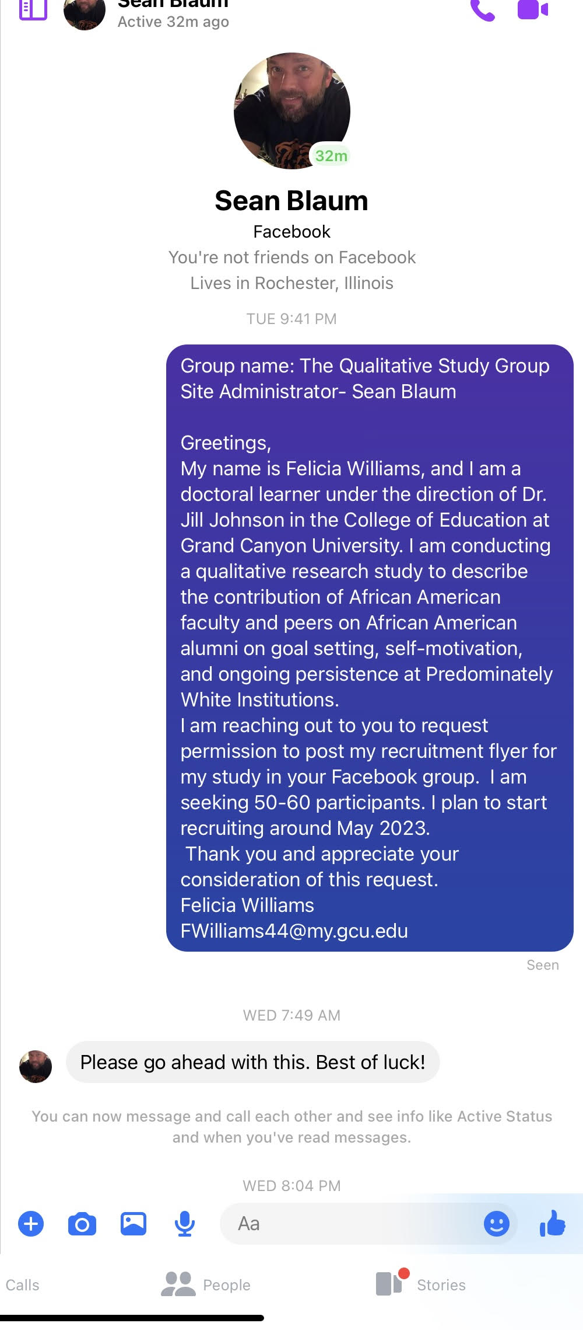

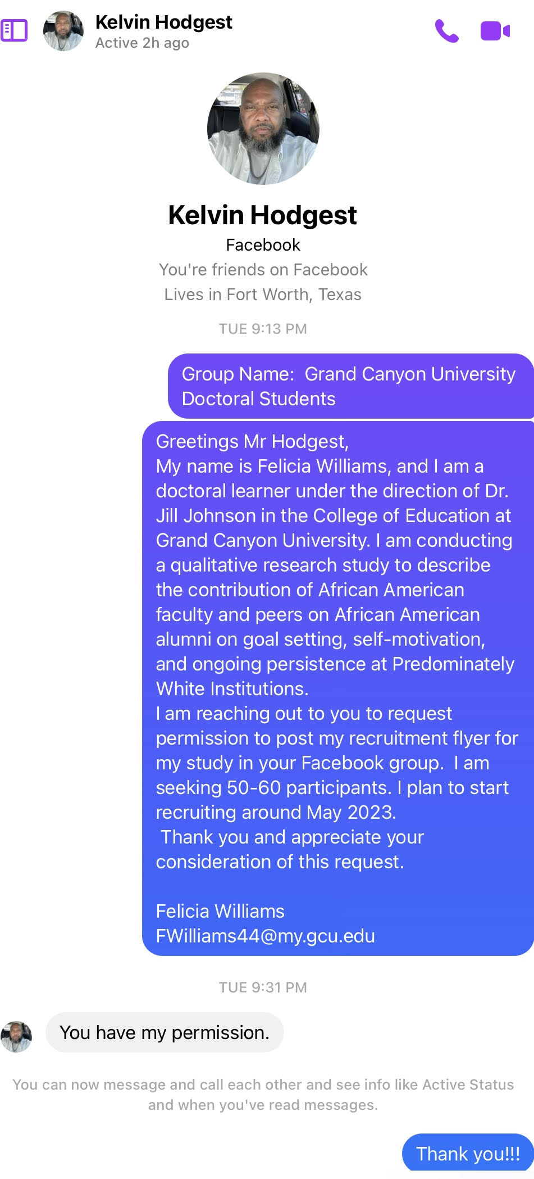

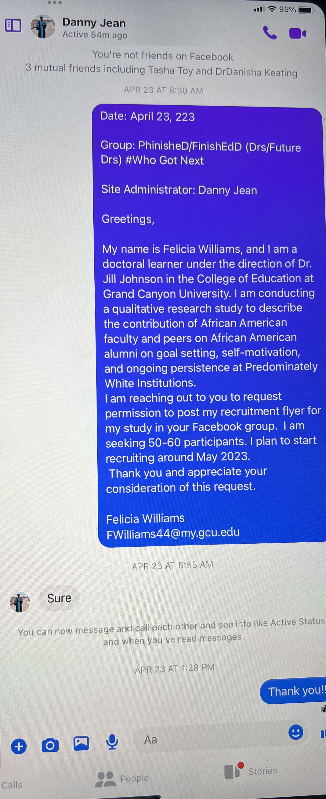

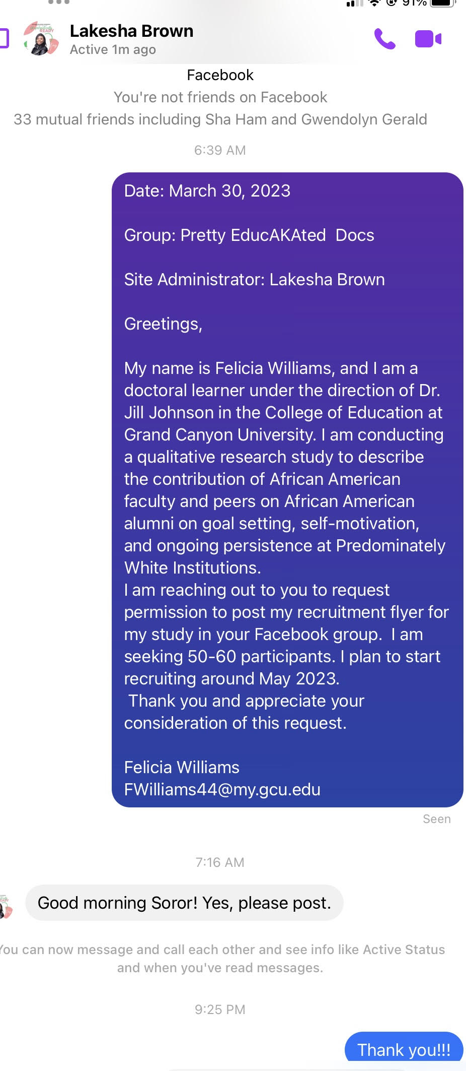

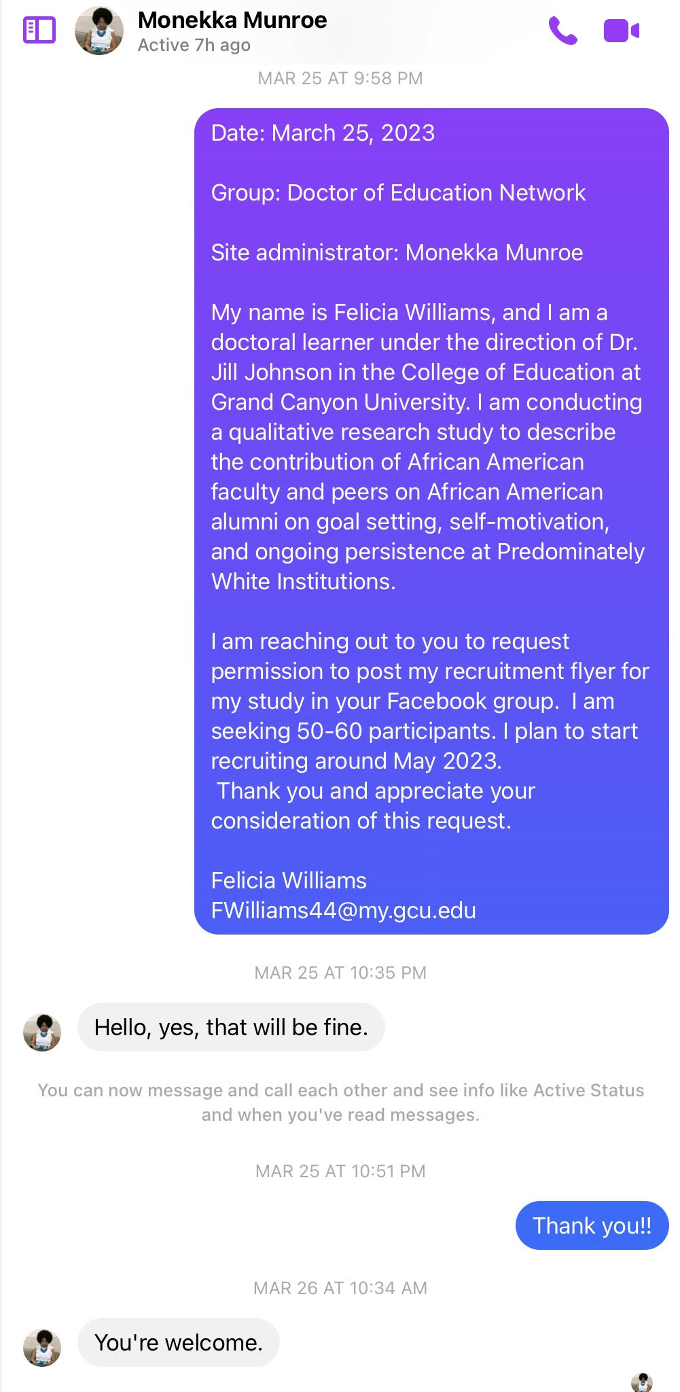

# Appendix C. IRB Approval Letter

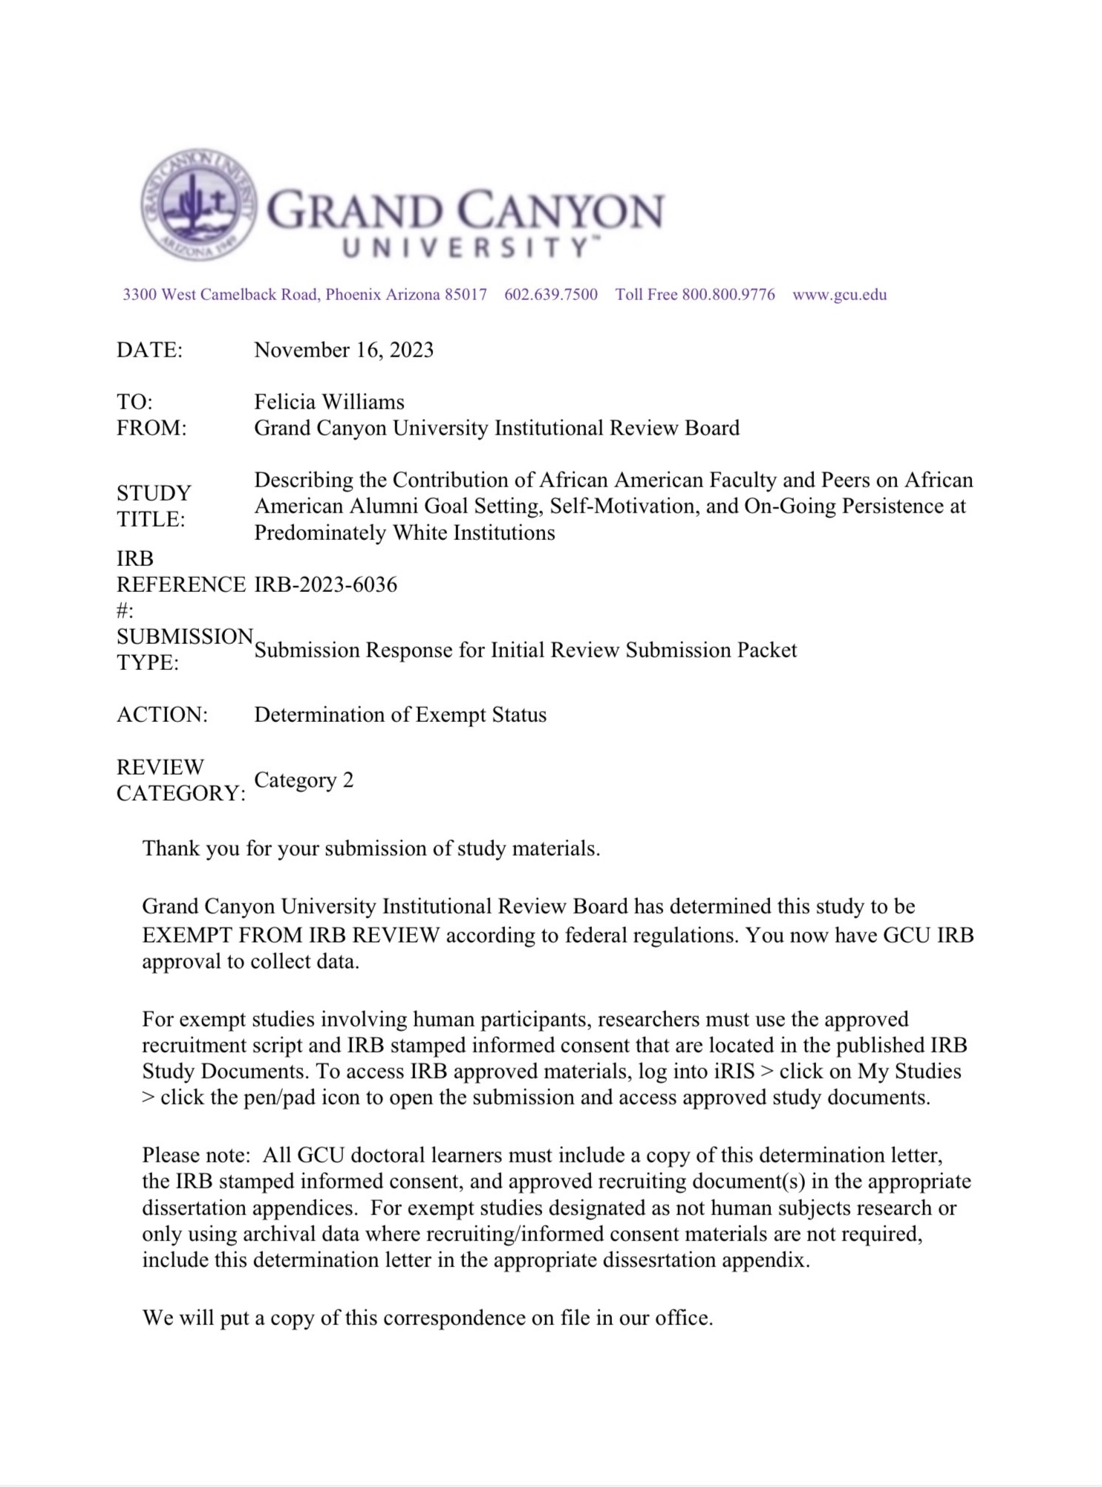

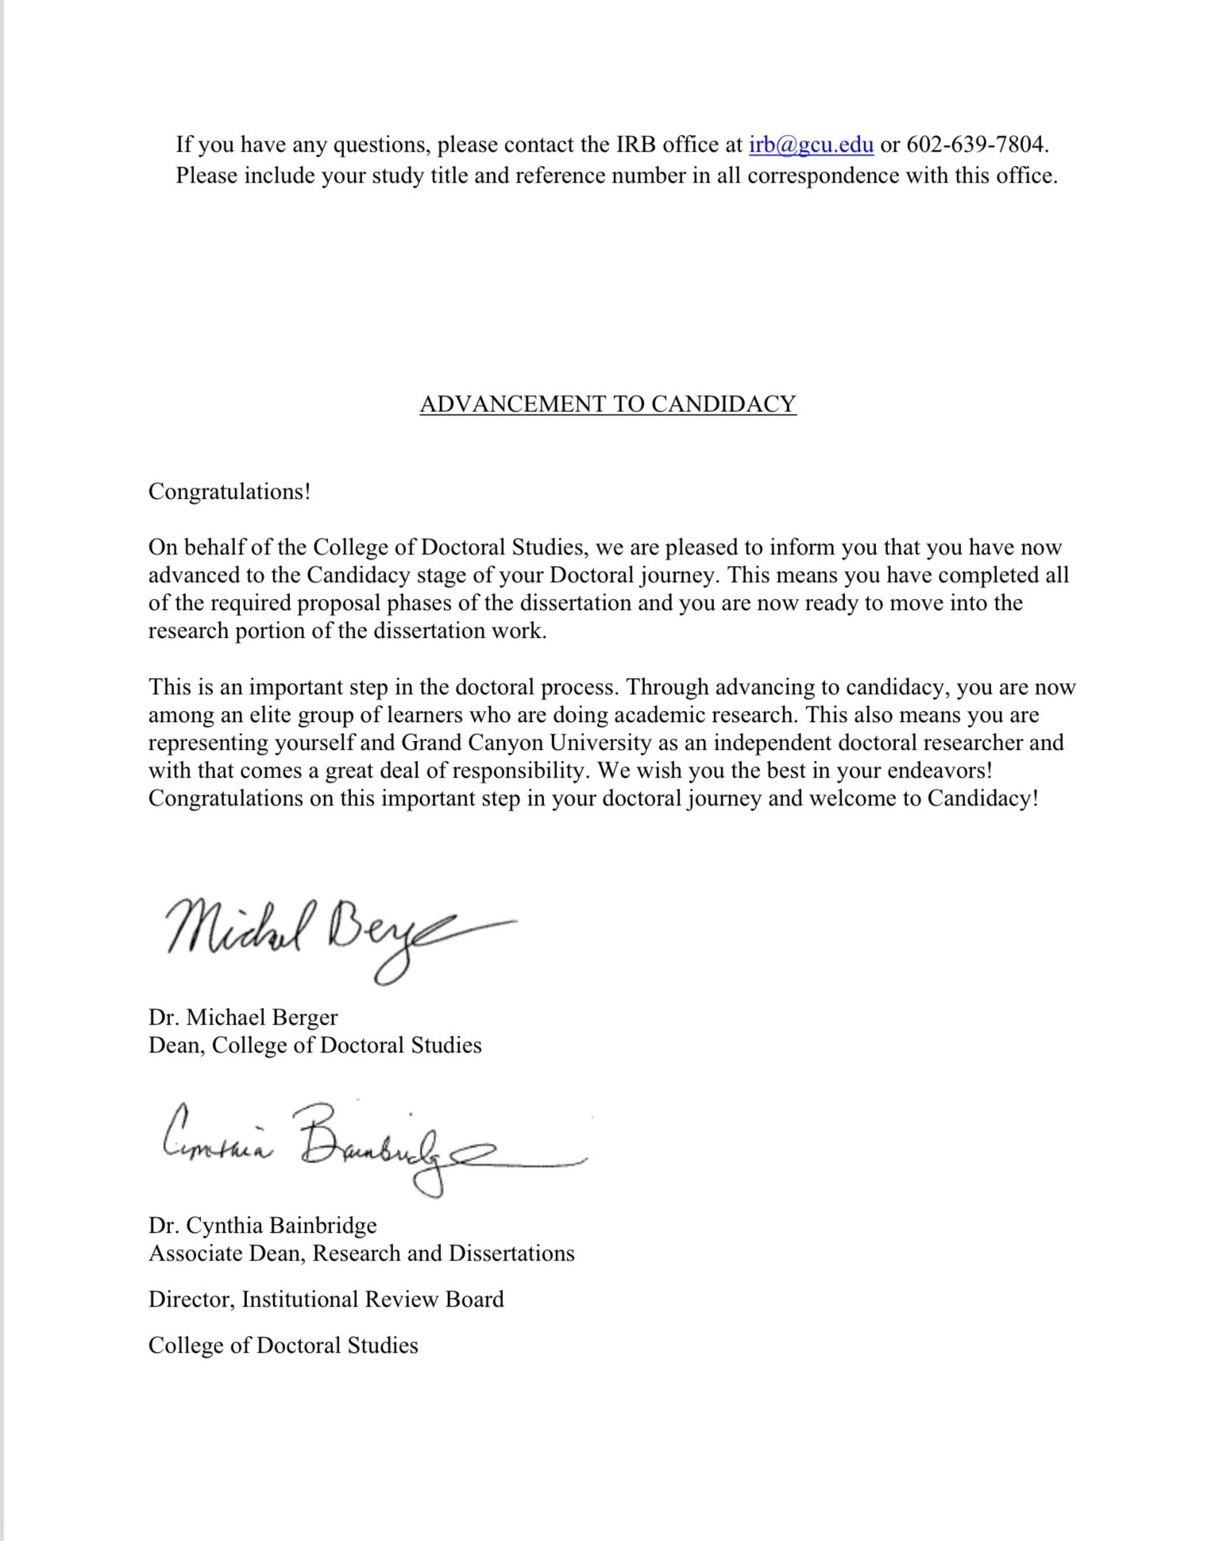

# Appendix D. Informed Consent

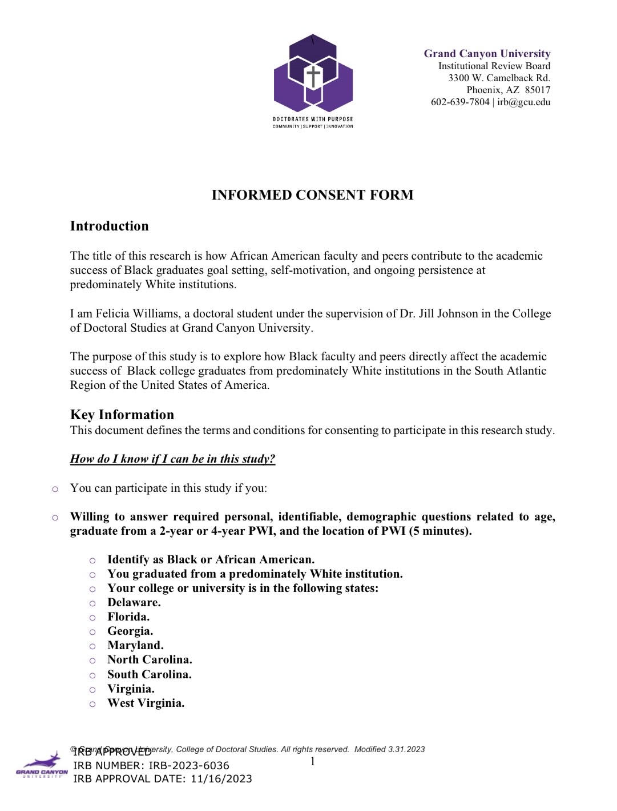

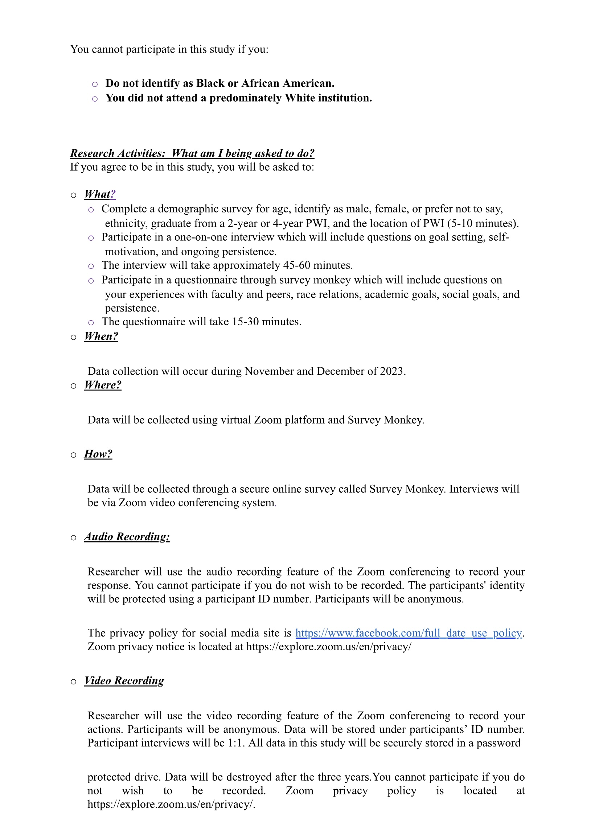

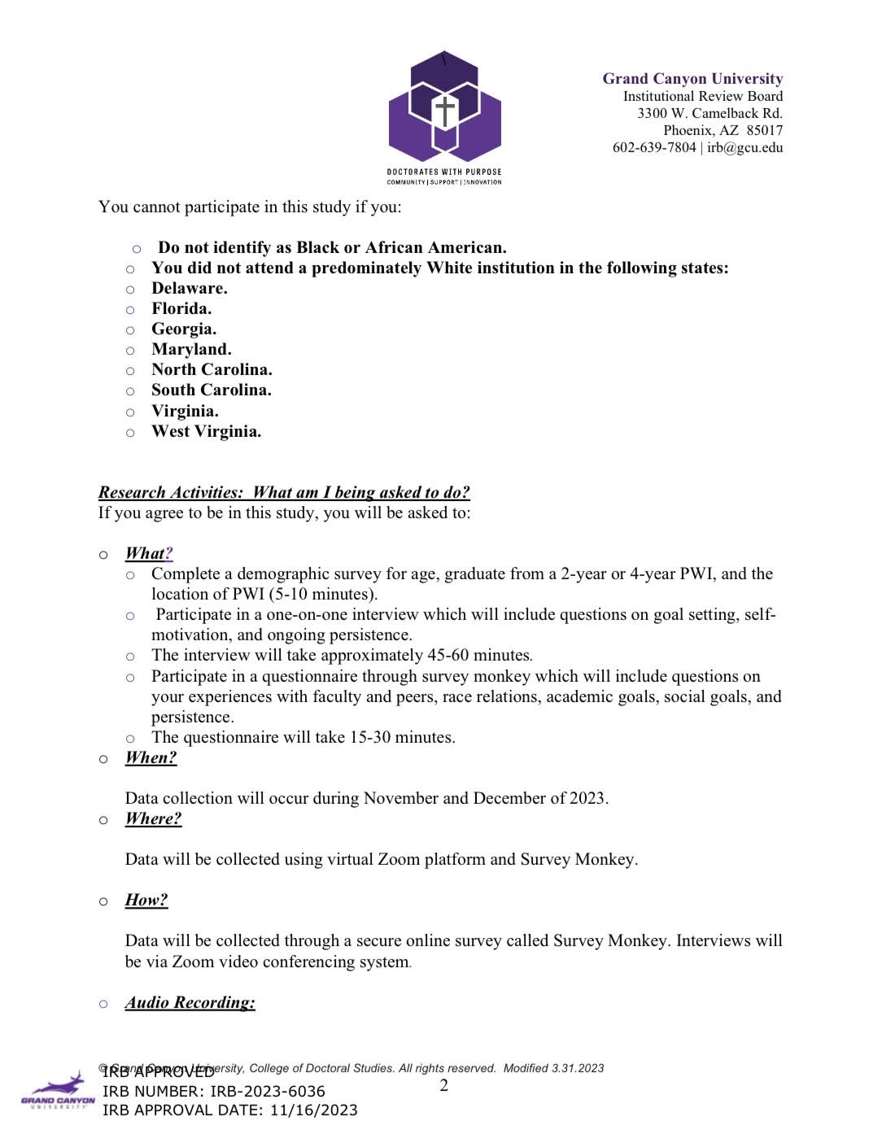

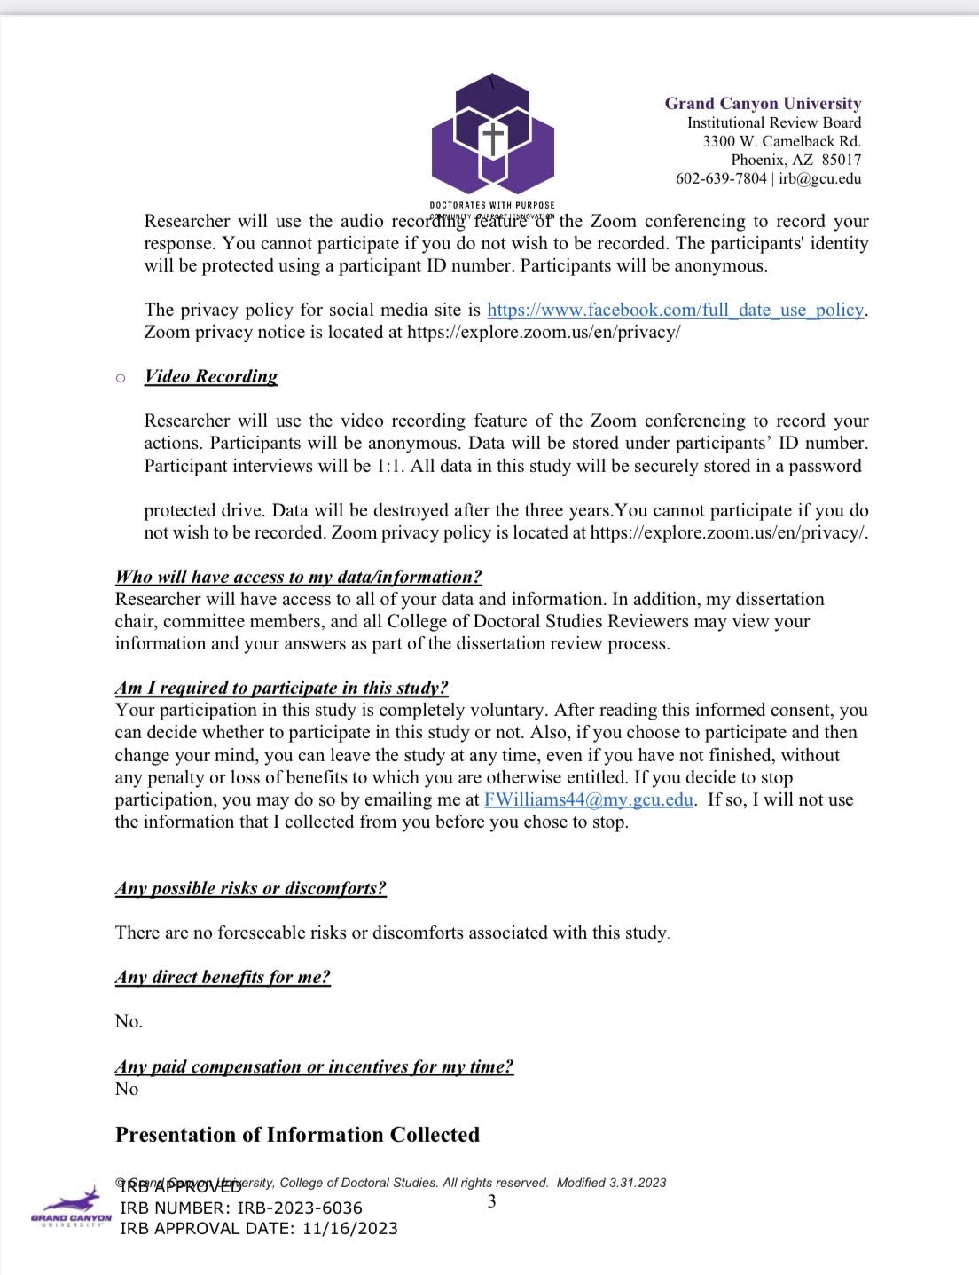

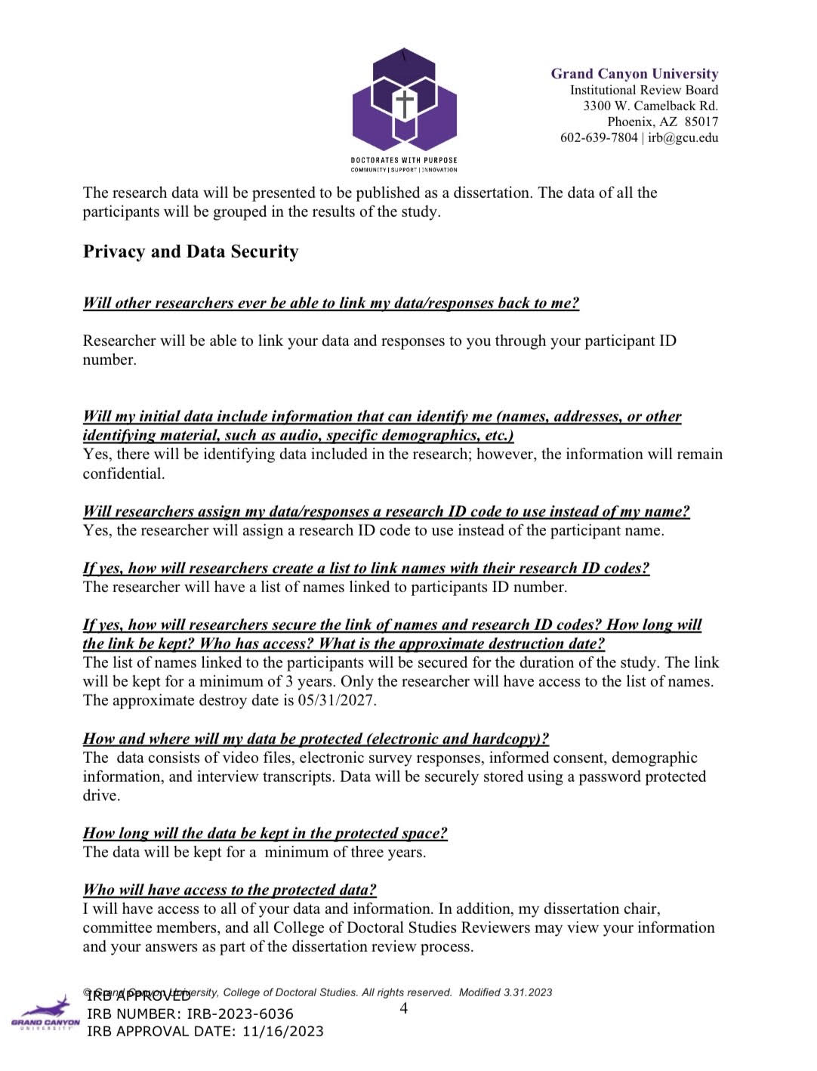

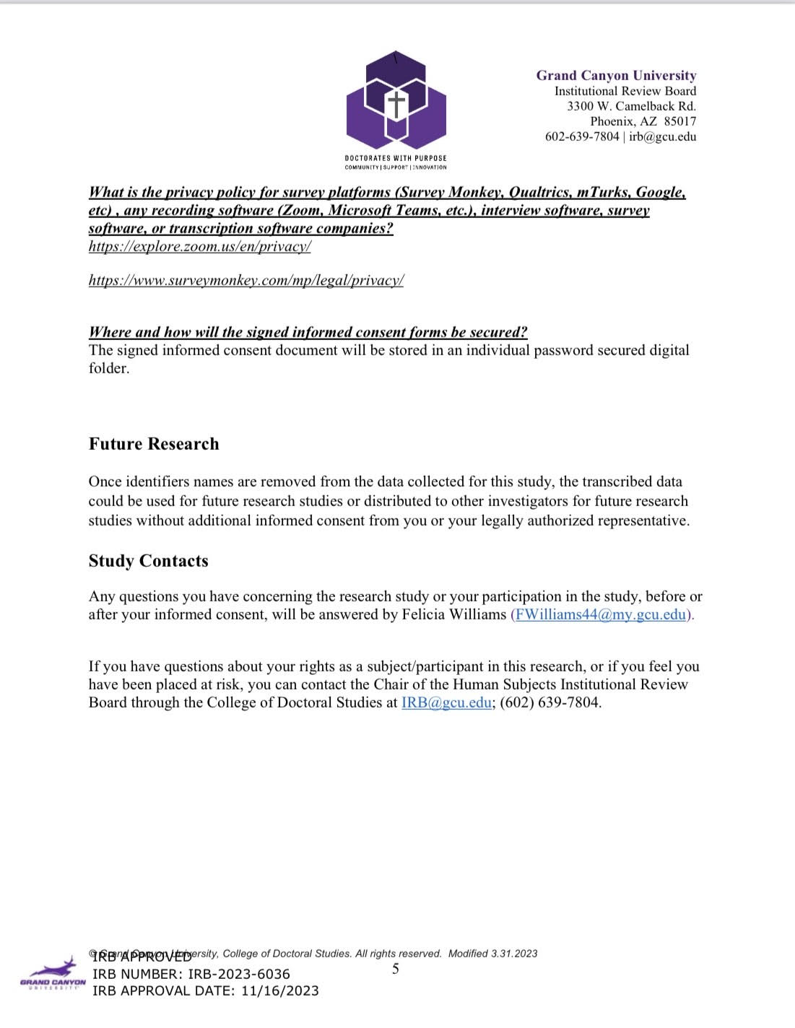

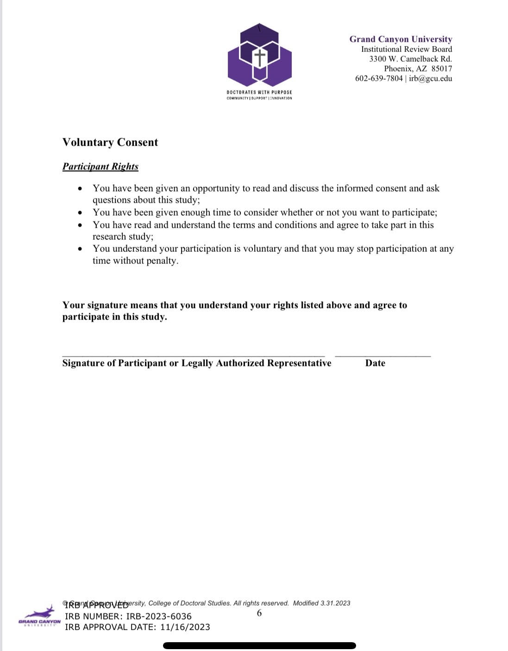

# Appendix E. Copy of Instruments

**Instrument 1: Demographic Questionnaire**

1. Do you identify as Black/African American? If yes, go to the next question. If not, thank you for applying.
2. Age of participant?
3. Do you identify as male, female, or prefer not to say?
4. Did you graduate from a 2 year or 4-year PWI?
5. What is the geographical location of your PWI?

**Instrument 2: Semi Structured Questionnaire**

1. Tell me about the best experience that stands out for you at your PWI?
2. What year were you in when that happened?
3. Tell me about the worst experience that stands out for you at your PWI?
4. What year were you in when that happened?
5. Can you describe your experience at the PWI in relation to race?
6. What academic goals did you have at your PWI?
7. What social goals did you have at your PWI?
8. Describe what helped you to persistence at your PWI?
9. Tell me about any experiences with faculty or peers, particularly those of African American background, which helped you persist at your PWI?
10. Did you ever consider leaving your PWI?
    1. If yes, what factors made you considering leaving your PWI?
    2. What factors motivated you to stay at your PWI?
11. What other factors do you feel influenced your successful completion of your degree program?
12. As a alumni from a PWI, what can you do to help incoming African American students to persist at their college or university?

**Instrument 3: Interview Questions**

RQ1: How do African American college alumni from Predominantly White institution located in the South Atlantic Region of the United States describe the contributions of their African American faculty and peers on goal setting?

Theme 1: **Goal setting**

Q.1. Describe the relationship with an African American faculty or peer that you had during your time at your PWI?

Q.2. How did your experience with African American faculty and peers at your PWI influences your educational/career goals?

Q3. Describe how the curriculum at your PWI influence your goals and choices for academic success?

RQ2: How do African American college alumni from Predominantly White institution located in the South Atlantic Region of the United States describe the contributions of their African American faculty and peers on self-motivation?

Theme 2: **Self-Motivation**

Q.1. Describe the relationship with an African American faculty or peer that motivated you during your time at your PWI?

Q.2. Describe the factors that motivated you to academic success?

Q.3. What life events happened that impact your ability for self-motivation?

RQ3: How do African American college alumni from Predominantly White institutions located in the South Atlantic Region of the United States describe the contributions of their African American faculty and peers on ongoing persistence?

Theme 3: **Ongoing Persistence**

Q.1. How would describe your overall college experience at your PWI?

Q.2. What are some defining experiences that made you persist at your PWI?

Q.3. Describe any organizations that gave you a sense of belonging to cause you to persist at your PWI?

**Interview Protocol**

1. **Participant Invitation Process**: African American participants will be invited to participate in the study via the recruitment flyer sent by the researcher. Participants will be provided with an explanation of the topic of the study, purpose of the study, importance of the study, and how the study will benefit the participants. This study will involve a questionnaire and interview questions. Participants information will be confidential and will be provided numbers or letters for identification. Participants must agree to a Zoom video conference.

**2. Interview Setup and Location**:

**Interview Location**: Interviews will be held via Zoom video/audio conference. All interviews will be recorded. Interviewer: Felicia Williams (Primary Researcher), will use a hard copy of the interview questions, notebook for field notes from the researcher during interview.

**Informed Consent**: Researcher will complete a review of informed consent with participant.

3. **Interview Overview:**

**Study purpose**: The purpose of this descriptive qualitative study is to explore how African American Alumni describes the contributions of African American faculty on goal setting, self-motivation, ongoing persistence at Predominantly White Institutions (PWI) in the South Atlantic Region of United States of America.

**Value of the participant’s information:** The data from this study is valuable as it will help to understand how African American faculty and peers can contribute to the overall retention and success of African American students at PWIs. The data in the study could open the doors for more research on retention of African American students at PWIs.

**Sharing Data Results:** The results of this study will be shared with the participants by providing them with a summary of the study.

**Interview length:** The length of the interviews will be 45-60 minutes. The interview includes the researcher asking open-ended questions and follow up questions if needed. The interview will be recorded. The researcher will address questions before the start of the interviews and after the interviews.

**4. Consent Form/Ethical Considerations:** Participants must sign a consent form that will discuss how confidentiality will be maintained and published in the final study. Participants will have an alias name or number for anonymity. All transcripts and recordings of the interview will be housed on a password-protected computer that will be accessible only to the researcher. Researcher and participants will have the ability to stop the research at any time without any consequences.

**Probing Questions**

PQ1: Could you please tell me more about…

PQ2: I’m not quite sure I understood…Could you tell me about that some more?

PQ3: I’m not certain what you mean by…Could you give me an example?

PQ4: Could you tell me more about your thinking on that?

PQ5: You mentioned that…Could you provide more details?

Permission to Use Figure 1



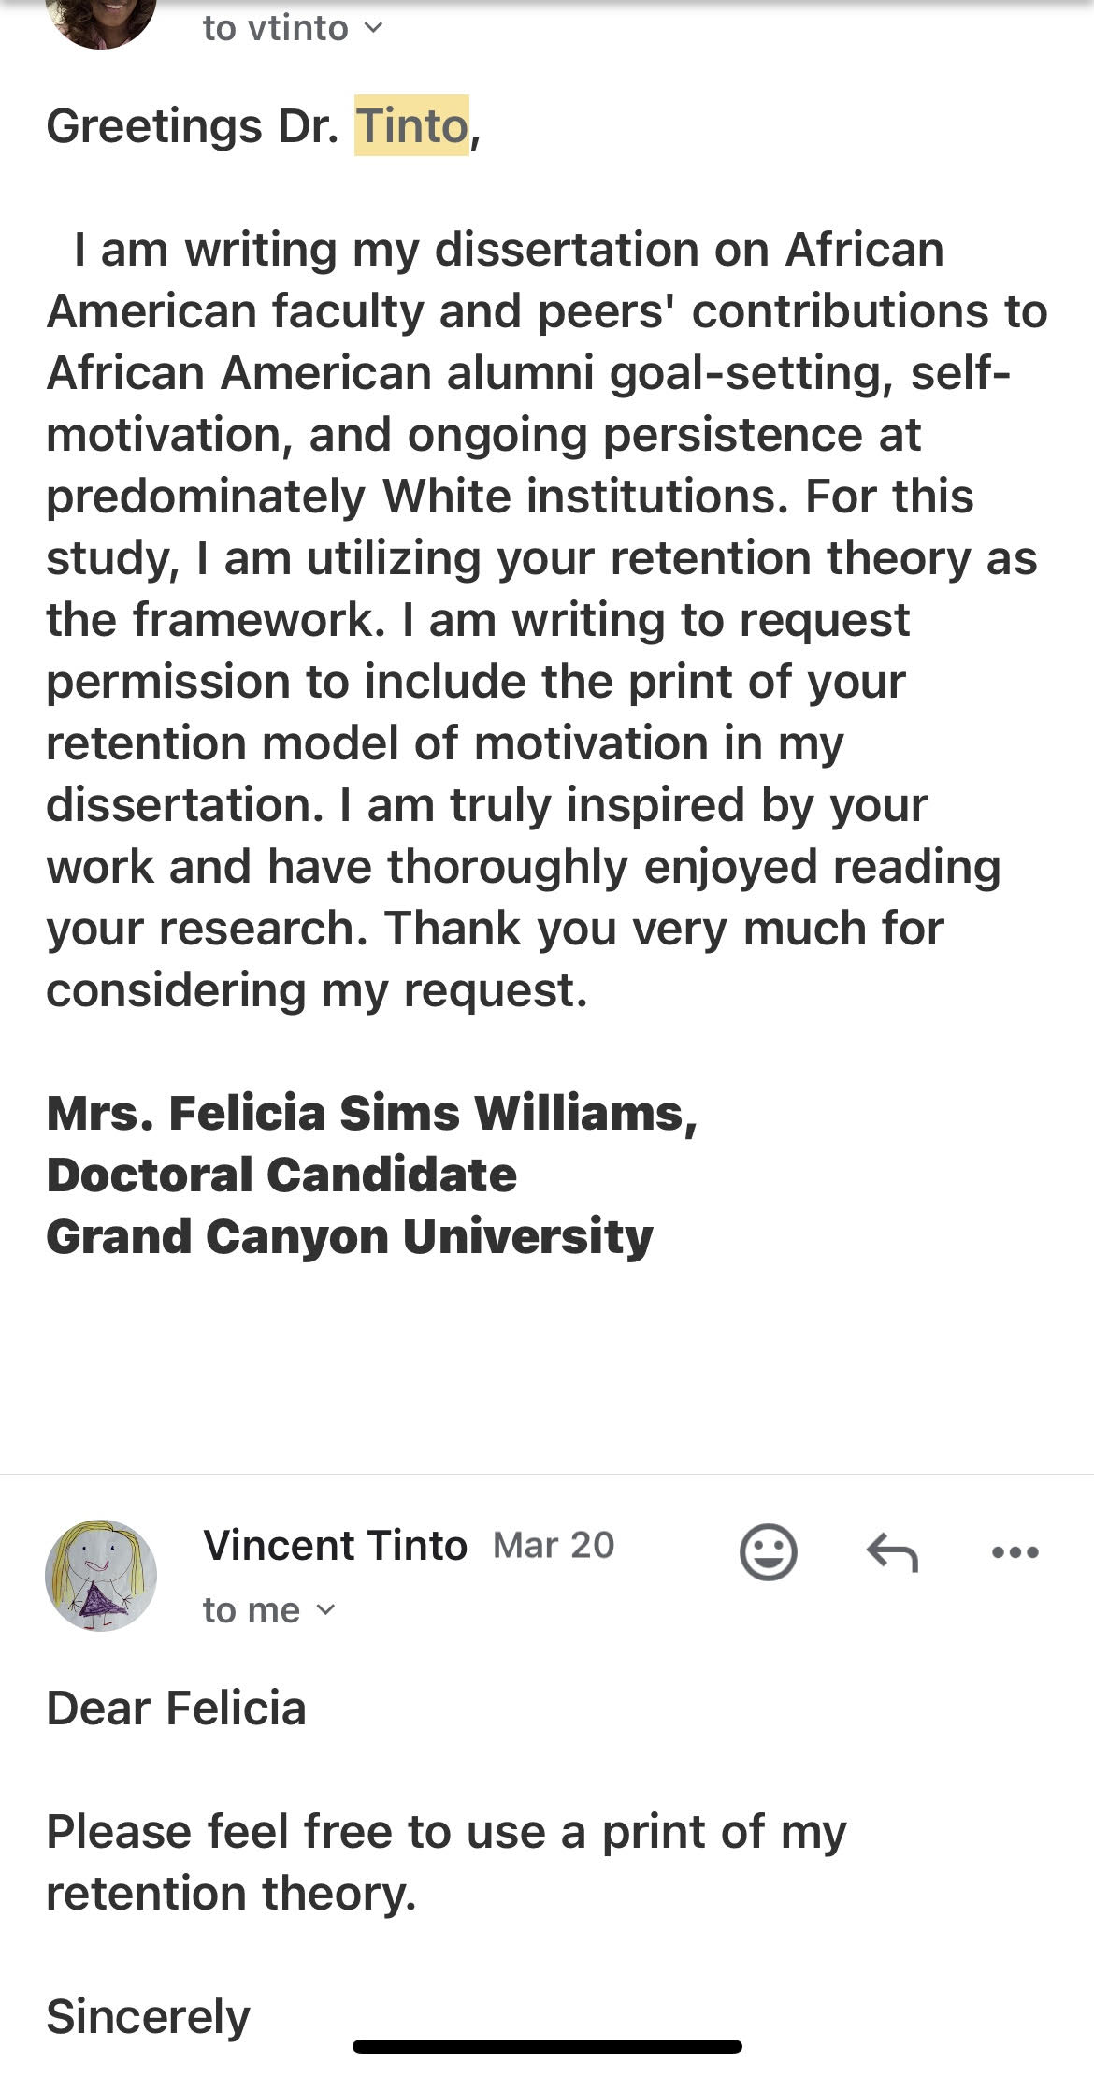



# Appendix F Full Codebook

# Appendix G. Transcripts

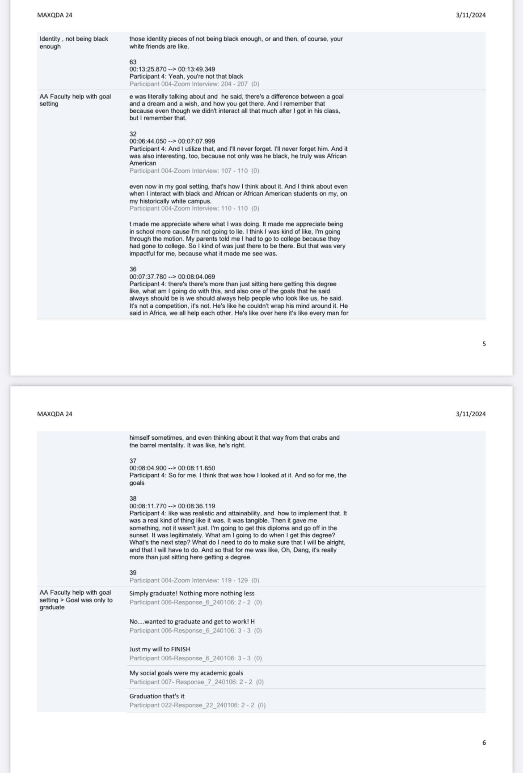

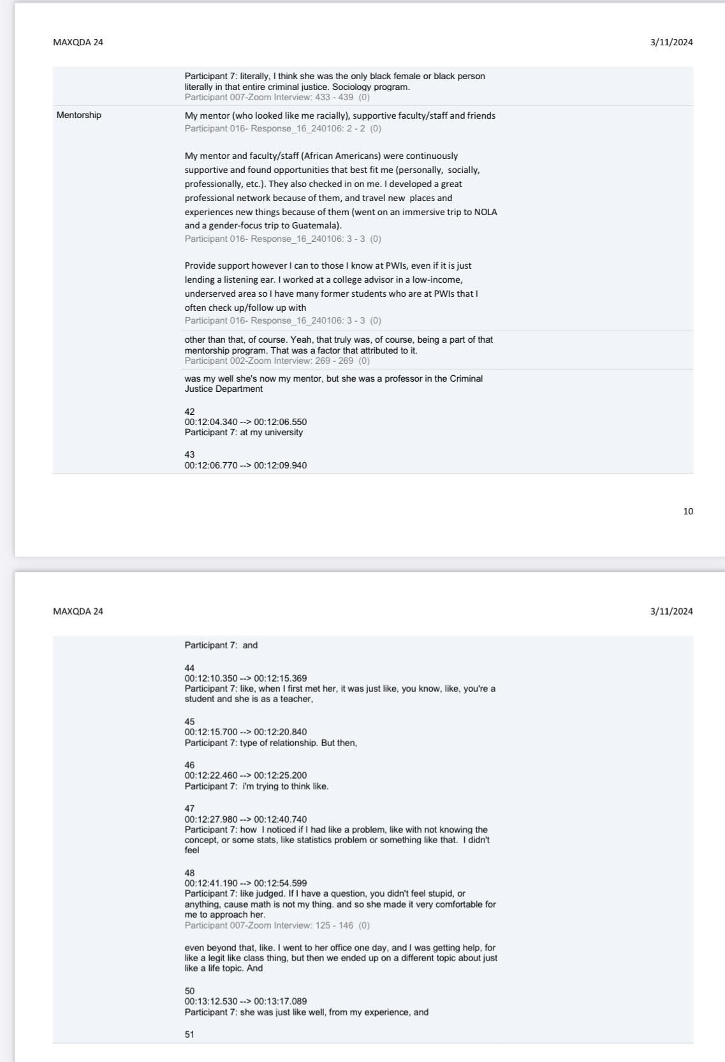

.

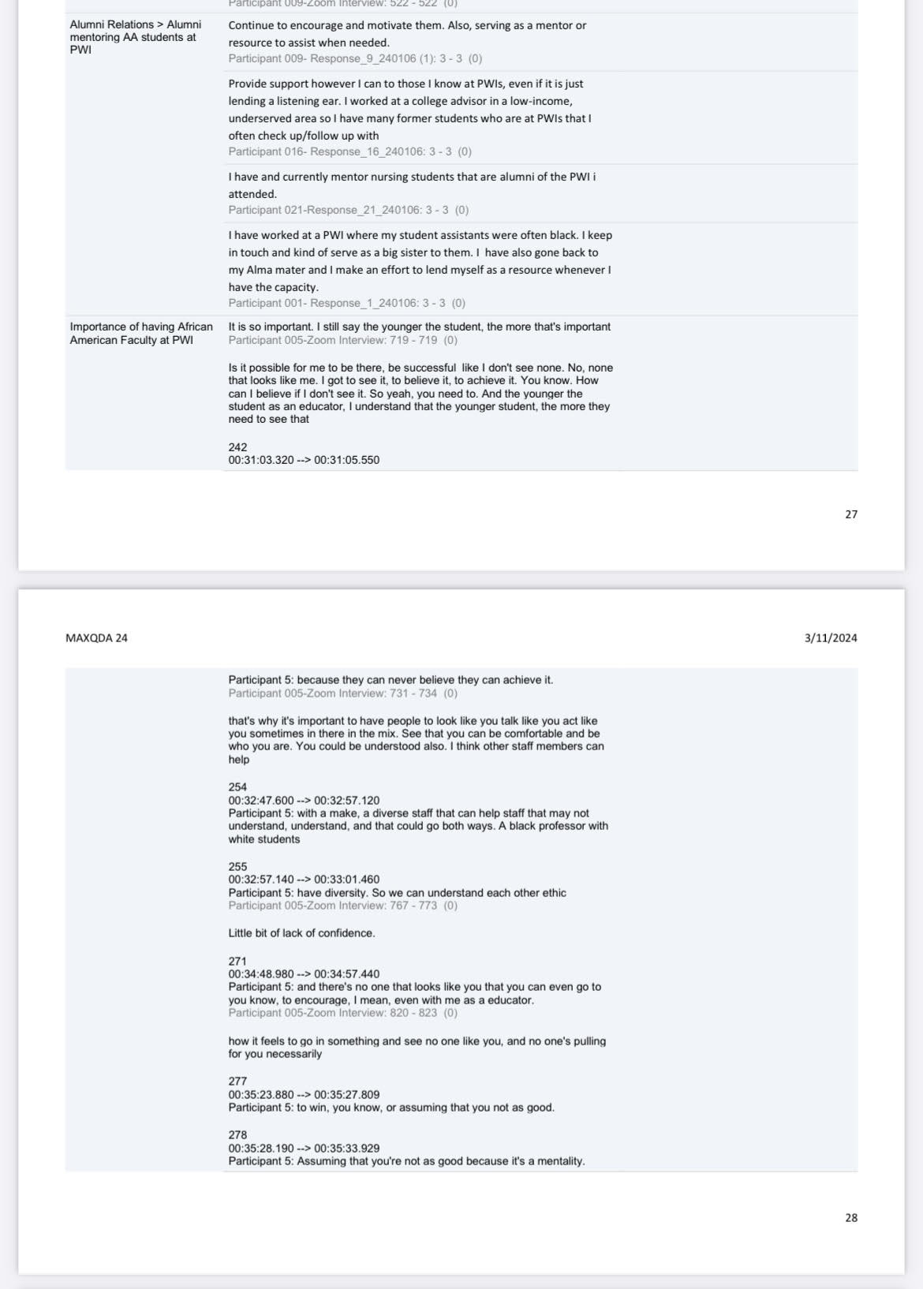

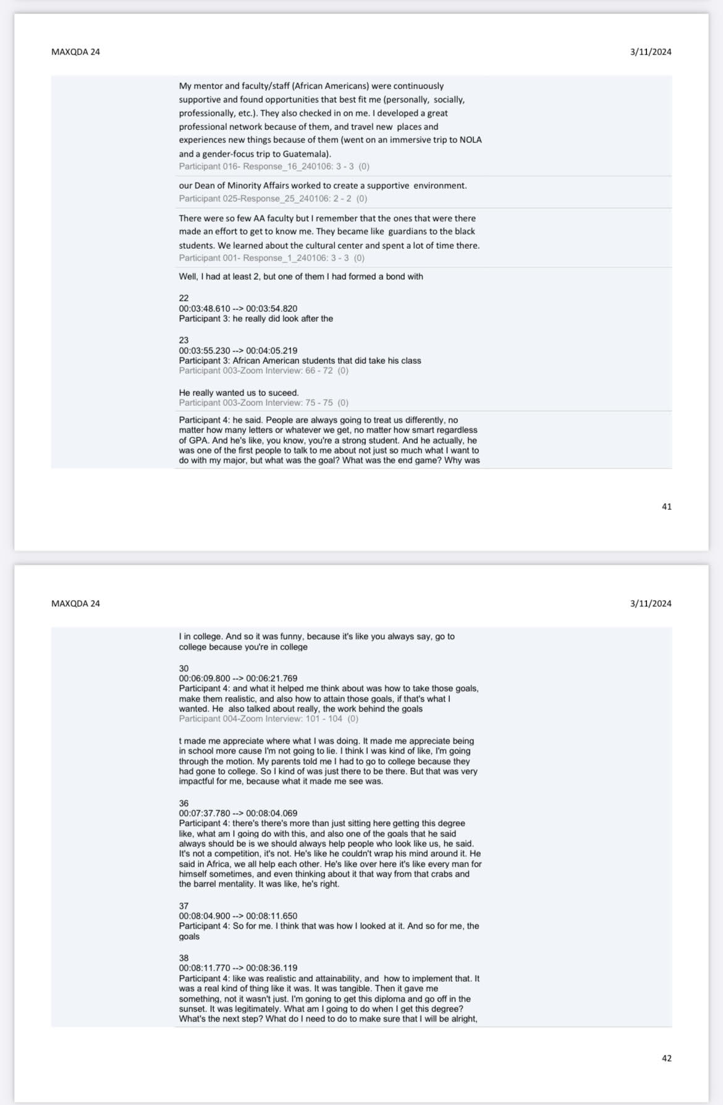

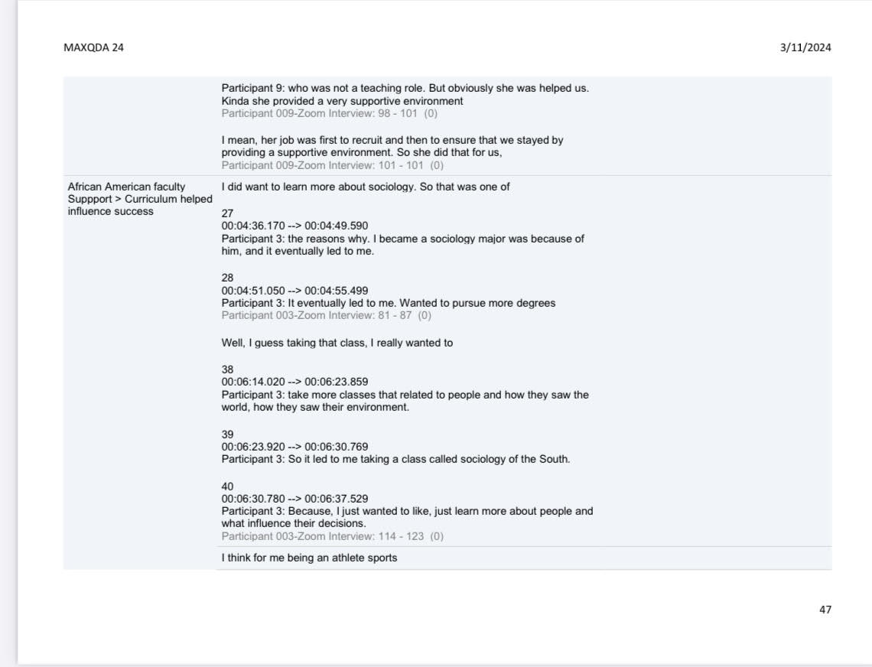

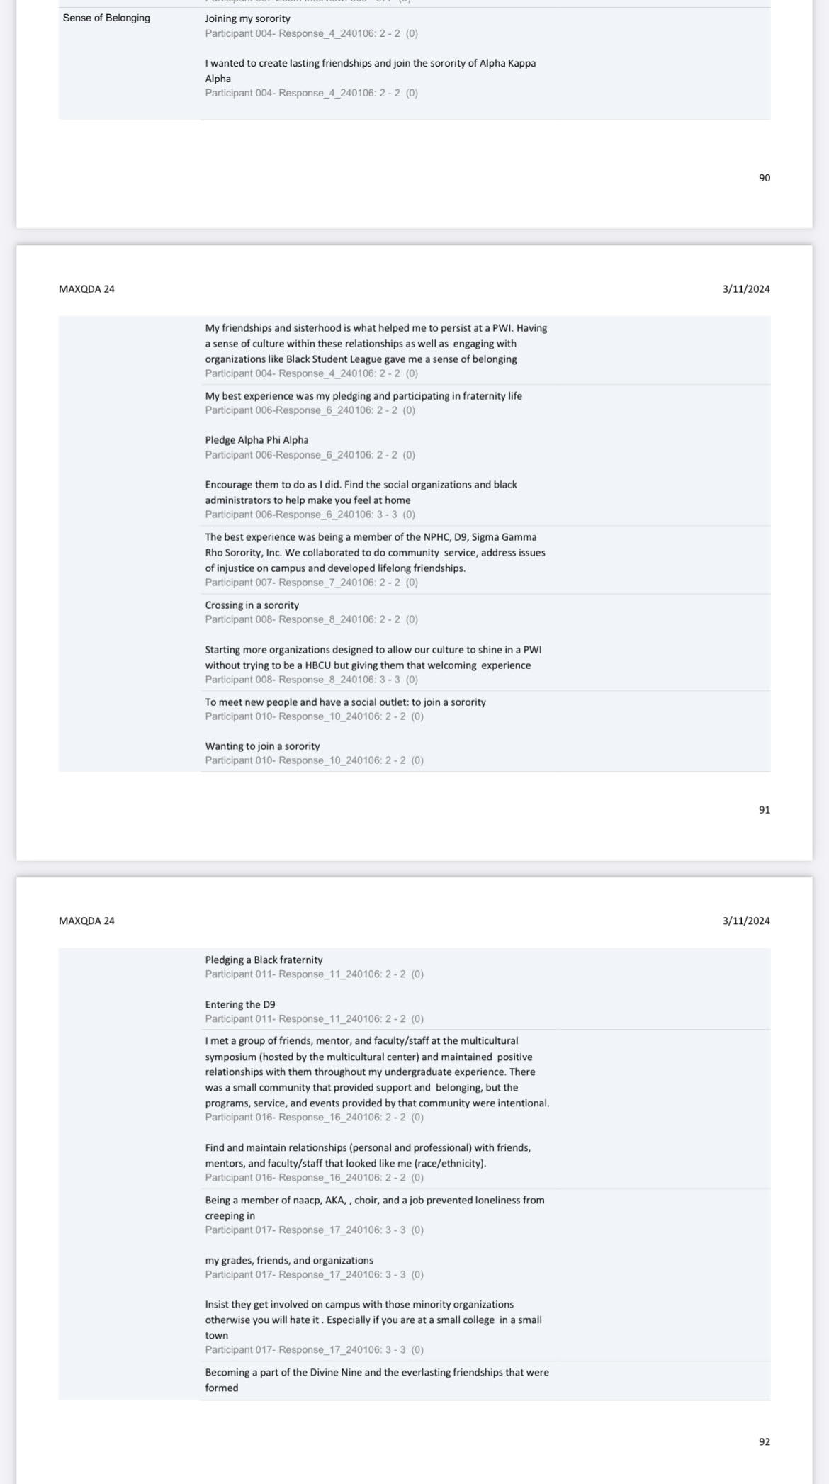

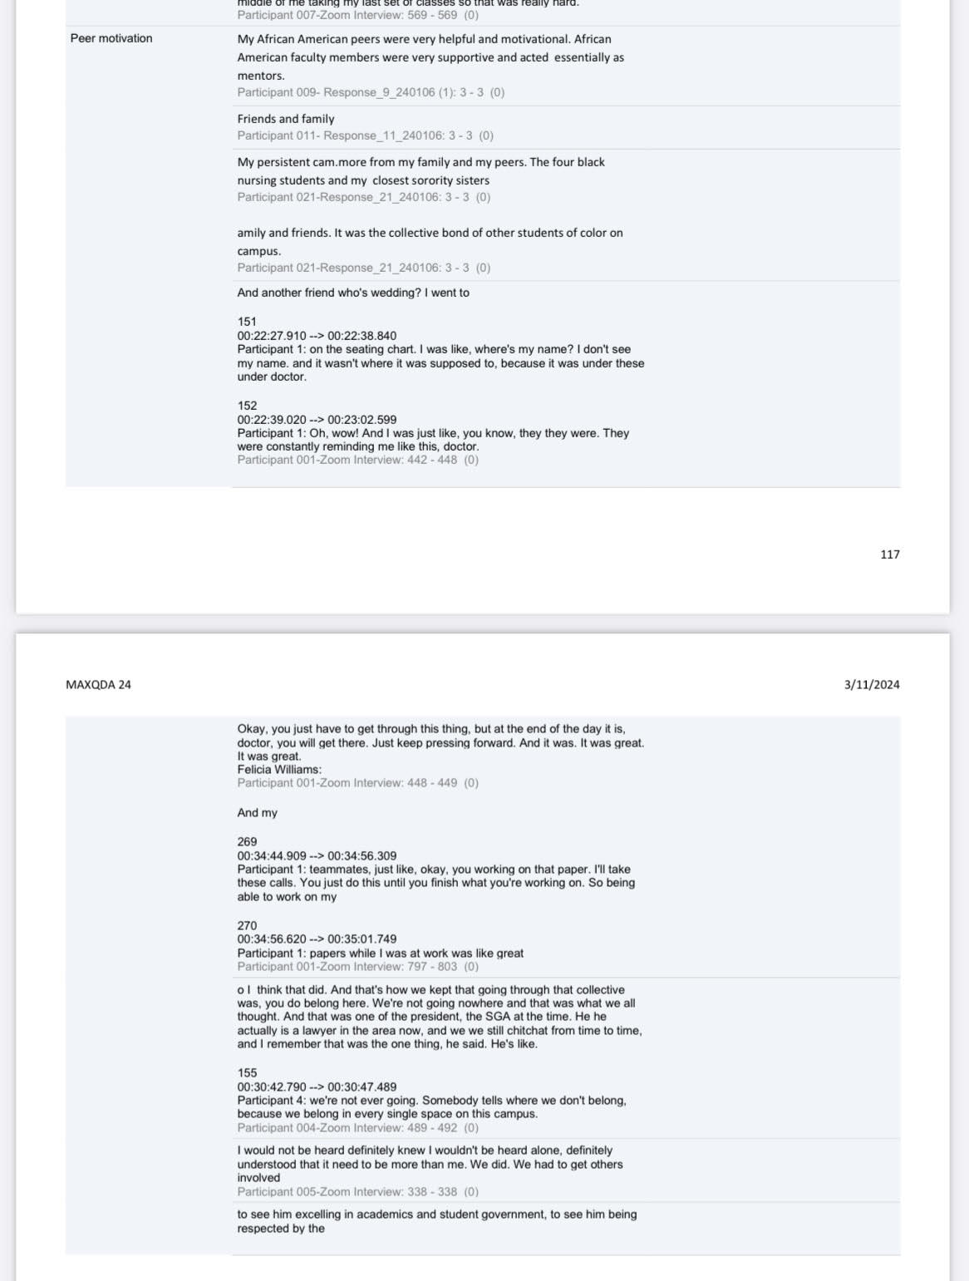

# Appendix H. Feasibility and Benefits Checklist

|  |  |
| --- | --- |
| Gatekeepers:  Who are the possible gatekeepers? (i.e., If you are in a school district, have you checked with the principal and the superintendent’s office or their designee to see what the process is for research? Or, if you are at a company, talked with the management, etc.?  If you are planning on collecting data from a college, what is the process? It is preferred that you obtain Institutional Review Board (IRB) approval from that institution prior to applying for GCU’s IRB approval). | Data will be collected using social media group such as private Facebook groups. Site authorizations will be required. Researcher personal Facebook page will also be used for recruitment therefore traditional site authorization is not required. Grand Canyon University IRB is the only IRB approval for the research study. |
| Gatekeeper Contact:  Who do you need to keep in contact with as you form your research project to ensure that the benefits outweigh the risk, and you can conduct your research? How will you initiate and maintain contact with them? | The researcher must keep in contact with all the participants throughout the entire study to ensure that the benefits of the study outweigh any risks to the participants. |
| Outside IRB:  If you are planning on recruiting participants or getting data from a college (or other institutions with an IRB), have you talked to their IRB to determine the process and what participants/data they will allow you access? Please note, IRB approval typically takes some time. | No outside IRB will be used for this research study. |
| Study Benefits:  What is the benefit of your research? Who do you need to keep in contact with as you form your research project to ensure that the benefits outweigh the risks?  *Remember that research should have a benefit; what benefit does your research have to others beside yourself?* | The benefit of the research is to explore how African American Alumni describes the contributions of African American faculty on goal setting, self-motivation, ongoing persistence at Predominantly White Institutions (PWIs). This study will help to understand how African American faculty and peers can contribute to the overall retention and success of African American students at PWIs. The data will benefit the research on retention of African American students at PWIs. Researcher will keep in close contact with the participants throughout the research to ensure the benefits outweigh the risks. |
| Research Activity:  Is your research part of *normal everyday activities*? This is significant because this must be outlined in your site authorization. A preliminary site authorization letter could simply be an email from a school/college/organization that indicates they understand what you want to do and how that benefits the school/college/organization. In some cases, this will determine the classification of the study (this is especially important for educational research studies).  ***Please see below for information regarding preliminary site authorization | This research is not a part of normal everyday activities. This research will require the participant to devote time to complete expectations of the research. |
| Recruitment:  Please describe your proposed recruitment strategy. How do you plan to involve your participants in the process? What would your flyer/email say? | The proposed recruitment strategy involves posting an approved recruitment flyer in previously approved Facebook groups and on the researcher personal Facebook page. Participants will not be involved in the recruitment process beyond meeting the qualifications. The proposed recruitment flyer will say:  Participants Needed!!  My name is Felicia Williams, and I am a doctoral learner under the direction of Dr. Jill Johnson in the college of Education at Grand Canyon University. I am conducting qualitative research to describe the contributions of African American faculty and peers on African American Alumni goal setting, self-motivation, and ongoing persistence at PWIs.  Who can participate?   * Must be African American * Must be a graduate of a PWI from the South Atlantic Region of the United States. * Must be willing to answer questions regarding your experiences with African American faculty and peers at your PWI.   What will I have to do?  Participate in questionnaire, 45–60-minute interview through Zoom. Interviews will be video, and audio recorded.  Participation in this study is voluntary. |
| Data Collection  What are you asking of participants? Are you asking them personal information (like demographic information such as age, income, relationship status)? Is that personal information necessary? How much time are you asking of participants (for example, if you are asking them to be interviewed, be in a focus group, fill out a questionnaire, fill out a journal/survey, collect artifacts, etc.)? How much time will they have to spend to be in your study? Does each part of your data collection help answer your research question? Participants must be told how long it will take to participants to participate in each activity. Are you concerned that the activities would take too long, and participants might not finish/drop out?  Can you collect your data in a reasonable amount of time considering the stakeholders and possible challenges of gaining access to participants? | African American participants will be required to meet all requirements for participation in this research and be willing to devote 45-60 minutes of their time to complete the questionnaire and interview process. No personal information will be asked of the participants. Each part of the data collection will answer the research questions. There are no concerns regarding the length of the research or participants dropping out of the research. There are no concerns regarding gaining research participants or the time to collect data. |
| Child Assent. Studies with children often fall under the regulations for a full board review (full board reviews take significantly longer in IRB). Each child must fill out a child assent AFTER there is parental consent. (It can be very difficult to get parental consent, especially if this is something sent home to parents). | No children will be participants in this study. |
| Informed Consent  Participants must be told how long it will take to participants to participate in each activity. Are you concerned that the activities would take too long, and participants might not finish/drop out? | Participants will be required to complete an informed consent and notified of the expectations and time requirements of the study. There is no concern regarding length of activities and participants dropping out of the study. |
| Site Authorization  Do you have a site authorization letter? How difficult will this be to get from the school/ school district/college/organization? Use the GCU template to ensure the correct information is included. | Site authorization to post recruitment flyer has been obtained from the administrator or moderator of the Facebook groups. No site authorization is needed from a school, college, or organization. GCU template was used for recruitment flyer information. |
| Can you collect your data in a reasonable amount of time considering the stakeholders and possible challenges of gaining access to participants? | Data will be collected within one month of authorization. Participants will be allowed to choose a time slot that is convenient for them. |
| Organizational Benefits:  Have you talked to your principal/supervisor/district/college/boss/ organization about your research? If so, have you asked them what you can do to help the district/organization/school? | The researcher does belong to organization (Sorority) that the participants may be a member of in the Facebook group. The organization itself will not personally benefit or participate in this study. |
| What is the overall benefit of your research to participants? | The overall benefit of the study is to understand how African American faculty and peers can contribute to the overall retention and success of African American students at PWIs |
| What are the risks of your research? Please note that there are usually some risks (like revealing participant identity) in all research. | Participants may be at risk of discussing racial microaggressions that occurred at PWIs. |
| Now that you have contemplated the above questions, how long do you imagine it will take you prior to access your participants/data? AND how much are you asking of your participants? | Participants are asked to devote 45 to 60 minutes of their time. Accessing participants for the study should not be difficult. |
| Based on the information that you have learned, is your study feasible? Why or why not? If not, how can you modify your ideas to make your study manageable? | Based on the goal and the information learned, the study is feasible. The participant commitment for this study is minimal and risks to the participant are low. |

# Appendix I. Readability



# Appendix J. Developing Qualitative Interview Questions Systematically

RQ1: How do African American college alumni from PWIs located in the South Atlantic Region of the United States describe the contributions of their African American faculty and peers on goal setting?

Theme 1: **Goal setting**

Q.1. Describe the relationship with an African American faculty or peer that you had during your time at your PWI?

Q.2. How did your experience with African American faculty and peers at your PWI influences your educational/career goals?

Q3. Describe how the curriculum at your PWI influence your goals and choices for academic success.

* RQ2: How do African American college alumni from PWIs located in the South Atlantic Region of the United States describe the contributions of their African American faculty and peers on self-motivation?

Theme 2: **Self-Motivation**

Q.1. Describe the relationship with an African American faculty or peer that motivated you during your time at your PWI?

Q.2. Describe the factors that motivated you to academic success?

Q.3. What life events happened that impact your ability for self-motivation?

*RQ3: How do African American college alumni from PWIs located in the South Atlantic Region of the United States describe the contributions of their African American faculty and peers on ongoing persistence?

Theme 3: **Ongoing Persistence**

Q.1. How would describe your overall college experience at your PWI?

Q.2. What are some defining experiences that made you persist at your PWI?

Q.3. Describe any organizations that gave you a sense of belonging to cause you to persist at your PWI?

What else that we have not discussed can you tell me…?

# Appendix K. Recruitment Letter

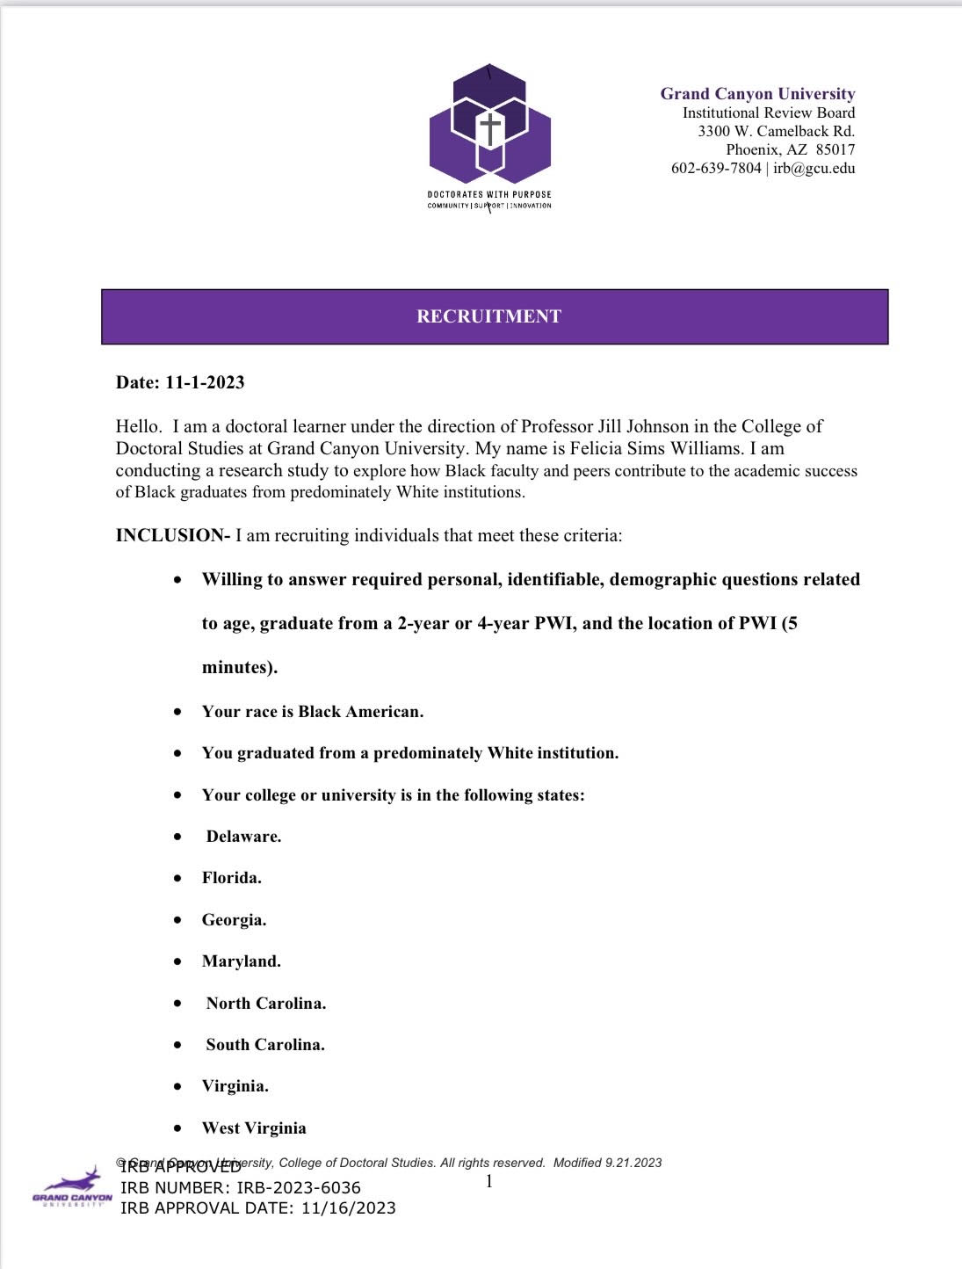

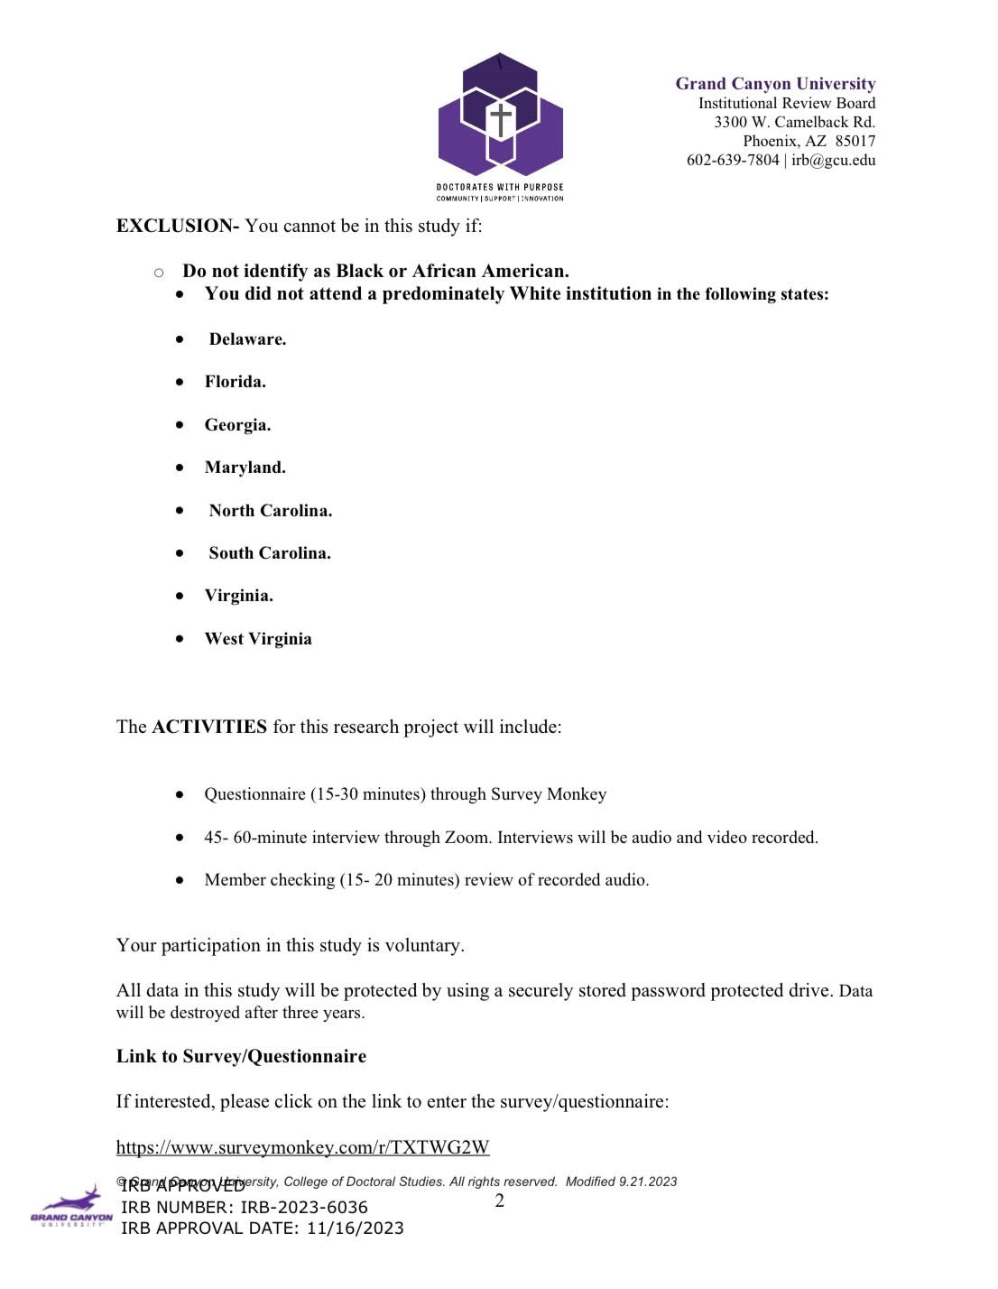

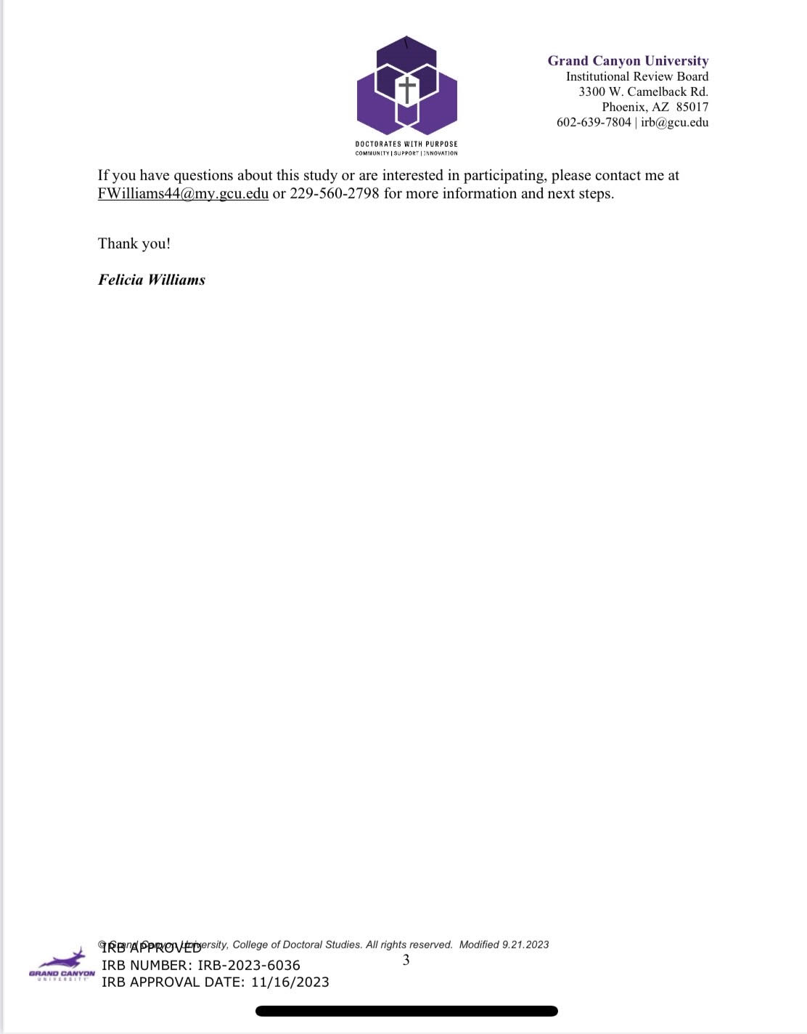

# Appendix L. Alignment of Questionnaire to Research Question

*Questionnaire and RQ Alignment*

|  |
| --- |
| 1. Tell me about the best experience that stands out for you at your PWI? RQ3  2. What year of college where you in when that happened?  3. Tell me about the worst experience that stands out for you at your PWI? RQ3  4. What year of college were you in when that happened?  5. Can you describe your experience at the Predominantly White institution in relation to race? RQ3  6. What academic goals did you have at your PWI? RQ 1 Alignment  7. What social goals did you have at your PWI? RQ 1 Alignment  8. Describe what helped you to persist at your PWI? RQ 3 Alignment  9. Tell me about any experiences with faculty or peers, particularly those of African American background, which helped you to persist at your Predominantly White institution? RQ 3 Alignment  10. Did you ever consider leaving your PWI? RQ 3 Alignment  A. If yes, what factors made you consider leaving your PWI? RQ 3 Alignment  B. What factors motivated you to stay at your PWI? RQ2 Alignment  11. What factors do you feel influenced your successful completion of your degree program? RQ 2  12. As a alumni from a PWI, what can you do to help incoming African American students to persist at their college or university? RQ 3 Alignment |

# Appendix M. Copy of Invitation to Participant (Study Advertisement)

I am a doctoral learner under the direction of Dr. Jill Johnson at Grand Canyon University. I am conducting a research study. The study will explore how Black faculty and peers contribute to the academic success of Black graduates from Predominantly White institutions.

**INCLUSION:** I am recruiting participants that meet these criteria:

* **Willing to answer required personal, identifiable, demographic questions related to age, identify as male, female, or prefer not to say, ethnicity, graduate from a 2-year or 4-year PWI, and the location of PWI (5 minutes).**
* **Your race is Black American.**
* **You graduated from a Predominantly White institution**
* **Your college or university is in the following states:**
* **Delaware.**
* **Florida.**
* **Georgia.**
* **Maryland.**
* **North Carolina.**
* **South Carolina.**
* **Virginia.**
* **West Virginia.**

**EXCLUSION:** You cannot be in this study if:

* **You do not identify as Black American.**
* **You did not graduate from a Predominantly White institution.**

The **ACTIVITIES** for this research include:

* Questionnaire (15-30 minutes) through Survey Monkey
* 45- 60-minute interview through Zoom. Interviews will be audio and video recorded.
* Member checking (15- 20 minutes) review of recorded audio.

Participation in this study is voluntary. Data will be protected and stored. Data will be destroyed after three years.

If you have questions, contact me at:

1. FWilliams44@my.gcu.edu
2. 229-560-2798







.

|  |  |  |  |  |  |  |  |
| --- | --- | --- | --- | --- | --- | --- | --- |
| Categories to Themes  **Theme 4:** African American faculty and peers as role models and mentors |  | **X** |  |  |  |  |  |
| **Theme 5:** Sense of belonging through involvement and relationships | **X** |  |  |  |  |  |  |

# Appendix P Final Themes to Research Questions

*Final Themes and Definitions*

|  |  |  |  |
| --- | --- | --- | --- |
| RQs | Definitions | Theme |  |
| RQ1: How do African American college alumni from PWIs located in the South Atlantic Region of the United States describe the contributions of their African American faculty and peers on goal setting? | African American alumni described the contributions of having a curriculum that focused on goal setting and having African American mentors while attending PWI. | African American alumni described that having a curriculum that reflects diversity, academic, and career development contributed to African American student’s goal setting and persisting at their PWI |  |
|  | African American alumni described the contributions of their self-motivation, personal ambitions, peer support, mentorship and guidance from faculty and peers while attending a PWI. | African American alumni described having faculty and peers who serve as mentors, who offer support and guidance with motivation, personal ambitions, peer support, mentorship and guidance while attending a PWI. |  |
| RQ2: How do African American college alumni from PWIs located in the South Atlantic Region of the United States describe the contributions of their African American faculty and peers on self-motivation? | African American alumni described their motivation despite racism and racial microaggressions while attending a PWI. | African American Alumni described the positive experience of being chosen by faculty or singled out to represent African Americans in diversity discussions and negative experiences endured of being excluded in social and academic settings of racism and racial microaggressions while attending a PWI. |  |
|  | African American alumni described having faculty serve as mentors and offer support and guidance for African American students while attending a PWI | African American alumni described how having African American faculty and peers as role models and mentors contributed to their ongoing persistence of African American students while attending a PWI. |  |
| RQ3: How do African American college alumni from PWIs located in the South Atlantic Region of the United States describe the contributions of their African American faculty and peers on ongoing persistence? | African American alumni described experiences and relationships that contributed to their academic, social, and ongoing persistence while attending a PWI | African American alumni described the effects of having a sense of belonging through campus and community involvement, fraternities, sororities, faculty and peer relationships. being in leadership roles or having leadership experience for ongoing persistence while attending a PWI. |  |

# Final Themes to Research Questions